ECE 472
POWER SYSTEMS II

EXPERIMENT 6 – WEEK 8
SOME GENERATOR PROTECTION FUNCTIONS

Objective
The objectives of this laboratory experiment are summarized below:
1. To become familiar with the Basler BE1-IPS100 relay.
2. To become familiar with connection of a Basler BE1-IPS100 relay to
a model power system.
3. Learn to perform measurements with the Basler BE1-IPS100 relay.
4. Learn to set Basler BE1-IPS100 relay for voltage protection.
5. Learn to set Basler BE1-IPS100 relay for Volts/Hz protection.
6. Learn to set Basler BE1-IPS100 relay for reverse power flow protection.

Pre - Lab
Familiarize yourself with the Basler BE1-IPS100 relay instruction manual.

Figure 1 shows a one-line diagram of the three-phase model power system which consists of:
- DC Motor
- Synchronous Generator
- BE1-IPS100 relay
- Three Phase Supply System
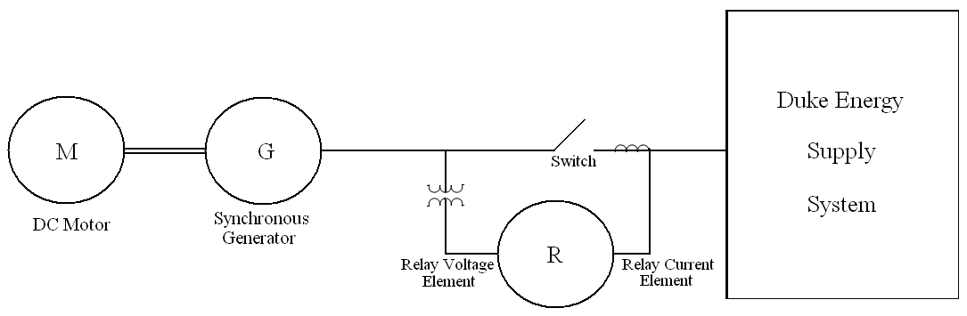

Figure 1. Model Power System

The following is the data for this model power system:

V_{Source} = 120 V (line-to-neutral)

Procedure
This lab will explore numerous generator protecting methods extending from undervoltage (27P) and overvoltage protection (59P), to Volts/Hz protection (24), and ending with reverse power flow protection (Reverse 32).

To access the relay settings on your computer you can navigate through the element features using the System Setup Summary icon (should be the first thing that loads up when opening the software, but it is also located on the toolbar). Here you can see that the desired elements have been activated and you can click on them to see specific settings. Later in the lab you will be asked to observe these specified values.

To connect the Basler BE1-IPS100 relay to the lab PC, turn the relay on (you should hear relay clicking) and double-click on the SEL icon. Then perform the following:

- Double Click on the Basler BESTCOMS icon on the computer desktop.
- Go to FILE → OPEN
Select ECE472_Relays_Basler_BE1-IPS100 folder and open ECE472_Gen Protection_Relay*.bst file (where Relay* refers to the number associated with your relay as indicated on top of the relay).
- Go to COMMUNICATION → SET DATE AND TIME
Click YES.
Enter the password ECE472 and click on OK.
Click on CLOSE.
- Go to COMMUNICATION → UPLOAD SETTINGS TO DEVICE
Enter the password ECE472 and click OK.
- Go into the relay settings for 27P and observe the preset value for undervoltage condition. Now go into the relay settings for 59P and observe the preset value for overvoltage condition. Make sure that the setting for undervoltage is 90% of the nominal voltage, and the setting for overvoltage is 108% of the nominal voltage.
- Now, set the synchronous generator rotor voltage to 60V-DC.
Apply 100V-DC to the DC motor shunt field and 120 V-DC to the DC motor armature. Adjust your DC field voltage until the motor turns at 1800 RPM.
Then adjust the synchronous generator rotor voltage until you get 120 V-AC at the generator terminal by observing it on the scope.
- Go to REPORTS → METERING
Click on the START POLLING box and check the voltage values. Observe this AC voltage in the METERING window.
- Decrease the synchronous generator rotor voltage until the generator terminal voltage is 105 V-AC in the METERING window. What has tripped?
- Return the synchronous generator terminal voltage back to 120 V-AC.
- Increase the synchronous generator rotor voltage until your generator terminal voltage is roughly 131 V-AC in the METERING window. What has tripped?
- Return the synchronous generator terminal voltage back to 120 V-AC.
- Next, observe the settings for the Volts/Hz logic (element 24). The value for this has been set based on the calculation: ${\text{Volts}}/{\text{Hz}}({\text{Vpp}}/{\text{Hz}})=\frac{\text{120}∗\sqrt{3}}{\text{60}}∗1\text{.}1$
- Now, to test your Volts/Hz logic, the motor should still run roughly at 1800 rpm. Once this is verified, increase the motor DC field voltage to reduce the motor’s speed. At the same time, adjust your synchronous generator rotor voltage to continuously maintain the terminal voltage at 120 V-AC. At roughly 1600-1700 rpm, the relay should trip indicating that you have a Volts/Hz violation. Record the exact speed at which the trip has occurred.
- Restore the synchronous generator to a 1802 rpm/120 V-AC state.
- For synchronization, connect channel 1 of the scope to Phase A-To-Neutral of the synchronous generator winding, and channel 2 to Phase A-To-Neutral of the variable three-phase AC supply (Duke Energy power system).
- Increase the variable three-phase AC supply line-to-neutral voltage to 120 V-AC and observe that channel 1 trace is moving with respect to channel 2 (channel 2 is stationary). Also, observe that the synchronous generator switch is in the OFF position. When the two voltage traces are overlapping on the oscilloscope, indicating synchronous operation at that moment, turn on the switch. Record values of the AC line currents from the relay METERING window.
- Now the two traces are lined up and the generator speed is exactly 1800 rpm. This is an indication that the generator is operating in synchronism with the Duke Energy power system.
- Increase the synchronous generator rotor voltage by turning the knob by approximately 30°. Then increase the dc motor armature voltage by turning the knob by approximately 30°. Notice that the generator is now feeding real and reactive power to the Duke Energy power system by observing and recording the values of line current, three-phase real power, three-phase reactive power, and power factor. Is the current leading or lagging the generator terminal voltage?
- Now remove the prime mover (i.e. loss of turbine) by turning off the DC motor switch. As a result, the synchronous generator is now a synchronous motor, since it draws real power from the Duke Energy power system. Record the values of line current, three-phase real power, three-phase reactive power, and power factor. Is the current leading or lagging the terminal voltage?
- Observe the relay action and document it. What has tripped?
- EXIT out of the relay and you should be back to your desktop.

Turn the power supplies voltages to zero and shut the power off.

Documentation
Turn in a brief Memo about this experiment in a week from the experiment date. Attach all of the computer printouts to your Memo.

