ECE 472 - POWER SYSTEMS II

Transformer Protection

Homework #4

A three-phase, wye-delta connected transformer is shown below. Transformer’s turns ratio can change from -10% to +10% in 1% steps. Also, MVA_{OA} 0.6 MVA_{FOA}.

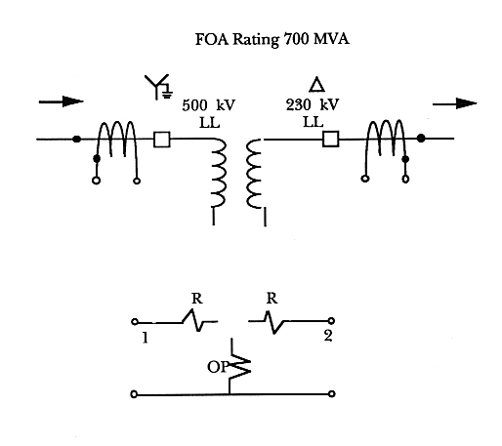

1. Assume the transformer is single phase (for this part only), as shown in the figure. Make the appropriate connections from CTs to terminals of percentage differential relay, such that:

a) There is no current through the operating coil for load or external fault
conditions, and
b) The sum of currents from the CTs flow in the operating coil for an internal
fault.

2. Calculate transformer’s primary and secondary line currents seen by CTs based on the transformer’s FOA and OA ratings.

3. Choose appropriate CTs from the following available list for each side:

4000:5
3000:5
2000:5
1500:5
1200:5
1000:5
800:5
600:5

4. Calculate currents into relay terminals 1 and 2 based on the transformer’s FOA and OA ratings.

5. Choose appropriate relay taps for terminals 1 and 2. Available taps are given on Page 14 of Transformer Protection Notes.

6. Calculate the percent mismatch for chosen taps.

7. Choose the appropriate percent slope setting. This choice should be made such that the relay has maximum sensitivity but does not operate due to mismatch errors. Assume available taps are 10%, 20% and 40%.

ECE 472 - POWER SYSTEMS II

Bus Protection

Homework #4

Refer to Slide 9 of Bus Protection PowerPoint notes (High Impedance Current Differential for a bus with 4 lines connected to it) to do this problem. Use the following information:

CT Ratio = 1500:5
CT = 300 turns, 0.01 ohms per turn (Use this to determine R_{CT})
Max. external single-phase fault current detected by saturated CT = 8000A
High Impedance Cur rent Differential Relay Setting = 200 V
Relay Impedance = 1700 Ohms

Assume all ohmic values are purely resistive, and the CT that measures the 8000 A saturates completely (X_{m} = 0, V_{CT} = 0).

1. Calculate the maximum allowable “one-way” CT lead resistance (R_{L}) for the given relay setting.

2. If the CT leads are #10 copper conductor (approximately 1 ohm/1000 ft.), calculate the “one-way” lead length (in feet) corresponding to the maximum lead resistance from Part 1.

3. Calculate the minimum detectable fault current with this setting. CT and thyrite curves are attached. Use the PVD21A curve.

