ECE 472 – POWER SYSTEMS II
Homework #10
- Three 21.875 MVA, 13.8 kV generators are connected to individual buses, from which various loads are supplied. These buses are connected to another bus through reactors, as shown in the following figure.
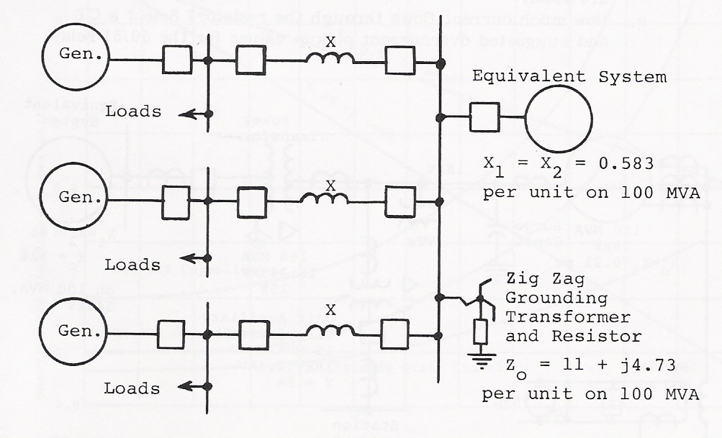

Also, the following additional data are provided:
- Generators and the Equivalent System are ungrounded (i.e. their zero sequence reactance is infinity)
- X_{d}’’_{1,2} (generator positive and negative sequence sub-transient reactance) = 13.9% on the generator MVA
- X_{1,2} (reactor positive and negative sequence reactance) = 0.25 Ω
- X_{o} (reactor zero sequence reactance) = 0

For this system:
- Calculate the three-phase fault current in amperes at the terminal of one of the generators.
- Choose a current transformer ratio (CTR) based on the rated current of the generators for differential relays to protect the generators. If the generator differential relays have a minimum pickup of 0.14 ampere, how many times pickup does the three–phase fault provide (multiples of pickup)?
- Calculate a single-phase-to-ground fault at the terminal of one of the generators.
- Will this ground fault operate the generator differential relays? If so, how many times pickup does the ground fault provide (multiples of pickup)?

