ECE 371
SUSTAINABLE ENERGY SYSTEMS

EXPERIMENT 9
WIND-TURBINE-GENERATOR SIMULATION WITH MATLAB

Objective
The objectives of this laboratory experiment are summarized below:
- To become familiar with a Simulink model of a wind-turbine-generator.
- To obtain the plot of rotor efficiency vs. tip speed ratio as a function of pitch angle for a wind-turbine-generator.
- To obtain the plot of the rotor power vs. windspeed as a function of rotor tip speed
for a wind-turbine-generator.
- To obtain the plot of the rotor power vs. windspeed as a function of rotor diameter
for a wind-turbine-generator.

Procedure
A simple model of a wind-turbine-generator is shown below. The windspeed is ramped from 0 to 25 m/s.
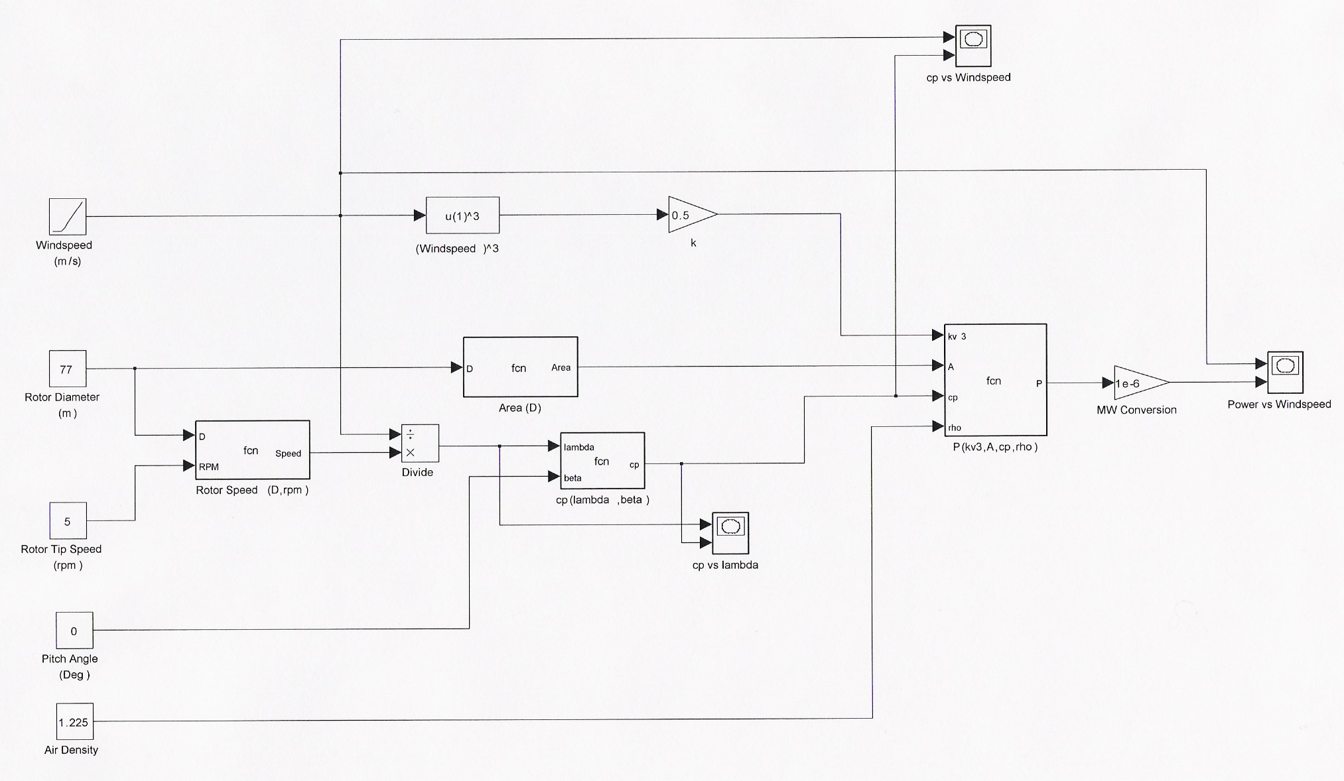
Figure 1. Simulink Model of a Wind-Turbine-Generator
This Simulink model uses five Function models that are found under Use-Defined-Models in the Simulink environment.

The first one is a Function that cubes the windspeed.

The second one is an Embedded Matlab Function that uses the rotor diameter to calculate the rotor sweep area:

function Area = fcn(D)
% This block supports an embeddable subset of the MATLAB language.
% See the help menu for details.

Area = 3.14159*D^2/4;

The third one is also an Embedded Matlab Function that converts the rotor tip speed in rpm to the rotor tip speed in m/s:

function Speed= fcn(D,RPM)
% This block supports an embeddable subset of the MATLAB language.
% See the help menu for details.

Speed = RPM*3.14159*D/60;

The fourth one is also an Embedded Matlab Function that uses the tip speed ratio and the rotor pitch angle to calculate the rotor efficiency Cp:

function cp = fcn(lambda,beta)
% This block supports an embeddable subset of the MATLAB language.
% See the help menu for details.

c1 = 0.52;
c2 = 116;
c3 = 0.4;
c4 = 5;
c5 = 21;
c6 = 0.0068;
lambda_rec = 1/(lambda + 0.08*beta) - 0.035/(beta^3 + 1);

cp = c1*(c2*lambda_rec - c3*beta - c4)*exp(-c5*lambda_rec) + c6*lambda;

The fifth one is also an Embedded Matlab function that multiplies four quantities to calculate the rotor power:

function P = fcn(kv3, A, cp, rho)
% This block supports an embeddable subset of the MATLAB language.
% See the help menu for details.

P = kv3 * rho * A * cp;

Part 1 – Building the Model
Build this model in the Simulink environment. Choose the following for the simulation Configuration Parameters:
  - Simulation Start Time of 0.0 second
  - Simulation Stop Time of 25.0 seconds
  - Solver Option Type of “Fixed-Step” and a Solver of “ode3”
  - Step Size of 0.01 second

Make sure that you produce the same results as those on your instructor website, then save this model.

After verifying that you have produced correct results, delete the XY Graphs and write Windspeed, P, Cp, and Tip Speed Ratio (lambda) in Workspaces. Save this model, since it will be your Base Case.

Part 2 – Simulation of Rotor Efficiency vs. Tip Speed Ratio as a Function of Pitch Angle
Start with a pitch angle of 0 degree and perform the Simulink simulation. Plot Cp vs. Tip Speed Ratio (λ) in Matlab. You should plot only the positive values of Cp by adjusting the range of y-axis. A range of 0 to 0.5 will produce a nice graph. The range of x-axis should be from 0 to 15. After obtaining a plot that you are happy with, type “hold” in the Matlab Command Window. This will freeze this plot and you can superimpose additional traces on this plot.

Now change the pitch angle (β) from 0 to 30 degrees in 5 degree increments, and superimpose the new traces on the original one that you have frozen. Then print the final plot and on the printout identify each trace manually.

Part 3 – Simulation of Rotor Power vs. Windspeed as a Function of Rotor Tip Speed
Start with the Base Case. Change the rotor tip speed to 10 rpm and perform the simulation. Plot the rotor power P vs. windspeed in Matlab. After adjusting the x- and y-axis and obtaining a plot that you are happy with, type “hold” in the Matlab Command Window. This will freeze this plot and you can superimpose additional traces on this plot.

Now change the rotor tip speed from 10 rpm to 2 rpm in 2 rpm decrements, and superimpose the new traces on the original one that you have frozen. Then print the final plot and on the printout identify each trace manually.

Part 4 – Simulation of Rotor Power vs. Windspeed as a Function of Rotor Diameter
Start with the Base Case. With the rotor diameter of 77 m, perform the simulation. Plot the rotor power P as a function of windspeed in Matlab. After adjusting the x- and y-axis and obtaining a plot that you are happy with, type “hold” in the Matlab Command Window. This will freeze this plot and you can superimpose additional traces on this plot.

Now change the rotor diameter to 50 m and 35 m, respectively, and perform the two simulations. Superimpose the new traces on the original one that you have frozen. Then print the final plot and on the printout identify each trace manually.

Documentation
At the end of the lab period, submit this document with your insertions, and:
- Matlab plot of rotor efficiency (Cp) vs. tip speed ratio (λ) as a function of pitch angles (β) on the same graph
- Matlab plot of rotor power (P) vs. windspeed as a function of rotor tip speeds on the same graphs
- Matlab plot of rotor power (P) vs. windspeed as a function of rotor diameters on the same graph

