Rose-Hulman Institute of Technology
Nuclear Energy
A Study of the Use and Future of Nuclear Energy
Brett Stephens
CM 305
12/21/09

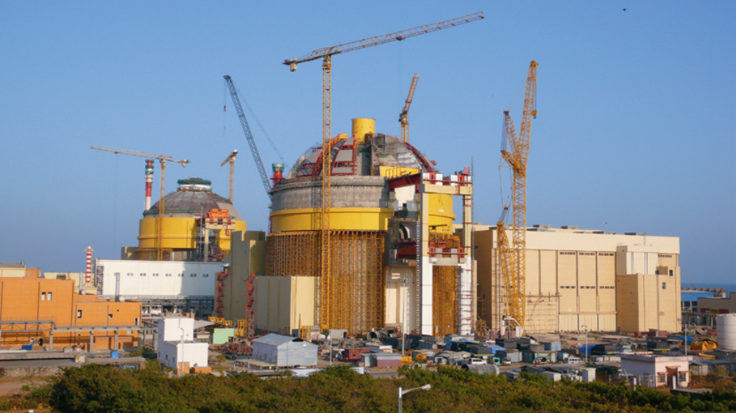
Table of Contents
Introduction......................................................................................................................................2
History..............................................................................................................................................3
How Nuclear Energy Works............................................................................................................4
Why Use Nuclear Energy................................................................................................................6
Nuclear Plant Design and Safety.....................................................................................................9
Future Use of Nuclear Energy.......................................................................................................16
Conclusion.....................................................................................................................................20
References......................................................................................................................................21

Introduction
For many years, the use of fossil fuels has been the major way to produce electricity for the nation’s power grid. However, since the 1970s and the oil embargos, the United States has started to focus on ways to produce electricity without being dependent on fossil fuels. There have been many new forms of renewable energy in the recent past. For example, in the last 10 to 20 years the nation has seen the increased development of wind, solar, hydro, biomass, nuclear, and many other forms of renewable resources.
The problem with most of the new forms of renewable energy is that they are not always reliable, such as wind and solar, nor are they as efficient as fossil fuels when they are producing energy. The capital costs for most forms of renewable energy are also much higher for the most part than their fossil fuel counterparts. These reasons have caused many electric power producers to not use these new forms of renewable energy.
Not all hope for the gradual replacement of fossil fuels is lost because there is one form of renewable energy that is clean, reliable, safe, and as efficient as a fossil fuel power plant. Nuclear energy has gained much ground in recent years as the way to reduce the nation’s dependence on fossil fuels, but many people still have the “not in my backyard” mentality towards a nuclear facility being built in their area. This mentality has developed because of the accidents at the Chernobyl and Three Mile Island nuclear facilities in the early days of nuclear energy. However the nuclear energy facilities have become markedly safer now that scientists have gained a greater understanding of how nuclear energy works and how to contain anything that might go wrong. This paper focuses on the history of nuclear energy, how it works, and where many scientists think that nuclear energy is headed in the future.

History
The development of nuclear energy and the principles behind the process have had a long history with many famous scientists working in the area.
The discovery of fission happened in 1934 when scientist Enrico Fermi conducted experiments in Rome that showed that neutrons could split many types of atoms. He developed this conclusion when he did not get the elements that he expected when he bombarded uranium with neutrons. The elements that he got were much lighter than uranium. In the fall of 1938, two other scientists, Otto Hahn and Fritz Strassman, fired neutrons from a source into a mass of uranium. They found the much lighter element of barium in the leftover materials. In previous reactions the leftover elements were only slightly smaller than uranium. It was scientist Lise Meitner who first used Einstein’s theories to show that the lost mass in the uranium reactions changed to energy [1].
The world’s first nuclear reactor was built in Chicago in November 1942 and was designated as Chicago Pile-1. The pile was erected on the squash court beneath the University of Chicago’s athletic stadium. The reactor contained uranium, graphite, and control rods made out of cadmium, which is a metal that absorbs neutrons. When the control rods were lowered into the reactor the reaction would slow because of the lower number of neutrons. Conversely when the rods were raised, the number of neutrons would increase and the reactions would speed up [1].
With the inception of World War II, most of the research done in the field of nuclear fission was done with the intention of developing atomic weapons under the Manhattan Project. However, there were some scientists that were working on developing breeder reactors that would produce fissionable materials for the use in chain reactions [1]. A description of a breeder reactor can be found in the Nuclear Plant Design and Safety section. After the war, the United States government encouraged scientists to develop nuclear energy for peaceful civilian uses. Congress created the Atomic Energy Commission in 1946, which authorized the construction of Experimental Breeder Reactor I in Idaho. This reactor produced the first amount of electricity from nuclear fission on December 20, 1951 [1].
A major goal of all of the nuclear research in the 1950s was to prove to the government and people that nuclear energy could produce enough electricity for commercial use. The first commercial electricity generating facility powered by nuclear energy was located in Shippingport, Pennsylvania. It reached its full generating capability in 1957, and it was designed as a light water reactor [1]. A description of what a light water reactor is can be found in the Nuclear Plant Design and Safety section.
The nuclear power industry grew rapidly in the 1960s as many power companies saw this new form of electricity production as economical, clean, and safe. However growth began to slow in the 1970s and 1980s as concerns over nuclear issues such as reactor safety, waste disposal, and other environmental considerations began to increase. Additionally growth began to slow as demand for electricity began to decrease. Even though growth began to slow, the United States still had twice as many operating nuclear power plants than any other country in 1991, which accounted for more than one fourth of the world’s operating plants and produced almost 22% of the electricity produced in the United States [1].
During the 1990s, the United States felt that it had to face several major energy issues and thus developed several major goals for nuclear power, which were: to maintain existing safety and design standards, reduce economic risk, reduce regulatory risk, and establish an effective high-level nuclear waste disposal program. Several of these power goals were addressed in the Energy Policy Act signed into law in October of 1992. The United States is working hard to meet these goals. For example, the United States Department of Energy (DOE) has undertaken a number of joint efforts with the nuclear power industry to develop the next generation of nuclear power plants, which are being designed to be safer and more efficient than their predecessors. There is also an effort within the government to make nuclear power plants easier to build by standardizing plant designs and simplifying licensing requirements, without lessening safety standards [1].
How Nuclear Energy Works
There are many ways for one to get energy from nuclear reactions. Listed below are three important areas that make the release of energy in nuclear reactions possible: nuclear fission, chain reactions, and moderators.
Nuclear fission – The fission of a heavy atom usually results in the formation of two lighter nuclei of about the same mass and in the release of several neutrons. The total mass of the fission products is less than the original atom. This lost mass is converted to energy. The fissioning of a single uranium atom releases about 200 MeV of energy and about 177 MeV of that is in the kinetic energy of the fission products, the remainder is radiant energy in the form of gamma rays. Although several types of heavy nuclei can be made to undergo the process of fission by bombarding them with neutrons, only three, uranium-235, uranium-233, and plutonium-239, are relatively easy to split and can be produced in quantity. The fission of all of the nuclei in one kilogram of uranium-235 would yield about 23,000,000 kilowatt hours of electricity. Uranium does occur in nature, but it forms less than one percent of the naturally occurring uranium. For commercial use, uranium-235 is usually obtained from enriching the naturally found uranium. Plutonium-239 and uranium-233 do not exist in nature and therefore have to be produced in a nuclear reactor [2]. Figure 1 shows a basic fission reaction [3].
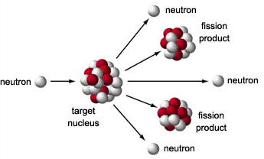
Figure 1: Basic Fission Reaction
Chain Reactions – On average two or three neutrons are released in each individual fission reaction. In a given quantity of fissionable material some of the neutrons will cause the splitting of other fissionable nuclei, some will escape, and some will be absorbed by nuclei that do not undergo fission. If at least one neutron from each fission reaction causes one other nucleus to undergo fission, and the reaction is sustained, then the process is called a chain reaction. The quantity needed to sustain a chain reaction is called the critical mass and it varies with the nature and shape of the fissionable material. In most nuclear reactors, neutrons are used as the bombarding particles to initiate the fission process. The target material is the material that is going to be bombarded and in most cases that material is uranium. This is because uranium can release neutrons continuously, thus keeping up with the flow of energy. Within a nuclear reactor, the chain reaction is controlled so that, on the average, just one neutron from each fission reaction causes another nucleus to undergo fission [2].
Moderators – Slow moving neutrons are captured by fissionable material several hundred times more easily than their fast moving counterparts. The neutrons that are released from the fission process move very fast, but a moderator can be used to slow down those neutrons. Typical moderators that are used are ordinary water, heavy water (made with deuterium instead of hydrogen), beryllium, paraffin, or graphite. When a fast moving neutron moves through the moderator it collides with the atoms that make up that moderator. Each of these collisions then slows the neutron down. By the time that the neutron has moved through the moderator material, the neutron is moving slowly enough that it can be easily captured by the fissionable material. Moderators must be able to reduce the speed of the neutrons without having an excess of collisions, and must be poor absorbers of slow neutrons [2].
Why Use Nuclear Energy
Over the past few years, many people around the world have called for the decline in the use of fossil fuels because of the harmful effects on the environment and global warming. The problem is that, with over 50% of the electricity produced in the United States comes from fossil fuels, how do the power companies reduce that dependency but still keep up with the increasing demand? Within the next 10 years, the world’s major economies will turn to nuclear power as its clean, high-capacity base load power. Nuclear power has experienced a rebirth in recent years, with 12 countries building 45 new reactors. Nuclear power currently generates 16% of the world’s electricity, but many scientists believe this number will increase to 30% by 2030 [4].
At one time, the United States was the world leader in the production of electricity through the use of nuclear energy. Today it is fourth behind France, Japan, and South Korea. Some reasons why the United States has been slow to develop nuclear facilities, is that the United States can get comparatively low-cost foreign oil, has plentiful coal and natural gas reserves, and there has been much domestic opposition to the development of new nuclear facilities. President Obama’s elimination of the funding for the state-of-the-art nuclear waste storage facility in Yucca, New Mexico, which the United States government had been developing to be the primary site for all of the nuclear waste, makes it probable that new nuclear facilities will be slow to develop in the coming years. However when brownouts are starting to occur with more regularity and the United States energy system is being forced to meet ever increasing demand with lower carbon emission, there currently is no other practical or cost-effective way other than nuclear power. The current United States nuclear capacity growth can be seen in table 1 [4].
Table 1: Current United States Nuclear Capacity Growth
Year | Number of Reactors | Total Electricity Production (in million kilowatt hours) | Share of Total US electricity generation
1990 | 112 | 576,862 | 19.0%
1998 | 104 | 673,702 | 18.6%
2008 | 104 | 806,182 | 19.6%
Other countries around the world that do not have as plentiful amount of the United States does have been forced to come up with other ways of meeting their electrical demand and many turn to nuclear energy. The current listing of some of the biggest nuclear power producing countries can be seen in Table 2 [4]. As can be seen in the table many of the countries around the world with nuclear power plants have a major percentage of their total electric power coming from nuclear energy with some having almost three fourths of their total output in nuclear energy such as France and Lithuania.

Table 2: Percentage of Power Derived from Nuclear Power
Country | 1998 (%) | 2008 (%)
Armenia | 24.7 | 39.4
Belgium | 55.2 | 55.3
Bulgaria | 41.5 | 32.9
Czech Republic | 20.5 | 32.5
Finland | 27.4 | 29.7
France | 75.8 | 76.2
Germany | 28.3 | 28.3
Hungary | 35.6 | 37.2
Japan | 35.9 | 24.9
Lithuania | 77.2 | 72.9
Slovakia | 43.8 | 56.4
Slovenia | 38.3 | 41.7
South Korea | 41.4 | 35.6
Sweden | 45.7 | 42.0
Switzerland | 41.1 | 39.2
Ukraine | 45.4 | 47.4
United States | 18.7 | 19.6

Worldwide demand for electric power is expected to rise sharply by 2030, mainly because of economic growth in developing countries and increased use of electric cars in industrialized countries. The United States is currently investing billions of dollars in developing alternative energy sources, but these sources are far away from being able to produce power at a gigawatt level that the United States requires. However, according to critics, nuclear energy is too costly to produce in facilities in great numbers while still keeping current electric bills the same. Estimated construction costs have increased by a factor of 3 from 2000 because of construction bottlenecks, increased material costs, and lack of trained workers. The United States DOE currently estimates that construction costs are $1,500 per kilowatt hour for basic reactor designs and $1,800 per kilowatt hour for advanced designs. Those cost figures suggest that it may take an initial investment of over $4 billion in order to build each new reactor, which many power companies cannot afford to put that much money into a project [4].
While nuclear reactors are very expensive to construct, they produce enormous amounts of electric power. According to the DOE, in 2007 the entire United States solar capacity generated 0.6 billion kilowatt hours. In the same year, the Wolf Creek nuclear plant in Kansas generated 10.4 billion kilowatt hours. The Wolf Creek’s generation capacity was also one third of the total United States wind capacity [4].
As can be seen in table 1, while the number of reactors has decreased the amount of kilowatt hours produced has increased meaning that the current nuclear facilities have become more efficient at generating electric power. According to the DOE, the amount that these reactors have produced has increased from 763.7 billion kilowatt hours of electricity in 2003 to 806.4 billion kilowatt hours in 2007 [4].
The reactors may cost more for construction but they can also produce more electric power with less fuel needed. Nuclear power does not lessen the importance of the development of renewable resources such as wind, water, and solar in places where nuclear power is impractical or where low-capacity generation is ideal. However in terms of massive base load capacity, there is a compelling need for nuclear power [4].
Nuclear Plant Design and Safety
In order for nuclear energy to be properly harnessed and controlled their reactions must take place in nuclear reactors. There are many different types of nuclear reactors that power companies and scientists use in order to facilitate nuclear reactions. A number of these different types and what they do can be found below. Nuclear facilities are usually oriented so that there are three areas for safety reasons. One area contains the nuclear reactor proper, and another contains the turbines and other equipment. Still another area on the grounds is used for spent fuel [2]. The basic layout of a nuclear reactor can be seen in Figure 2 [5].
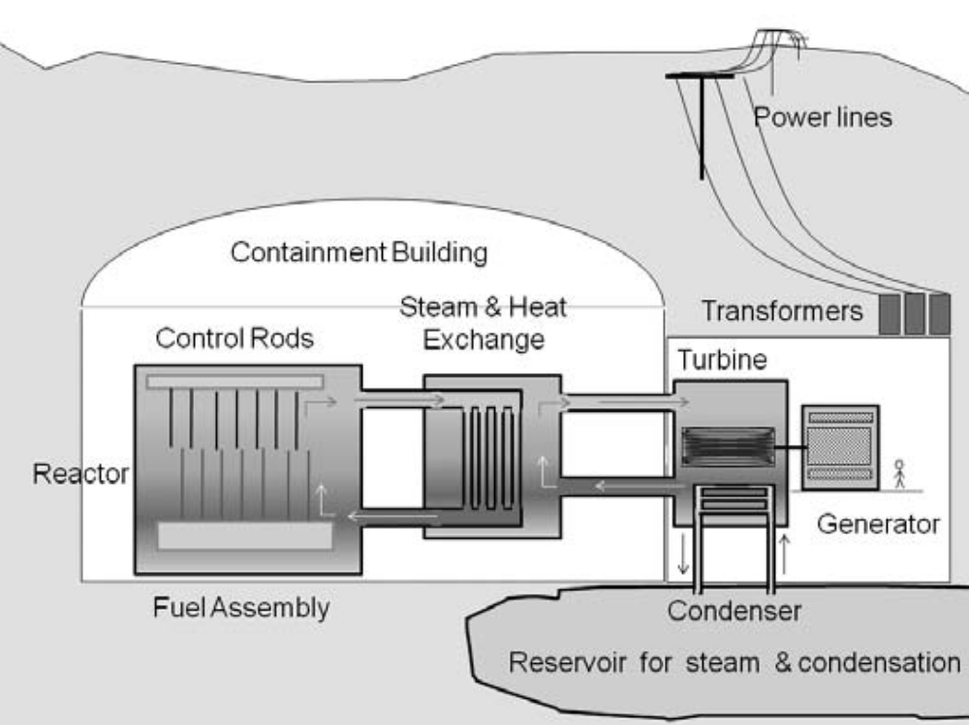
Figure 2: Basic layout of a nuclear reactor
Power Reactors – Power reactors use the heat produced during nuclear fission reactions to produce steam. In nuclear power plants, this steam is then used to turn turbines to produce electrical energy. Many of the large nuclear power plants can generate more than 1,000 megawatts of power. Most power reactors use regular water as a coolant for the reactors. These reactors are called light water reactors as opposed to those reactors that use heavy water like deuterium as a coolant. In the light water reactors, the reactor core is surrounded by water that is under pressure within a container called a pressure vessel. The nuclear fuel is usually enriched uranium with 2% to 4% of uranium-235. This fuel is then converted to uranium dioxide for use in the fuel rods. There are two types of light water reactors, the boiling water reactor and the pressurized water reactor. In the boiling water reactor, the water is heated in the reactor so that it boils and produces steam. This steam then turns the turbines and then condenses and moves back to the reactor core. In the pressurized water reactors, the water is heated and kept under very high pressures so that it cannot boil. This water then flows through a heat exchanger that is surrounded by water in narrow pipes. The water that is in the narrow pipes receives heat from the high pressure water so that it boils and produces steam. This steam then turns the turbines. This steam then condenses and moves back into the heat exchanger. There are several other types of power reactors that are used in different countries. These reactors include the CANDU reactor developed in Canada and the advanced gas reactor (AGR) developed in Great Britain. The CANDU reactor uses natural non-enriched uranium as its fuel and heavy water as its coolant. The AGR uses enriched uranium as its fuel, graphite as the moderator, and carbon dioxide as the coolant [2].
Breeder Reactors – Power reactors that produce more nuclear fuel than they produce are called breeder reactors. The core of the breeder reactor produces an excess of neutrons that are used to convert uranium-238 or thorium-232 into the fissionable fuels, plutonium-239 and uranium-233 respectively, for the power reactors. The most important type of breeder reactor is the liquid metal fast breeder reactor. It uses plutonium as a fuel and liquid sodium as a coolant. As in the pressurized water reactors, the heated coolant is passed through the heat exchanger to produce steam to run the turbines and generate electricity. In a fast reactor there is no material used as a moderator to slow down the production of neutrons in the reactor core. Instead the reactor core is surrounded by a blanket of uranium -238. As the fast moving neutrons move through the layer some of the neutrons hit the nuclei of uranium-238 are absorbed forming uranium-239 which then decays forming plutonium-239. The plutonium is then separated from the rest of the blanket for use in other breeder reactors. Currently, France runs the breeder reactor that produces the most energy, but many other countries also run breeder reactors [2].
High Temperature Gas-Cooled Reactor – This type of reactor uses uranium oxycarbide as a fuel and helium as a coolant. The fuel is contained within ceramic containers. This safety feature was developed to ensure that the fission of the uranium inside the container would not rupture the container, in the event that the coolant escaped. As long as the containers are not damaged due to heat release during the reaction, the fuel remains inside the container [2].
The sole purpose of the reactors is to heat up water in some area of the power plant to produce steam which then turns a turbine connected to a generator. The generator has two basic parts, the stator, which is stationary, and the rotor which is allowed to turn. The electromagnetic field is produced by strategically placing electromagnets in different locations around the stator. Electromagnets are coils of wire wrapped around an armature or metal frame that helps to structure the magnetic field. When the electrical current flows through a conductor, it produces an electromagnetic field, and when the conductor is coiled the field is much stronger. The rotor also has coils of wire wrapped around an armature. These coils, turned by the turbine, then spin rapidly inside the electromagnetic fields, and consequently an induced electric current is produced in the coils. This process shows how mechanical energy can be converted into electrical energy. A basic layout of a generator in a nuclear power plant can be seen in Figure 3 [5].
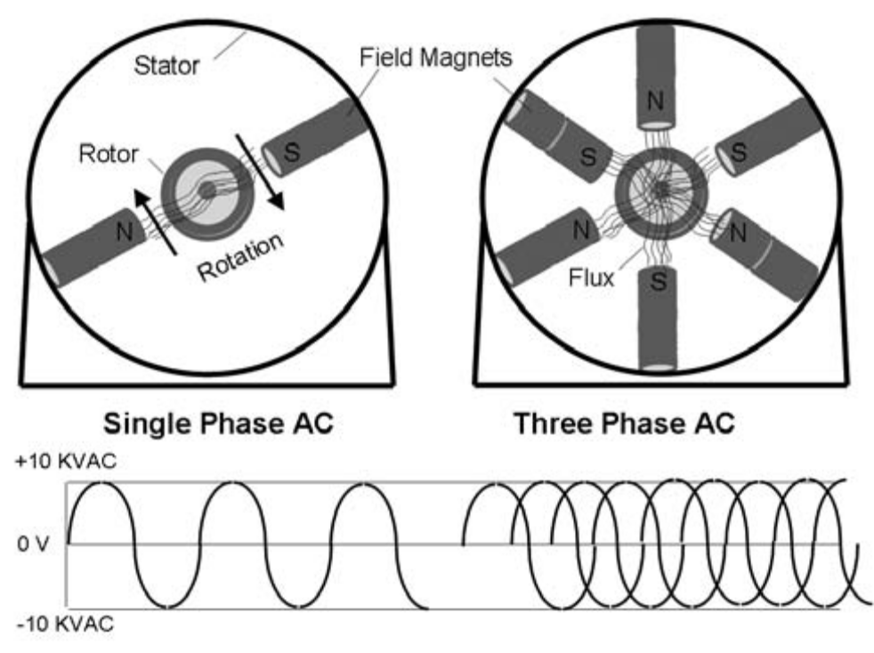
Figure 3: Basic layout of a generator in a nuclear facility
There may be many types of reactors in use but the designs are useless without the generation of nuclear fuel and the safety features designed into each design. Safety has become an ever increasing concern with nuclear facilities especially with the events that have occurred at Chernobyl in Ukraine and at Three Mile Island in the United States. In recent years there have been many safety features that have been enacted at nuclear facilities and there also have new regulatory agencies to watch over the facilities and to ensure that the public is in no danger from this powerful type of energy. The ways that the fuel is generated, some of the safety features, and some of the regulatory agencies can be seen below.
Preparation of Nuclear Fuel – Between when uranium is mined and when it undergoes fission, it goes through many processes in order to purify it. The percentage of uranium-325 present within each quantity of fuel should be around 5%, which is attained by enriching the uranium in an enrichment plant after the uranium is mined. The next step in the process is to oxidize the uranium and then put it into small tubes, which are then sealed at the ends [2].
Nuclear Reactor Safety – During the process of nuclear fission, it produces many types of nuclear radiation, mainly gamma rays and high-speed neutrons, which are harmful to the human body when they are absorbed in certain quantities. For these reasons, heavy shielding is placed around the reactor and the pressure vessel to ensure the safety of the public. The fission reaction also produces a variety of both gaseous and solid radioactive materials, some of which can emit harmful radiation and can stay radioactive for a very long time. A reactor is built with safety features that prevent these materials from getting out into the environment. Some of these features include metal cladding on the fuel rods to contain the radioactive materials produced in the fuel, and filters to remove the impurities from the water that may have become radioactive as they pass through the reactor core. Most reactors are housed within a steel-lined concrete bunker called a containment building whose purpose is to contain any radioactive materials that may have been released in the event of an accident. When a serious accident does occur, the reaction can be contained and immediately stopped with the rapid introduction of the control rods into the reactor core, which is called scramming. One of the most serious accidents that can occur in a commercial reactor is the loss of its coolant that is present around the core. Even when the reaction in the core is stopped immediately the loss of coolant could result in the core overheating. The ensuing meltdown would cause the formation of an extremely hot mass that could melt its way through its containment vessel. If the hot mass got to the ground it would contaminate the area with radioactive material and it would cause the water in the ground to turn into steam thus releasing the harmful radiation into the air. To prevent this possibility, nuclear reactors are built with one or more safety measures to add extra coolant in the event that it is needed [2]. A basic cycle that shows how uranium makes it from the mine to being put into a nuclear reactor can be seen in Figure 4. The diagram shows the approximate yearly flows of materials for a 1000 MW light water reactor, where case 1 is no recycling and case 2 is with recycling [6].
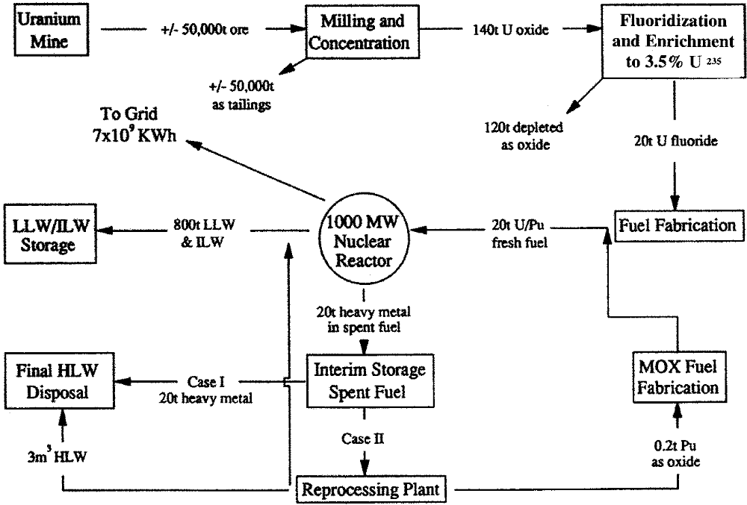
Figure 4: Cycle of uranium for a 1000 MW light water reactor facility.

Disposal of Radioactive Wastes – A serious hurdle in the use of nuclear energy for power is the handling, treatment, and disposal of the radioactive waste products that it creates. These wastes, such as liquids used for cooling and moderator purposes, spent fuel rods, and harmful gases, contain dangerous radioactive materials. Such materials can remain radioactive for more than 500 years, making them a potential health hazard for many generations into the future. Some materials, such as plutonium, retain their radioactivity for more than 1000 years. Several methods have been developed and tested for the long term disposal of radioactive wastes. The most widely used plan in action today is to bind the wastes in a glasslike or ceramic substance that is very resistant to corrosion. The material would then be placed deep underground in stable geological formations where it would remain undisturbed. Several countries have long range plans that include disposal of the wastes in granite formations underground or under the sea floor, in frozen clay, or in salt domes. The United States however has no agreed upon long range disposal plan. Currently radioactive wastes are being stored in containers that are placed into pools of water near the nuclear plants. The water carries away the heat produced by the radioactive decay of the wastes and also serves as a shield against the radiation they emit [2].
Nuclear Regulatory Agencies – There are many agencies around the world that attempt to control the nuclear power industry in order to ensure the safety of the public and the environment. The agency in the United States that governs how each nuclear plant can operate is the Nuclear Regulatory Commission (NRC). The NRC has many offices that control and monitor different areas of the power industry. The most important of these offices are the Office of Nuclear Reactor Regulation (licensing and regulating the development and use of nuclear reactors), the Office of Nuclear Material Safety and Safeguards (ensures the safe processing, transportation, and handling of nuclear materials), and the Office of Nuclear Regulatory Research (devises policies and procedures regarding nuclear regulation). The NRC is under the direction of five commissioners who are appointed by the president with the advice and approval of the Senate. The commissioners serve five year terms. The NRC was established under the Energy and Reorganization Act of 1974 and it took over the regulatory functions of the disbanded Atomic Energy Commission [2].
Nuclear energy is a powerful form of energy that can be used for electrical generation. It is considered a renewable resource because of the relatively low amount of fuel needed to produce very great amounts of energy. However, because nuclear energy is so powerful and it produces harmful wastes, it must be closely monitored to protect the safety of the public and the environment.

Future Use of Nuclear Energy
Notwithstanding that there is little current development of new nuclear facilities coupled with the popular dislike of nuclear energy amongst the people in some places, there are many critics who say that this is a temporary phenomenon that will be forgotten when the next energy crisis hits the people of the world. However the new issues of climate change and the decreased demand for the use of fossil fuels, makes it more likely that there will be a strong need for nuclear power. Still other critics disagree with this analysis and believe that focusing on increasing efficiency and renewable resources will be enough to meet the world’s increased energy demand. They suggest that the world can achieve an energy balance without using nuclear energy [6].
Even though both of these theories are completely different than each other, the vast uncertainties of the future could put both of these theories in the realm of possibility. As shown by the forecasts that were developed for nuclear energy in the 1970s, they were wildly wrong. However, even though forecasts done a century ahead are somewhat useless, it is still possible to achieve an understanding of the social, economic, technological, and political forces that will strongly affect the energy output of the world [6].
Forecasts can be done by using simple scenarios to explore different possible energy futures. If the chosen futures are widely different from each other, but all are still plausible, there exists a wide range of possible outcomes. A study was done by the World Energy Council and the International Institute for Applied Systems Analysis, two internationally known organizations that are seen as neutral in the nuclear energy debate. The results from their study can be seen in table 3 [6]. What the table is saying and a description of what the scenarios are can be seen below the table.

Table 3: The energy distribution under different scenarios in the year 2050
 |  | A |  |  | B | C
Scenario (%) | 1990 | A1 | A2 | A3 | B | C1 | C2
Primary Energy (TWy) | 12.9 | 35 | 35 | 35 | 28 | 20 | 20
Mix
Coal | 23 | 15 | 32 | 9 | 21 | 11 | 10
Oil | 36 | 32 | 19 | 18 | 20 | 19 | 18
Natural Gas | 18 | 19 | 22 | 32 | 23 | 27 | 24
Nuclear Energy | 5 | 12 | 4 | 11 | 14 | 4 | 12
New Renewables | 2 | 16 | 17 | 24 | 15 | 29 | 26
Old Renewables | 16 | 6 | 6 | 6 | 7 | 10 | 10

The Scenarios
The study used three scenarios based on different social, economic, and political conditions. For studying the energy supply, variants making different technological and supply assumptions were introduced in order to give a wide range of outcomes, while still keeping all of those outcomes within the realm of possibility. Scenario A assumes a high economic growth and a rapid increase in wealth. Scenario B assumes a more modest growth. Scenario C assumes a more ecological approach where governments help make improvements in energy efficiency and reducing the amount of greenhouse gas emissions [6].
The table shows that the demand could vary between 20 and 35 TWy, which is between a 50% and a 200% increase in the demand found in 1990. However such a wide range is still possible because demand is tied to many different and uncertain factors such as the rate, kind, and areas of future economic growth, the rate of improvement in energy intensity, technological improvements and developments, population growth, and government policies [6].
Regarding table 3, scenario A1 assumes a continuation of a strong oil and gas sector over the next century. Scenario A2 assumes that there will be less worry about greenhouse gas emissions, which, couple with improvements in technology and efficiency, would bring coal to the forefront ahead of oil and gas. Scenario A3 assumes that the world has made rapid technological gains in renewable energy resources and has made nuclear energy more acceptable, which would mean that the demand for coal and oil would be drastically reduced over the next century. Scenario B assumes a more pessimistic approach about oil and natural gas resources and lets coal, renewable resources, and nuclear power pick up the slack in the demand. Finally, Scenario C assumes there will be a reduction in the use of fossil fuels throughout the rest of the century. Scenario C1 also assumes that nuclear energy will be phased out so that by the year 2050, renewable resources would take up about 80% of the supply with oil and gas the rest. Scenario C2 assumes that by the year 2100 nuclear energy will be able to expand considerably and be able to meet 20% of the total demand [6].
Nuclear Energy Options
It is plausible that perhaps the world should keep the nuclear option open for the foreseeable future, which means that nuclear power must be able to supply a significant portion of the world’s energy demands. The scenarios listed above indicate that by the year 2050, nuclear energy might supply about 10% to 15% in those cases where there is an assumption of greater acceptability of nuclear power. The supply demand could increase to as much as 20% by the end of the century. This assumption means being ready for a vast expansion of the nuclear power industry, possibly as much as 80 to 100 GW/yr by midcentury and then continuing on for the rest of the century. Table 4 provides a possible estimate of nuclear capacity for the given scenarios. In order for such an expansion to be a practical proposition, the industry will have to resolve those issues that make nuclear energy unpopular and feared amongst the world’s people today: safety, economics, proliferation, and waste disposal [6].

Table 4: Nuclear Capacity Under Different Scenarios
 | Scenarios (GW)
Year | A1 | A2 | A3 | B | C1 | C2
2020 | 646 | 417 | 732 | 645 | 480 | 605
2050 | 1875 | 782 | 1860 | 1915 | 380 | 1240
2100 | 6415 | 3680 | 6725 | 5700 | 0 | 2750

Conclusion
Nuclear energy is a very powerful and reliable source of electricity and it should be respected as such. Many people are afraid of nuclear energy because they simply do not understand how it works or they are afraid of what will happen if an accident occurs at a facility. However in recent years nuclear facilities have become far safer with the advent of regulatory agencies and the standardization of how new nuclear facilities are to be built. These facilities are hiring new and better trained personnel than previous facilities.
Without the development of a newer technology the only way to reduce the nation’s dependency on fossil fuels is through the use of nuclear energy. Currently the only renewable energy that is as reliable and efficient as fossil fuels is nuclear energy. The only problem with nuclear energy is that the amount of money needed to build a new facility is in the hundreds of millions to billions of dollars, which a lot of power companies cannot afford. The cost of building a new facility could be reduced with pre-approved facility drawings that could reduce the time and money needed to get building permits and to pass other such regulations.
The future of nuclear energy has the possibility of being quite bright. It could reduce the dependence on fossil fuels, reduce the amount of carbon emissions, and if given enough time could help reduce the level of greenhouse gases in the atmosphere. The only safe, reliable, efficient, and clean way to reduce the dependence on fossil fuels is to pursue, develop, and use nuclear energy.

References
[1] Energy, U.S. Department of. 1994. “Nuclear Energy.” P 1-7.
[2] “Nuclear Energy." 18 August 2009. HowStuffWorks.com. http://science.howstuffworks.com/nuclear-energy-info.htm. 22 December 2009.
[3] “Nuclear Fission: Basics.” 2008. AtomicArchives.com. http://www.atomicarchive.com/Fission/Fission1.shtml. 22 December 2009.
[4] Stieglitz, Richard, and Rick Docksai. 2009. “Why the World May Turn to Nuclear Power.” Futurist. Nov/Dec2009, Vol. 43 Issue 6: p16-22.
[5] Childress, Vincent W. 2009. “Producing Nuclear Power.” Technology Teacher. Dec2009/Jan2010, Vol. 69 Issue 4, p5-10.
[6] Beck, Peter W. 1999. “Nuclear Energy in the Twenty-First Century: Examination of a Contentious Subject.” Annual Review of Energy and Environment. Vol. 24 Issue 1, p113, 25p

