Homework 8
ECE 207 – Electrical Engineering
Due: 10/30/2012

- A 10 kΩ potentiometer has 300º of rotation, as shown below. The voltage source is V_{s} = 20 V. It is desirable to have an output voltage of V_{o} = 5 V. Determine:
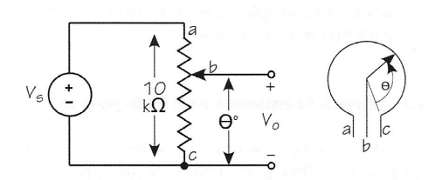
  - Resistance between points “b” and “c”
  - How many degrees the slider should rotate (i.e. find θ from point c)

- It is required to design an amplifier circuit with a gain of 27,000. A number of inverting
op-amps are cascaded to accomplish this task. The gain-bandwidth product of each op-amp
is 350 kHz. The available resistors are 1, 3, 5, and 30 kΩ. Due to the circuit board space
limitations, it is not allowed to connect resistors in series or parallel. Design this op-amp
circuit and draw the final design diagram with resistor values specified on it.

- Design a low-pass filter with an op-amp that has a flat gain of 20 dB and a bandwidth of 60 krad/s. The input resistance of this op-amp circuit should be 1 kΩ. Then:
  - Draw the circuit diagram with resistor and capacitor values specified on the diagram
  - Write the transfer function of this op-amp in the standard form
  - Draw the asymptotic Bode magnitude plot

- Design a high-pass filter with an op-amp that has a flat gain of 20 dB and a bandwidth of 60 krad/s. The input resistance of this op-amp circuit should be 1 kΩ. Then:
  - Draw the circuit diagram with resistor and capacitor values specified on the diagram
  - Write the transfer function of this op-amp in the standard form
  - Draw the asymptotic Bode magnitude plot

- Design a low-pass filter with an op-amp that has a pass-band gain of 20 dB. It should have a lower cutoff frequency of 10 krad/s and an upper cutoff frequency of 100 krad/s. The input resistance of this op-amp circuit should be 1 kΩ. Then:
  - Draw the circuit diagram with resistor and capacitor values specified on the diagram
  - Write the transfer function of this op-amp in the standard form
  - Draw the asymptotic Bode magnitude plot

