Homework 7
ECE 207 – Electrical Engineering
Due: 10/23/2012

- Two amplifiers are connected in cascade (series) as shown below. The gain of the first amplifier is 10 db, and the gain of the second amplifier is 20 db. If the input voltage is 1.0 V, find the output voltage of amplifier 1 and 2.
Vin
Vmid
Amplifier 2
Gain = 20 db
Vout
Amplifier 1
Gain = 10 db

- For the given H(s),
$H\left(s\right)=\frac{10,000}{s+10}$
  - Sketch the asymptotic Bode magnitude plot
  - Verify your answer with Matlab

- For the given H(s),
$H\left(s\right)=\frac{10,000}{(s+10)(s+100)}$
  - Sketch the asymptotic Bode magnitude plot
  - Verify your answer with Matlab

- For the given H(s),
$H\left(s\right)=\frac{10,000s}{(s+10)(s+100)}$
  - Sketch the asymptotic Bode magnitude plot
  - Verify your answer with Matlab

- For the given closed-loop system,
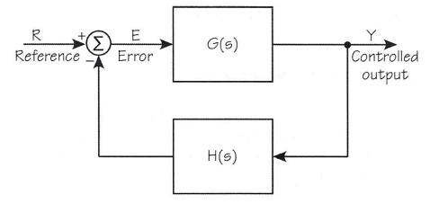

$$G\left(s\right)=\frac{1000}{s+10}$$
$$H\left(s\right)=\frac{1}{s+100}$$
  - Sketch the asymptotic Bode magnitude plot
  - Verify your answer with Matlab

