Homework 6
ECE 207 – Electrical Engineering
Due: 10/16/2012

- The shown linear system is a first-order system. The time constant τ is 0.1 second and the gain k is 20. This system is excited with a step function of amplitude 2. Find:
  - Time domain expression for the step function and its Laplace Transform
  - Transfer function of this system
  - An expression for the output X(s)
  - Inverse Laplace Transform of X(s), which is the time domain output response x(t)
  - Rise time of the system
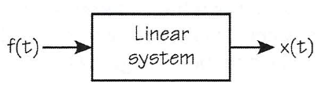
- The shown linear system is a second-order system. The damping ratio is 1.25 and the natural frequency ω_{n} is 10,000 radians/second. Find:
  - The characteristic polynomial
  - Transfer function of this system
  - Roots of the characteristic polynomial
  - Type of the output response (over-damped, under-damped, or critically-damped)
- For the shown second-order linear system, the damping ratio is 0.2 and the natural frequency ω_{n} is 1,000 radians/second. Find:
  - The characteristic polynomial
  - Transfer function of this system
  - Roots of the characteristic polynomial
  - Type of the output response (over-damped, under-damped, or critically-damped)
  - % Overshoot

- The time response of a first-order system is shown below. Each vertical division is 1 V, and each horizontal division is 0.1 second. Find:
  - Time constant τ and gain k
  - The expression for output response x(t)
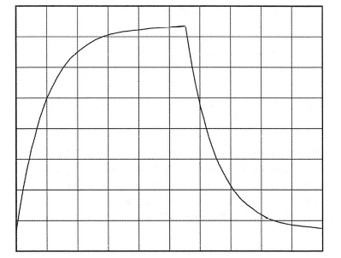

- The time response of a second-order system is shown below. Each vertical division is 2 V, and each horizontal division is 0.05 second. Find:
  - The damping ratio, undamped natural frequency, and damped natural frequency
  - % Overshoot and OS
  - 1% and 2% settling time
