Homework 5
ECE 207 – Electrical Engineering
Due: 10/4/2012

- Two conductors were run in parallel in a duct with a distance of 3 inches between them.
Conductor #1 is carrying a current of 50 A, and conductor #2 is carrying a current of 300 A
in the opposite direction. If the conductors are attached to the opposite sides of the 50 ft
duct, then calculate:
  - Force exerted on the duct for the above load currents
  - Force exerted on the duct, if the short circuit current of conductor #1 is 750 A
  - Force exerted on the duct, if the short circuit current of conductor #2 is 3,000 A
  - Maximum feasible force on the duct

- The shown magnetic circuit has the following dimensions:
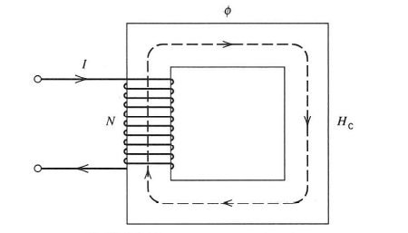
  - Cross-sectional area of 16 cm²
  - Average core length of 40 cm
  - Number of turns of 350
  - Core relative permeability of 50,000
  - Magnetic flux density of 1.5 Tesla
Determine:
- Magnetic flux φ
- Total flux linkage λ = N φ
- Required current through the coil
- Inductance of the coil

- An air gap of 0.05 cm in length is cut in the right leg of the magnetic circuit of Problem 2
that changes the magnetic flux density. If a current of 1.2 A flows through the coil, then
calculate:
  - Magnetic flux φ
  - Total flux linkage λ = N φ
  - Magnetic flux density
  - Inductance of the coil

- Calculate the force in the air gap for Problem 3, if:
  - Current is 1.2 A
  - Current is 2.4 A
  - Current is 3.6 A
What can you conclude from this exercise?

- A cylindrical actuator is to be designed with the following parameters:
  - Diameter is 5 cm
  - Air gap length is 0.4 cm
  - Attached weight is 0.5 kg
Calculate the number of turns, if:
a. The coil current is 1.5 A
b. The coil current is 3 A
What can you conclude from this exercise?

