Homework 1
ECE 207 – Electrical Engineering
Due: 9/6/2012

- For the circuit shown, use the node-voltage method to find v₁ and v₂.
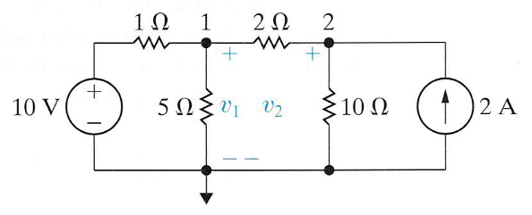
- For the circuit shown, use the node-voltage method to find i_{a}, i_{b}, and i_{c}.
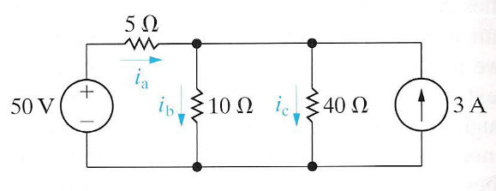
- The sinusoidal current source in the circuit shown produces a current of:
i_{s} = 8 cos 200,000t A
- Construct the phasor domain circuit.
- Find the time domain expressions for v, i₁, i₂, and i₃.
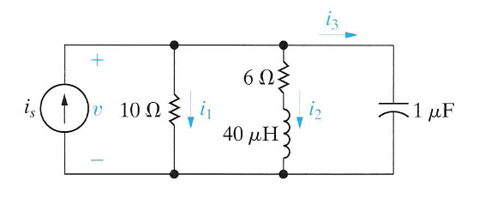

- An electrical load is connected to a 240 V source. The load absorbs a power of 8 kW at 0.8
leading power factor. Ignoring the line impedance, calculate:
- Reactive power Q
- Complex power S
- Apparent power S
- Draw the power triangle

- A 200 kVA load is operating at a of 0.6 lagging power factor. This load is connected to the
source via a line with the impedance of Z_{line} = 4 + j24 Ω. The voltage across the load is 6400
V. Calculate:
  - Source voltage V_{s}
  - Percent voltage regulation
  - Efficiency of the transmission system

