ECE 204 - AC CIRCUITS

Lab 9 - Transformer Equivalent Circuit

The objectives of this laboratory experiment are:
1. Gain an understanding of the concept of modeling a single-phase transformer as an equivalent electrical circuit.
2. Measure the efficiency and voltage regulation of a single-phase transformer and compare them to the values predicted by the equivalent circuit.

1.0 PRE-LAB

1.1 Read the complete laboratory procedure and be ready to apply it to your work. If you do not understand anything in the lab procedure, go and ask your instructor — don’t wait until the lab has started; remember, the instructor has to deal with fifteen groups and you will be “waiting in line”. Note that “waiting in line” is not a valid excuse for failing to finish the lab. You are expected to “budget your time” in lab and not waste it socializing.

1.2 Determine the approximate equivalent circuit (shown in Figure 1) for a single-phase transformer that has a turns ratio of 1:1 and the following test data:

Open-Circuit Test: V = 120 V, I = 0.042 A, P = 3.28 W
Short-Circuit Test: V = 6.9 V, I = 1.0 A, P = 6.8 W

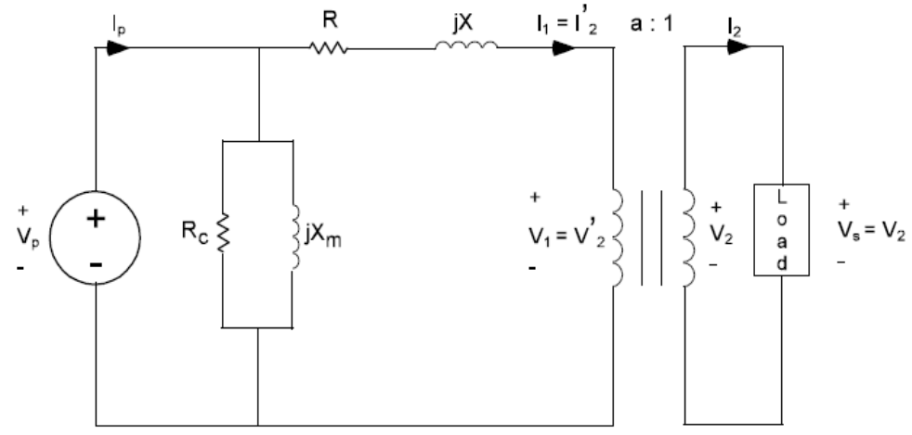

Figure 1 - Transformer Approximate Equivalent Circuit.

1.3 Determine the voltage regulation and efficiency of this transformer when it supplies its rated load (120 VA, 120 V) at 0.8 lag power factor.

1.4 Submit a photocopy of the pre-lab at the start of the lab period.

1.5 Follow the instructions for keeping lab notebooks (Lab B) in the course webpage.

2.0 LAB PROCEDURE

2.1 Read the specification sheet (in the equipment manual at the bench) for Model T-100-3A transformer, pay attention to the ratings of this transformer. Document the ratings (V, I, S and turns ratio) of the transformer for the configuration of Figure 2. Note that the primary is made up of two windings that are rated at 120 V and are connected in parallel, while the secondary is also two windings that are rated at 60 V and are connected in series.

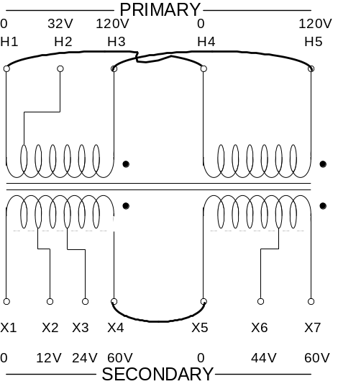

Figure 2 - Transformer Primary and Secondary Configurations.

2.2 Connect the wiring of the single-phase transformer, as shown in Figure 3. Be sure to connect the 2.0 A fuse (in the blue box) between the voltage source and the transformer, as shown.
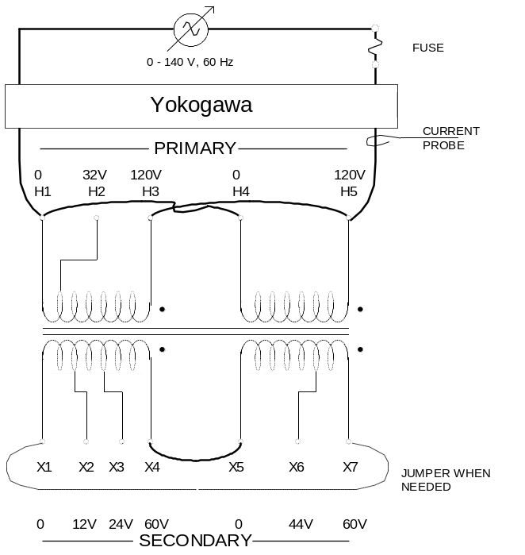

Figure 3 - Transformer Connections for Open-Circuit and Short-Circuit Tests.

2.3 Perform the open-circuit test by leaving the jumper (shown by dashed lines) out. With the power supply set at 120 V and no load on the transformer, record the Yokogawa readings of the voltage, current, and the real power.

2.4 Perform the short-circuit test by turning the power supply down to zero volts and placing the jumper between terminals X1 and X7. Be sure that your connection is correct, then slowly increase the supply voltage until the current display indicates 1.0 A (rated current). Record the Yokogawa readings of the voltage, current, and real power.

2.5 Determine the approximate equivalent circuit parameters for your transformer. Then calculate voltage regulation and efficiency when it supplies its rated load (120 VA, 120 V) at 0.8 lag power factor.

2.6 Switch the supply off and remove the jumper. Connect channel 2 of the Yokagawa to the secondary and apply a load of 150 Ω, 0.8 H and 1.6 H all in parallel, as shown in Figure 4.

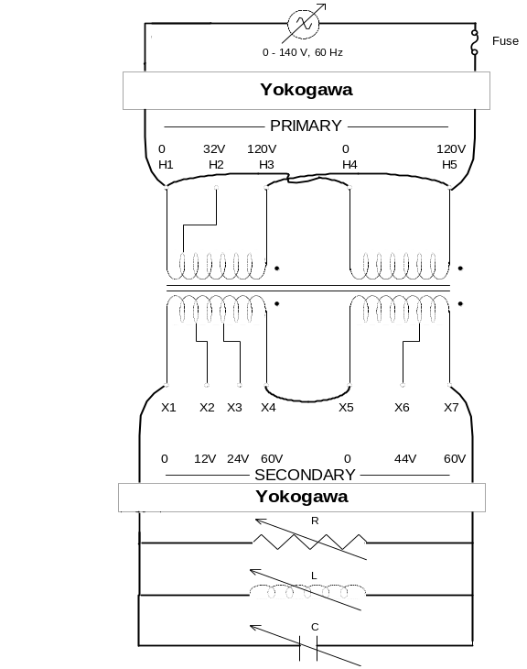

Figure 4 - Transformer with Load Attached to the Secondary.

2.7 Increase the supply voltage until the load voltage magnitude is 120 V. Record the Voltage and Real Power at the Primary and Secondary. Use this to calculate the voltage regulation and efficiency and compare them to the predictions in 2.5.

2.8 Completion
The lab-work is finished now make sure your lab notebook is properly completed by following the format of Lab B. Be sure to write a conclusion that shows what you have learned from doing the lab.

