ECE 204 - AC CIRCUITS

Lab 8 - Self & Mutual Inductance

The objectives of this laboratory experiment are to take a closer look at real inductors, ones that are obviously made from large coils, ones that exhibit both inductance and resistance, and ones that can be coupled to provide mutual inductance.

1.0 PRE-LAB

1.1 Read the complete laboratory procedure and be ready to apply it to your work. If you do not understand anything in the lab procedure, go and ask your instructor — don’t wait until the lab has started; remember, the instructor has to deal with fifteen groups and you will be “waiting in line”. Note that “waiting in line” is not a valid excuse for failing to finish the lab. You are expected to “budget your time” in lab and not waste it socializing.

1.2 Look back over what you know about inductors and inductance. Then develop formulas or methods of calculation that will determine the following:
- From phasor measurements of the voltage across an inductor and the current through it (Fig 1), write an equation to find R_{L}, X_{L}, and L as a function of V_{L}∠0° and I_{L}∠θ° and frequency, f.
- From magnitude measurements of the voltage applied to one coil (V₁) and the voltage across a coil coupled to the first (V₂), plus a knowledge of the self-inductance of the first coil (L₁), write the equation to find the mutual inductance M. Assume that the second coil is an open circuit.
- From the knowledge of both self-inductances (L₁and L₂) and the mutual inductance (M) of a pair of coupled coils, write the equation for the coupling coefficient k.
- Read the portion of Section 6.4 (in your Nilsson text) that gives a method for determining the dots for a pair of coupled coils. Write a brief description of this method in your journal.

1.3 Submit a photocopy of the pre-lab at the start of the lab period.

2.0 LAB PROCEDURE

You will use two plastic-encased inductors, one wound with heavy wire (Coil #1) and one wound with lighter wire (Coil #2), and five strips of magnetic iron (these should be on your bench.) You’ll also need a 10 Ω resistor.

2.1 Resistance of coils. Record information on your two coils (Coil #1 and Coil #2). Measure the inherent d-c resistance (R_{L}) of each coil using the DMM, and the a-c resistance of each coil with RLC Meter at a frequency of 1 kHz. Also measure the resistance of the 10 Ω resistor with both meters.

2.2 Measure the self-inductance of the coils. Before starting this part, read ahead to see how much data you’ll be taking in this part and the next. Then plan a tabular method to record the data. Note that the Function Generator (AWG1) is grounded, so you have to use the circuit in figure 1 to avoid “ground loops”. The voltage on C2 will give you the current as a phasor; divide the voltage on C1 by the current to get the “total” impedance:

Z = 10 + R_{L} + jωL

For each of your measurements, do the following:
- Adjust the amplitudes of the waveforms so that they fill the maximum possible amount of the screen.
- Adjust the time base so that the scope displays no more than two complete periods of the waveforms.

2.3 Measure the self-inductance of each coil using the function generator and the scope as shown in figure 1:

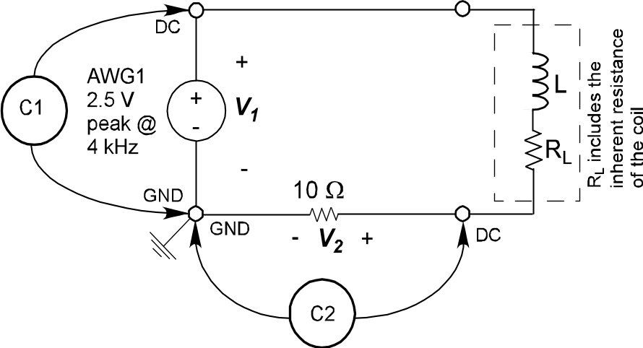

Figure 1 - Circuit Diagram for Voltage & Current Phasor Measurement

- Set the function generator to 4 kHz and adjust its output to 2.5 V (peak). Display the AWG voltage and voltage proportional to the current on the scope.
- From these data, determine the impedance of the coil plus the 10 Ω resistor. Note that the phase angle of the impedance for an inductor must be in the first quadrant.
- Calculate the inherent resistance (R_{L}), reactance (ωL), and inductance of each coil. Repeat part 2.3 for each coil with the magnetic iron inserted. Use 5 thin strips.

2.4 Measure the mutual inductance. Turn the FG off by reducing its output to zero. Remove the 10-Ω resistor. Place the thick coil (Coil #1) flat against the thin (Coil #2). Then excite the thin coil from AWG1 with 5 V (peak). You may need to reduce the voltage to avoid saturating the coil (look at the wave-shape on the oscilloscope). Use the oscilloscope to measure the coil voltages as shown in figure 2.

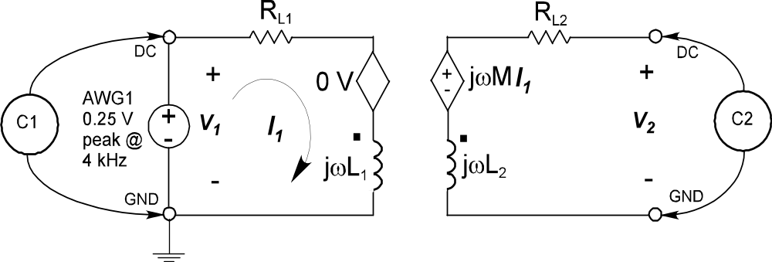

Figure 2 - Circuit Diagram for Mutual Inductance Measurement

From these data, calculate the mutual inductance M and the coupling coefficient k for the coupled coils. Turn the coils so they form a T and again get M and k. Set the coils so one coil edge touches the other coil edge, and one is swung out to about 45°. Then determine M and k. With the coils flat against one another, insert the 5 strips of iron into the coils and find M and k. Once again, you may need to reduce voltage to avoid saturation.

2.5 Coil dots. With the coils connected and coupled as at the end of the previous part, connect the scope to observe the coil voltages. The probes should be connected red to red and black to black. From the phase between the two, determine where the dots belong for your pair of coils. Be sure to record how the coils are physically placed with a figure or circuit diagram, since there are two possible orientations. Use the red terminals of the coil as your reference.

2.6 Completion
The lab-work is finished now make sure your lab notebook is properly completed. Be sure to write a conclusion that shows what you have learned from doing the lab.

