ECE 204 - AC CIRCUITS

Lab 7 - Three-Phase Power Measurements

The objectives of this laboratory experiment are:
1. Learn to perform voltage, current, and power measurements in three-phase ac circuits, using the Yokogawa digital meter.
2. Verify the phase and line relationships for the delta and wye-connected loads.
3. Observe the effect of various load combinations on the volt-ampere relationship in three-phase 60 Hz, ac circuits.

1.0 PRE-LAB

1.1 Read the complete laboratory procedure and be ready to apply it to your work. If you do not understand anything in the lab procedure, go and ask your instructor — don’t wait until the lab has started; remember, the instructor has to deal with fifteen groups and you will be “waiting in line”. Note that “waiting in line” is not a valid excuse for failing to finish the lab. You are expected to “budget your time” in lab and not waste it socializing.

1.2 Review section 1.2 of Lab 6 to re-familiarize yourself with the laboratory set-up.

1.3 Draw the complete circuit diagrams for Sections 2.4 and 2.6 of the laboratory procedure. Note that “complete” means from the source to the load, including the metering.

1.4 Calculate the following quantities for the circuits in Sections 2.4 and 2.6:
a) Line and phase voltage magnitude and angle
b) Line and phase current magnitude and angle
c) Total real power consumption of the load
d) Total reactive power consumption of the load
e) Source power factor

1.5 Submit a photocopy of the pre-lab at the start of the lab period.

2.0 LAB PROCEDURE

Note that the load bank elements are rated for 120 V. Always make sure that the supply voltage is properly set for the load configurations (delta or wye), such that the load bank voltage rating is not exceeded.

2.1 Set the variable three-phase ac supply on the left side of the bench to 208 V (line-to-line), which is 120 V (line-to-neutral) and refer to Figure 1 for connecting the oscilloscope to the variable three-phase supply. This connection will display all three line-to-neutral voltages. Note that the voltages as marked on the benches are not the positive abc sequence. Your task is to identify the actual phase sequence. Do not mark the phase sequence on the benches after you have identified it.

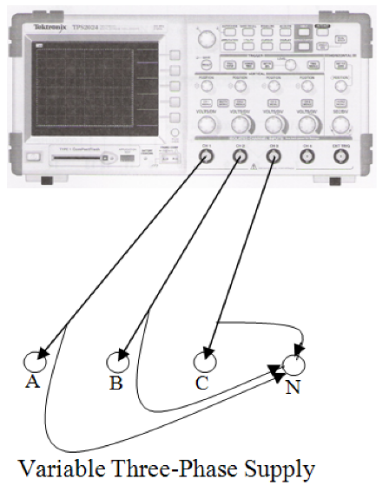

Figure 1 - Scope Connections for Measuring 3 L-N Voltages.

2.2 Reconnect the oscilloscope to the variable three-phase power supply, as shown in Figure 2. This connection will allow you to display line-to-line and line-to-neutral voltages for phase "a". Observe and record the magnitude and phase angle for the two voltages.
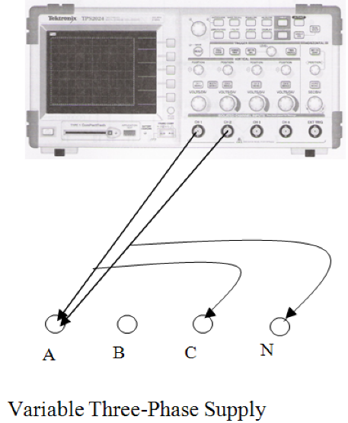

Figure 2 - Scope Connections for Measuring 3 L-L Voltages.

2.3 Connect the Yokogawa digital meter to the three-phase power supply, using the three-phase four-wire system (measurement of 3 voltages and 3 currents) of Figure 3; where “CC” stands for “current channel” and “VC” stands for “voltage channel”. Figure 3 shows the actual a, b, and c phases in the lab. Now you are prepared to record the voltages and currents that each Yokogawa channel is measuring. Pressing the “Σ” button measures the total three-phase power.
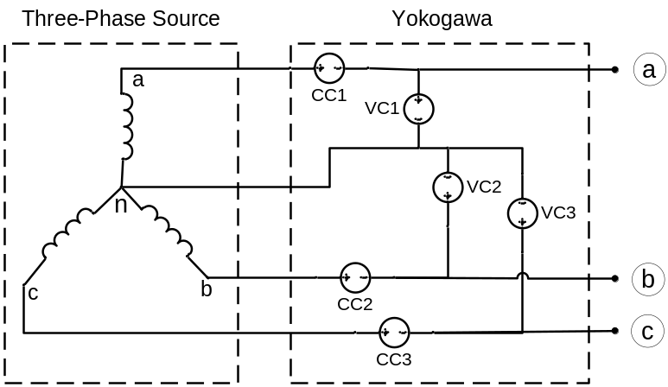

Figure 3 - Power Measurements with Yokogawa Digital Meter.

2.4 Switch the supply off. Connect a 300 resistor and a 0.8 H inductor in parallel for each leg of the three-phase delta-connected load of Figure 4. Set the supply to 120 V (line-to-line), you can measure this with a Fluke voltmeter. The Yokogawa should read 69.28 V because it is measuring line-to-neutral.
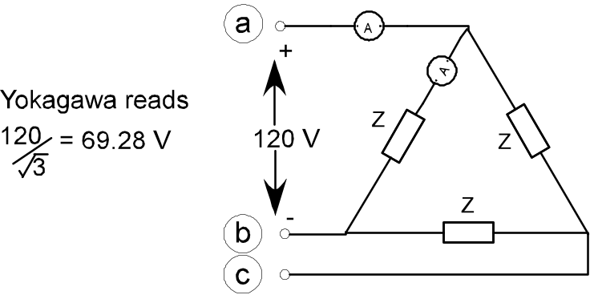

Figure 4 - Delta-Connected Loads with Embedded Ammeter.

2.5 Use the voltmeters and ammeters (Fluke or Yokogawa) to measure the magnitude of the line voltage (V_{ab}), phase voltage (V_{ab}), line current (I_{a}), and phase current (I_{ab}). Use the oscilloscope and the current probe to measure the phase angle of the I_{ab} with respect to V_{ab}. Use the line voltage, line current, and the power factor angle to calculate the three-phase active and reactive powers. Compare these values with the readings of the Yokogawa digital meter. Compare both with the pre-lab predictions. Capture the oscilloscope screen image and print it following the procedure described in lab 6.

2.6 Switch the supply off and disconnect the load. Connect a 300 and a 0.8 H inductor in parallel for each leg of a wye-connected three-phase load, as shown in Figure 5. Note that there is no connection between the neutral of the load and the neutral of the supply. Set the supply to 120 V line-to-neutral, which is 208 V line-to-line.

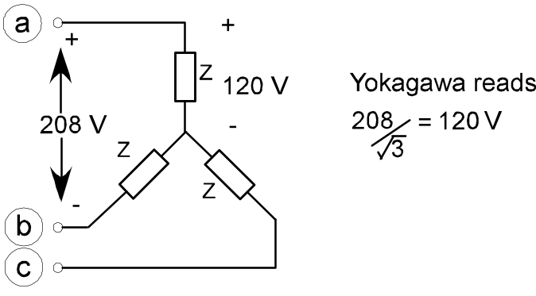

Figure 5 - Wye- Connected Loads.

2.7 Use the voltmeters and ammeters (Fluke or Yokogawa) to measure the magnitude of the phase voltage (V_{an}), line voltage (V_{ab}), and the line and phase currents (I_{a}). Use the oscilloscope and the current probe to measure the phase angle of the I_{a} with respect to V_{an}. Use the phase voltage, line current, and the power factor angle to calculate the three-phase active and reactive powers. Compare these values with the readings of the Yokogawa digital meter. Compare both with the pre-lab predictions. Capture the oscilloscope screen image and print it.
2.8 Switch the supply off. In addition to the 300 resistor and the 0.8 H inductor, connect a 0.4 H inductor in parallel for each leg of the three-phase wye-connected load. Now, connect a wire between the neutral point of the load and the neutral point of the supply. Set the supply voltage to 130 V line-to-neutral, which is 225 V line-to-line. Use the current probe to observe the distorted neutral current waveform. What is the frequency of the neutral current? Capture the oscilloscope screen image and print it.

2.9 Completion
The lab-work is finished now make sure your lab notebook is properly completed. Be sure to write a conclusion.

