ECE 204 - AC CIRCUITS

Lab 6 - Single-Phase Power Measurements

The objectives of this laboratory experiment are:
1. To become familiar with the equipment in the Power Lab.
2. To use the equipment to measure the real power (P), reactive power (Q), apparent power (S), and power factor angle (φ).
3. To correct power factor to a specified level.

1.0 PRE-LAB

1.1 Read the complete laboratory procedure and be ready to apply it to your work. If you do not understand anything in the lab procedure, go and ask your instructor — don’t wait until the lab has started; remember, the instructor has to deal with fifteen groups and you will be “waiting in line”. Note that “waiting in line” is not a valid excuse for failing to finish the lab. You are expected to “budget your time” in lab and not waste it socializing.

1.2 The purpose of this section is to get you familiar with the equipment you will be using in the lab. Figure 1 shows a typical bench set-up.

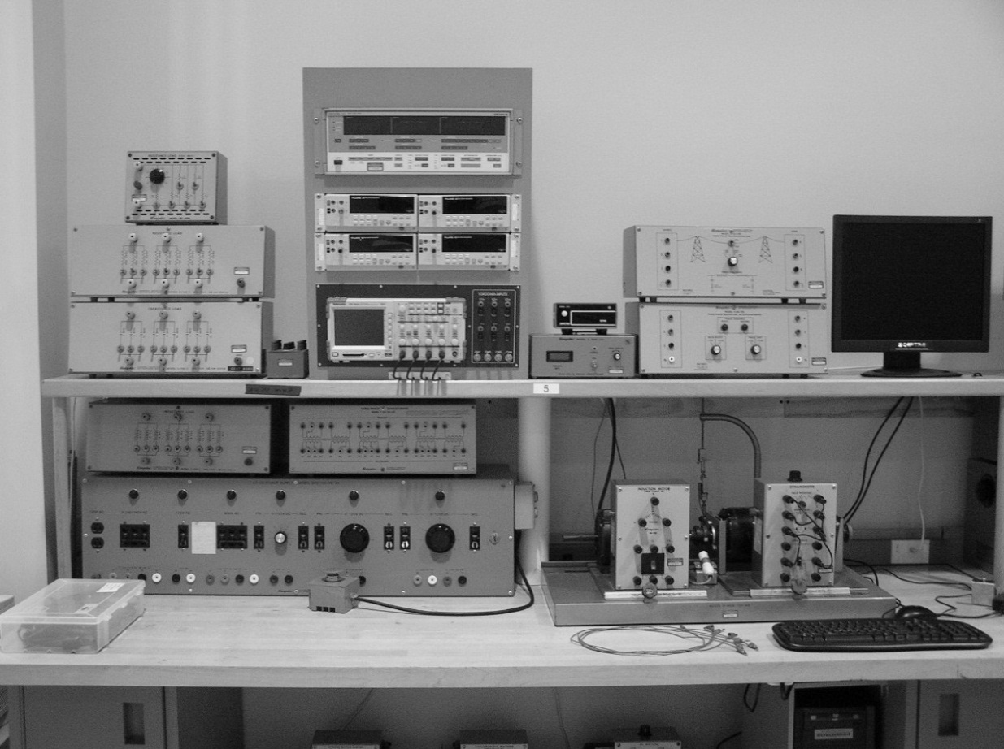

Figure 1 - Lab Equipment
The power supplies are enlarged in Figure 2. Note that this lab will use the 60 Hz, single-phase supply that is located on the extreme right.

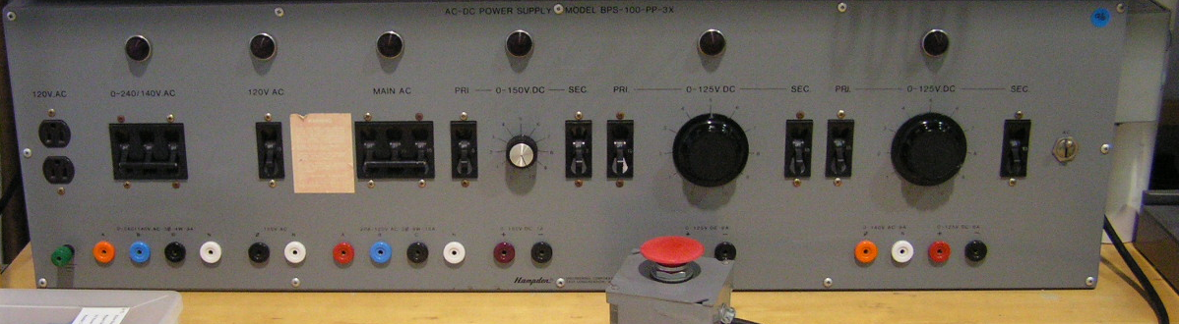

Figure 2 - Power Supplies

The bench contains of a variety of different sources and can be dangerous if not handled properly. To get power to the bench, push the black start button on the right corner of the Power Supply. To disconnect the power from the Power Supply, push the red button below the black start button. There is also a box that is connected to the start/stop box with a big red button; this is the panic button, and pushing it will shut off the entire Power Supply. Keep it close for the first few experiments. Should anyone come in contact with any live equipment, do not touch the affected person and instead depress the panic button. Finally there is a Main ac Breaker towards the center of the bench which must be switched upward in order for any of the supplies to function. The power supply on the extreme right can be operated as a dc or ac Power Supply. The switch position on the right side of its secondary breaker will determine the mode of operation. Turning on any power supply will turn on a red light on top of the associated power supply.

The loads that you will be using are shown in Figure 3. Each has three identical banks and each bank has three different values. Switches in the up position indicate that the load is connected.
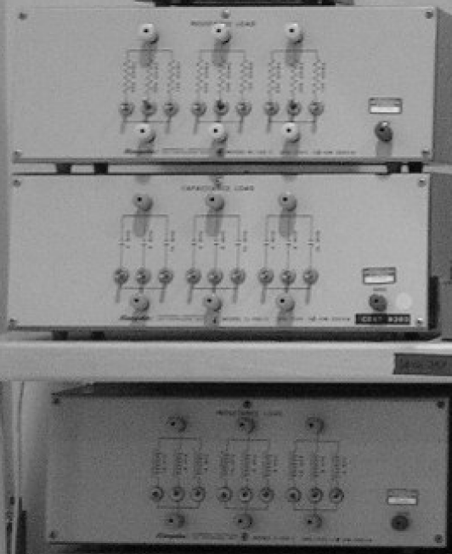

Figure 3 - Resistance, Capacitance & Inductance Loads

The Instrument Panel in Figure 4 consists of the Yokogawa Power Meter (top), four Digital Multimeters (middle), an Oscilloscope (bottom), and the junction box (bottom right) that contains the input terminals for the Yokogawa Power Meter and the Oscilloscope.

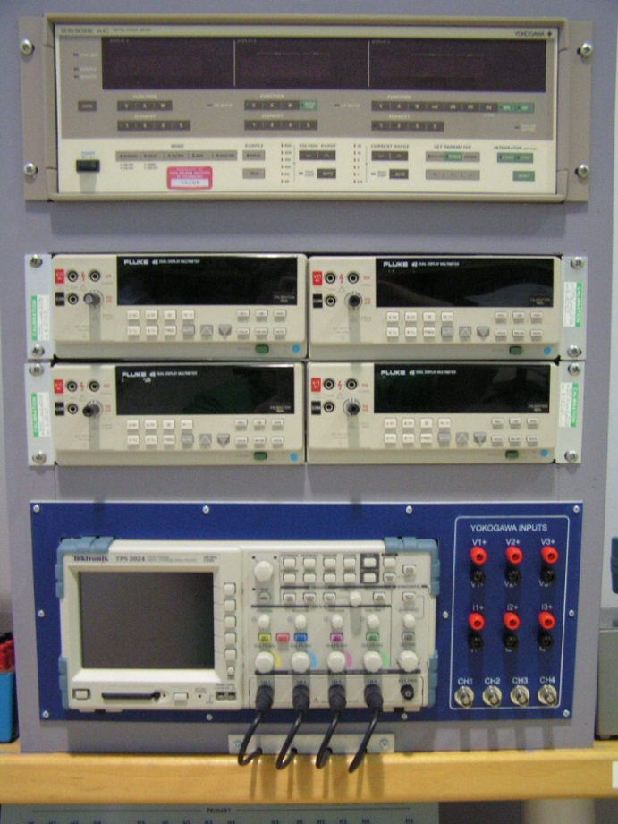

Figure 4 - Instrument Panel

1.3 Figure 5 shows the arrangement you will be working with. For each of the four specified load combinations calculate I, P, Q, S and the power factor, when the supply voltage is maintained at 120 V, 60 Hz. Complete the calc. columns (predictions) in Table 1.

Case 1: R = 600 L = 0.8 H C = O.C. (Open Circuit)
Case 2: R = 300 L = O.C. C = 4 F
Case 3: R = O.C. L = 1.6 H C = 4 F
Case 4: R = 150 L = 0.4 H C = 16 F

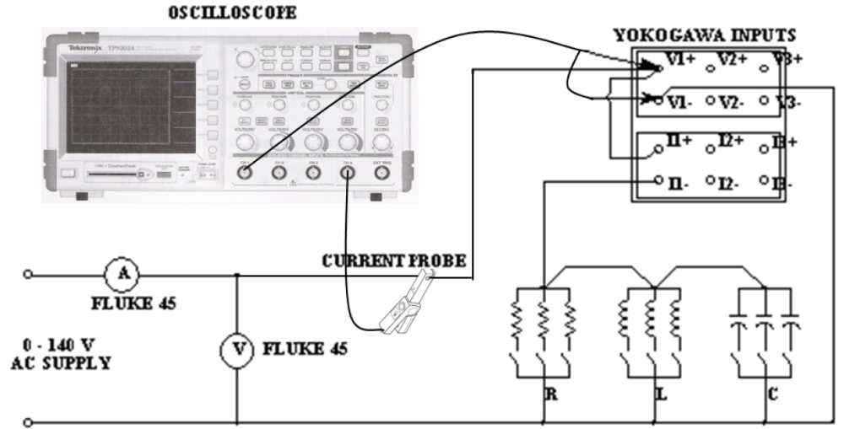
Figure 5 - Connections for Power Measurements

Table 1—Summary of Predictions & Measurements

CASE | ELEMENT | I (A) |  | P (W) |  | Q (VAR) |  | S (VA) |  | P.F.
 |  | Calc | Meas | Calc | Meas | Calc | Meas | Calc | Meas | Calc | Meas
1 | R & L
2 | R & C
3 | L & C
4 | R & L & C

1.4 Calculate the value of capacitance (μF) needed to correct the power factor in Case 1 to 0.98 lagging.

1.5 Submit a photocopy of the pre-lab at the start of the lab period.

2.0 LAB PROCEDURE

2.1 We will start by configuring the oscilloscope for voltage and current measurements.
a) You need to set the oscilloscope to match the scale of your voltage probe.
To set the scale, follow these steps:
1. Connect the voltage probe to Channels 1, 2, or 3.
2. Push the channel Menu button.
3. Push the Probe option button.
4. Push the Voltage option button.
5. Push the Attenuation option button and select 20X.

b) The current probe provides a voltage signal proportional to the current. You need to set the scope to match the scale of your current probe. To set the scale, follow these steps:
1. Connect the current probe to Channel 4, and set the range switch on the probe to 100mV/A.
2. Push Channel 4 Menu button.
3. Push the Probe option button.
4. Push the Current option button.
5. Push the Scale option button and select 10X.

c) The scope traces can be stored on the CompactFlash (CF) Card. Follow these
steps:
1. Insert a CF card into the card slot.
2. Push the Utility button.
3. Push File Utilities and select More then select Format.
4. Select Yes to format the CF card.

d) To store a waveform on the CF card and print it follow these steps:
1. Push the Save/Recall button.
2. Push the Action button and select Save Image.
3. Push the File Format button and select BMP.
4. Push the Save Button and wait a few seconds for the red LED to turn on and the waveform is stored.
5. Remove the CF card from the oscilloscope and insert it into the lab computer.
6. Select the Drive F to display the stored waveforms.
7. Push the print button and select the waveform then choose the 4 x 6 size.

2.2 Setting up the other meters:
a. The voltmeters and the scope probes can be overlaid on the circuit. Therefore, it is recommended to construct the entire voltage measuring circuit after the power circuit has been built.
b. Set all of the measuring devices (meters) for ac measurements. Choose the Auto Scale measuring mode.
c. The Yokagawa meter will measure voltage, current, real power, reactive power, apparent power, and power factor, for any of the three channels. Only channel 1 will be used in this lab, so select “1” for any quantity you are measuring.

2.3 Construct the circuit shown in Figure 5 with a supply voltage of 120 V. This voltage should be maintained fixed throughout the experiment, since it is the control variable.

2.4 For each of the four load configurations that you have used for the pre-lab calculations, record the appropriate values in Table 1. Note that the Yokogawa digital meter can be used for reading the values. The lagging or leading power factor can be determined from the voltage and current traces that are being displayed on the scope.

2.5 Use the CompactFlash Card to store pictures of voltage and current traces.

2.6 Modify Figure 5 to include a reactive power compensating circuit (shunt capacitor banks) to give a source power factor of 0.98 lagging. Verify the adequacy of your design experimentally by recording the values of real power, reactive power, and the power factor.

2.7 Completion
The lab-work is finished now make sure your lab notebook is properly completed. Be sure to write a conclusion.

Sample Calculations for Case 1
