ECE 204 - AC CIRCUITS

Lab 5 - Thévenin & Maximum Power Theorems

The objectives of this laboratory are to predict the Thévenin equivalent and maximum power output of a circuit in the phasor domain and to confirm the predictions with direct phasor measurements.

1.0 PRE-LAB

1.1 Read the complete laboratory procedure and be ready to apply it to your work. If you do not understand anything in the lab procedure, go and ask your instructor — don’t wait until the lab has started; remember, the instructor has to deal with fifteen groups and you will be “waiting in line”. Note that “waiting in line” is not a valid excuse for failing to finish the lab. You are expected to “budget your time” in lab and not waste it socializing.

1.2 Re-draw Figure 1 in the phasor domain, based on a frequency of 5 kHz.

1.3 Compute the Thévenin equivalent for the circuit described in Figure 1. Report your answer as a phasor, with peak voltage magnitude and give the angles in degrees. Model the 33 mH inductor with an inherent resistance of about 50 Ω, and the 4.7 mH inductor with about 8 Ω.

1.4 At 5 kHz the Thévenin Impedance should be a resistor (R_{Th}) in series with an inductive reactance (jX_{Th}), R_{Th} should be slightly over 60 Ω and X_{Th} ≈ 2R_{Th}. The power dissipated in the load is P_{Load} = |I|² R_{Load} and will vary with both R_{Load} and jX_{Load}. Apply a software package of your choice (e.g. MATLAB, MAPLE, EXCEL, etc.) to model a Thévenin equivalent (like Figure 2) with a variable load, comprised of a resistor (R_{Load}) and a capacitive reactance (-jX_{Load}). Plot a graph with P_{Load} as the y-axis and R_{Load} as the x-axis, as R_{Load} goes from zero to 10R_{Th} and X_{Load} equal to -X_{Th}. An example of this type of graph is shown below for four values of X_{Load}; P_{max} occurs when Z_{Load} = Z_{Th}*.

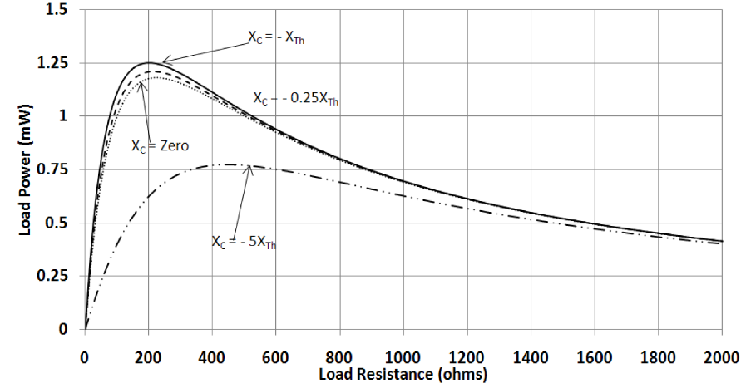

1.5 Submit a photocopy of the pre-lab at the start of the lab period.

2.0 LAB PROCEDURE

2.1 Measure Component Values
Measure the nominal values of each individual component shown in Figure 1, using one of the RLC meters at the front of lab, and then calculate the percent errors.

2.2 Measure the Thévenin Equivalent Components
Connect the circuit of Figure 1. Set the AWGs to provide 7 volts (peak) at 5 kHz sinusoidal output.

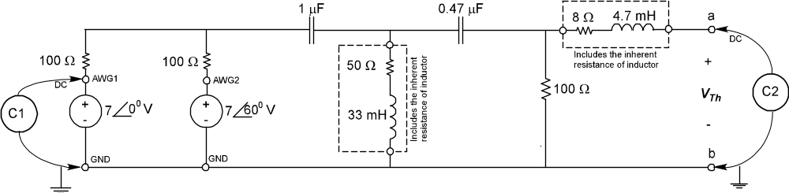
Figure 1—Circuit Diagram for Thevenin Analysis

Measure the magnitude and phase angle of the V_{Th}. The Oscilloscope should be triggered off the AWG1. Calculate the percent error in Thévenin Voltage magnitude and the difference in phase angle in degrees.

Next, short the terminals by inserting a 2.7 Ω resistor across terminals ab. Measure the magnitude and phase angle of the short circuit current I_{sc}. Calculate the percent error in short circuit current magnitude and the difference in phase angle.

Finally, obtain the measured value of Z_{Th} = V_{Th}/I_{sc}. Calculate the percent error for R_{Th} and X_{Th}.

2.3 Cancel Reactance and Measure Power as a Function of Load Resistance
Predict the load reactance (X_{Load}) needed to cancel the Thévenin reactance (X_{Th}). Use a standard capacitor value to get close. Then add in parallel a variable capacitor to tune the capacitance to the exact amount needed to cancel the reactance and keep it constant. Next, attach a variable resistor in series with the capacitive load as shown in Figure 2. Trigger the Oscilloscope off the Load Voltage (V_{Load}) and measure the load current phasor as the load resistance is varied from 0.1R_{Th}, 0.3R_{Th}, 0.6R_{Th}, R_{Th}, 2R_{Th}, 3R_{Th}, 6R_{Th}, and 10R_{Th}.

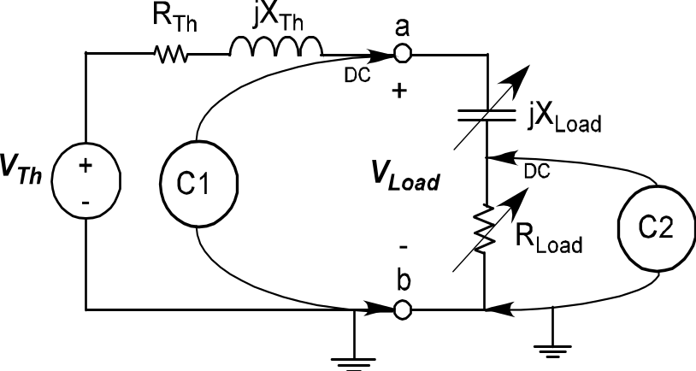
Figure 2—Circuit Diagram for Load Power Measurement

Calculate the load power from the current and load resistance values and plot it against load resistance. Compare these data to the pre-lab data on the same plot.

2.4 Completion
The lab-work is finished now make sure your lab notebook is properly completed. Be sure to write a conclusion.

