ECE 204 - AC CIRCUITS

Lab 3 - Phasor Magnitude & Angle Measurements

The objectives of this laboratory experiment are:
1. To predict Phasor relationships in RLC circuits.
2. To use the Oscilloscope to make phase angle measurements.
3. To confirm that KVL & KCL apply in the phasor domain.

1.0 PRE-LAB

1.1 Read the complete laboratory procedure and be ready to apply it to your work. If you do not understand anything in the lab procedure, go and ask your instructor — don’t wait until the lab has started; remember, the instructor has to deal with fifteen groups and you will be “waiting in line”. Note that “waiting in line” is not a valid excuse for failing to finish the lab. You are expected to “budget your time” in lab and not waste it socializing.

1.2 Re-draw Figures 1 & 3 in the phasor domain and use KVL & KCL to make predictions for the unknown items in Tables 1 & 2. Make the predictions phasor quantities, with peak magnitudes and angles in degrees. Note that the inductor has an inherent resistance of about 50 Ω. Set V_{FG} = 2.5Ð0 V (peak), and calculate the other phasors for a frequency of 2 kHz.

Table 1—Ideal Predictions for Figure 1

Item | Prediction
AWG1 Voltage (V_{FG}) | 2.5Ð0
Source Current (I) mA
Inductor Voltage (V_{L})
Resistor Voltage (V_{R})
Capacitor Voltage (V_{C})

Table 2—Ideal Predictions for Figure 3

Item | Prediction
AWG1 Voltage (V_{FG}) | 2.5Ð0
Source Current (I) mA
Inductor Current (I_{L}) mA
Resistor Current (I_{R}) mA
Capacitor Current (I_{C}) mA

1.3 Using EXCEL, plot a graph of Inductive Reactance (X_{l} in Ω) & Capacitive Reactance (positive value of X_{c} in Ω) vs. Frequency (Hz) as the frequency goes from 100 Hz to 100 kHz. Assume that the inductance is 33mH and the capacitance is 0.47µF. Use logarithmic scales for both axes and estimate the frequency at which the reactances are equal, this is called the RESONANT FREQUENCY.
1.4 Submit a photocopy of the pre-lab at the start of the lab period.

2.0 LAB PROCEDURE

2.1 Measure Component Values
We will start by analyzing the phasor relationships in the series circuit of Figure 1. Measure the nominal values of each individual component using one of the RLC meters at the front of lab, and calculate percent errors.

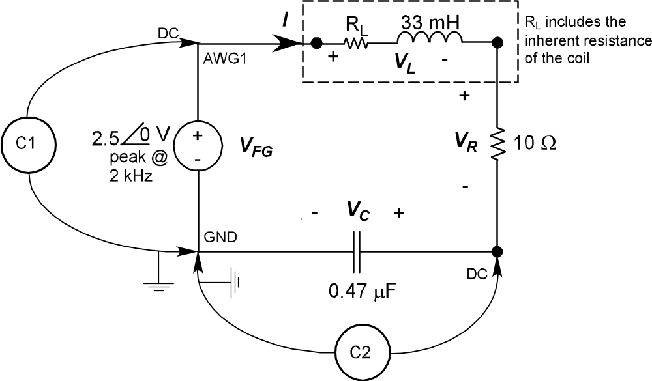

Figure 1 - Circuit Diagram for Series R, L, & C Elements

2.2 RLC Circuit in Series
Set the AWG1 to give 2.5 V (peak) at 2 kHz sinusoidal output. Use the Oscilloscope to measure the items that were predicted in Table 1 (pay attention to polarity). Compute the currents using Ohm’s Law when the voltage across the resistor is measured. Compute the errors in magnitude and phase. The Oscilloscope should be triggered off the AWG1 (V_{FG}) and it will show you the peak-to-peak values and phase shift. Remember that last week we saw how to measure phase shift from:

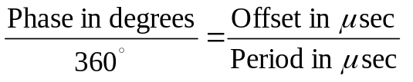
Or,
$$φ=360 ∙f ∙∆t$$

Note: you can only display the voltage across the component connected to the negative side of the FG (the capacitor in Figure 1); you will have to re-configure the circuit each time you measure a component’s voltage.

2.3 Phasor Diagram of KVL
Switch-off the AWG1 and construct a phasor diagram similar to the one in Figure 2, drawn with a protractor and a straight-edge (but make it larger ~½ page) made-up of the sum of the four voltages and record the voltage mismatch around the loop as a percentage of |V_{FG}|.

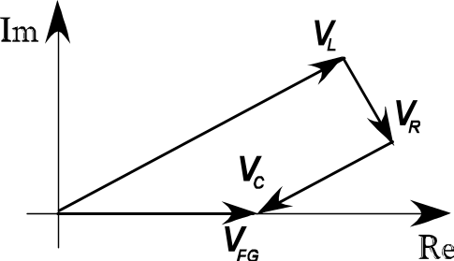

Figure 2 - Phasor Diagram for Series R, L, & C Elements

2.4 Parallel RLC Circuit
We will continue by analyzing the phasor relationships in the parallel circuit of Figure 3. Measure the nominal values of all three resistors using one of the RLC meters at the front of lab, and calculate percent errors.

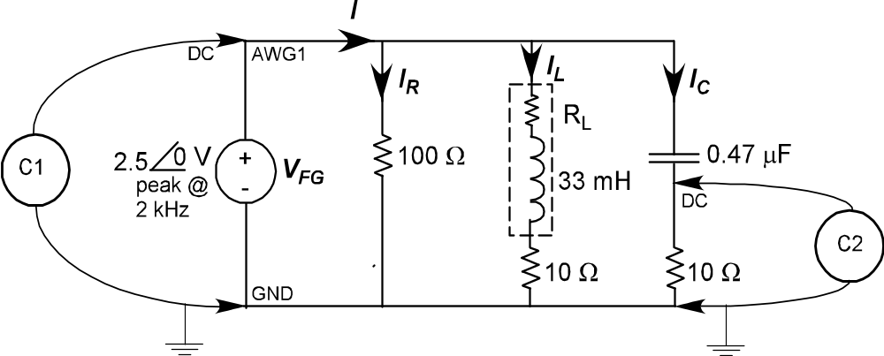

Figure 3 - Circuit Diagram for Parallel R, L, & C Elements

Set the AWG1 to give 2.5 V (peak) at 2 kHz sinusoidal output. Once again, use the Oscilloscope and Ohm’s Law to measure the items that were predicted in Table 2, and then compute the errors in the magnitude and phase.

Note that you do not need to re-configure the circuit this time because all resistors have a common negative terminal.

2.5 Phasor Diagram of KCL
Switch-off the AWG and construct a phasor diagram made-up of the sum of the four currents and record the current mismatch at the top node as a percentage of |I|.

2.6 Resonant Frequency
Connect the inductor directly across the AWG1 and use the oscilloscope to measure the voltage (convert it to rms) and the DMM in ammeter mode (rms is default). Apply Ohm’s Law to determine the magnitude of the inductive reactance (remember to take out the ~50 Ω resistance) as the frequency is varied from 10 Hz to 10 kHz, using steps of 10, 30, 100, 300, 1k, 3k and 10k. Draw a figure of your experimental set-up.

Repeat this process for the capacitor.

Now plot both reactances on logarithmic scales (the plot should look like straight lines). Determine the resonant frequency from your measurements and compare it to the pre-lab value. Calculate the percent error.

2.7 Completion
The lab-work is finished now make sure your lab notebook is properly completed. Be sure to write a conclusion that shows what you have learned from doing the lab.

