ECE 204 - AC CIRCUITS

Lab 2 - Measurement of R, L & C

The objectives of this laboratory experiment are:
1. Learn to measure load element values with the RLC Meter.
2. Become familiar with variations of R, L & C from their nominal values.

3. Learn to obtain load element voltage waveforms from oscilloscope measurements.

1.0 PRE-LAB

1.1 Read the complete laboratory procedure and be ready to apply it to your work. If you do not understand anything in the lab procedure, go and ask your instructor — don’t wait until the lab has started; remember, the instructor has to deal with fifteen groups and you will be “waiting in line”. Note that “waiting in line” is not a valid excuse for failing to finish the lab. You are expected to “budget your time” in lab and not waste it socializing.

1.2 Given a voltage across a load, determine the magnitude of current through the load, using phasor analysis for the following cases. Assume that the voltage is a sinusoidal signal at 1 kHz frequency with the peak value indicated in Table 1 below. First find the reactance (X) in ohms then find the current through the load in each case. Report the peak value of the current and the rms value of the current and fill-in Table 1.

Table 1—Ideal Predictions

Case | Voltage  (V_{peak}) | Reactance  (Ω) | Current  (mA_{peak}) | Current  (mA_{rms})
C = 0.47 μF | 5
C = 0.47 μF in series with 0.1 μF | 7
C = 0.47 μF in parallel with 0.1 μF | 7
L = 4.7 mH | 1
L = 4.7 mH in series with 33 mH | 5
L = 4.7 mH in parallel with 33 mH | 1

1.3 Submit a photocopy of the pre-lab at the start of the lab period.

2.0 LAB PROCEDURE

You are going to determine the values of components by direct measurement with an RLC Meter. Then you will make measurements of voltage and current using the Digilent Waveforms Board (DWB).

2.1 Measure Component Values
Measure the resistance of handheld DMM to check for a blown fuse. You can use one of the Fluke DMMs as an ohmmeter. Do this in all labs from now on.

Measure the value of each individual component using one of the RLC meters at the front of lab and calculate percent errors using the formula of Lab 1.

2.2 Measure Voltage and Current
Using DWB, connect AWG1 across each combination of components in Table 1 and set the voltage to the specified value. Use the handheld DMM to confirm the rms value of voltage from AWG1. Measure the magnitude of current through the component in mA_{rms} by inserting the orange ammeter in the circuit. These are your I_{measured} values.

Compute and report the percent error between the predicted value and the measured value using the formula of Lab 1. Comment on the errors that you calculated.

2.3 Analysis of the Non-ideal Inductor Effects
Now re-analyze the case where you measured the 4.7mH inductor. This time you should model the effect of the inherent resistance of the inductor due to the loss in the wound wire that makes the coil. Measure the dc resistance of the inductor with the handheld DMM (it should be a few ohms), and use that value in the non-ideal inductor model below to calculate impedance of the non-ideal inductor. Recalculate the expected current in mA_{rms} for the circuit model below. Calculate the percent error with your new prediction of the current. Based on your results, make a conclusion about how to properly model inductors.

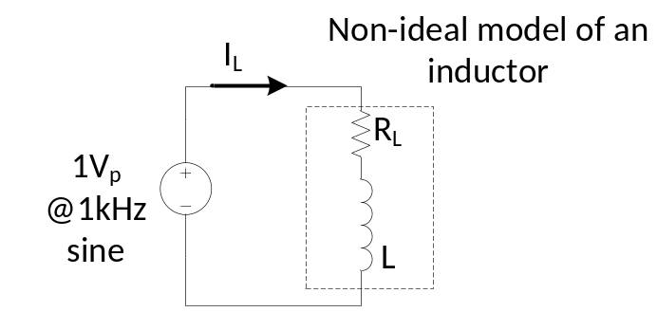

Figure 1 - Circuit Diagrams for modeling the inherent resistance in an inductor

2.4 Oscilloscope Measurements of an RLC Circuit
Turn AWG1 off and build an RLC series circuit shown below in Figure 2, where R=100 Ω, L=33 mH and C=0.47 μF. Apply 1 V (peak) at 1 kHz and use the oscilloscope to observe the shape of the voltage across each component. For the oscilloscope use the DC input and the “arrow” (→) symbols. Note that the arrow means “ground”, so all the arrows are connected together. Trigger the scope from AWG1 on C1 and use C2 to observe the component voltage (which will have to be moved so that the scope grounds stay connected to each other). Use these images to determine the phase difference between AWG1 voltage and component voltages, by using the “cursors” in the “X” mode. The following diagrams show why you need to move the component under observation, so that you avoid “ground loops” shorting out components. Since the oscilloscope only displays voltages, the current in the circuit has to be determined by observing the voltage across the resistor (Figure 2 (c)) and applying Ohm’s Law.

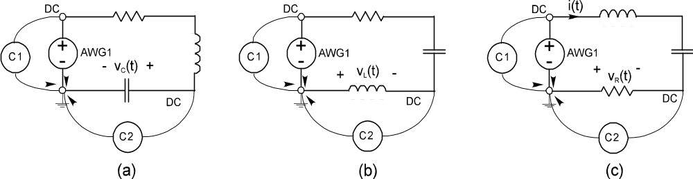

Figure 2 - Circuit Diagrams for Measuring Component Voltages

For each case print a picture of the scope output and denote on the picture if the voltage over the component signal ‘leads’ or ‘lags’ AWG1. Make sure to indicate on the graph which signal is AWG1 and which signal is the component’s voltage. Use the time scale factor and the cursors function in DWB to measure the phase difference in degrees. A simple way to calculate the phase offset is to use a proportion ratio:

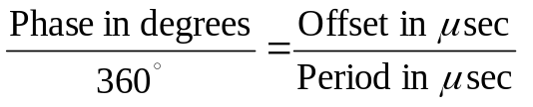
Or,
$$φ=360 ∙f ∙∆t$$

Comment in your lab journal about why you need to rearrange the circuit components when using the scope to display voltages.

2.5 Completion
The lab-work is finished now make sure your lab notebook is properly completed. Be sure to write a conclusion that shows what you have learned from doing the lab.

