Scroll bars in Excel 2007 MJM
- Click the round icon at the upper left of the Excel sheet.
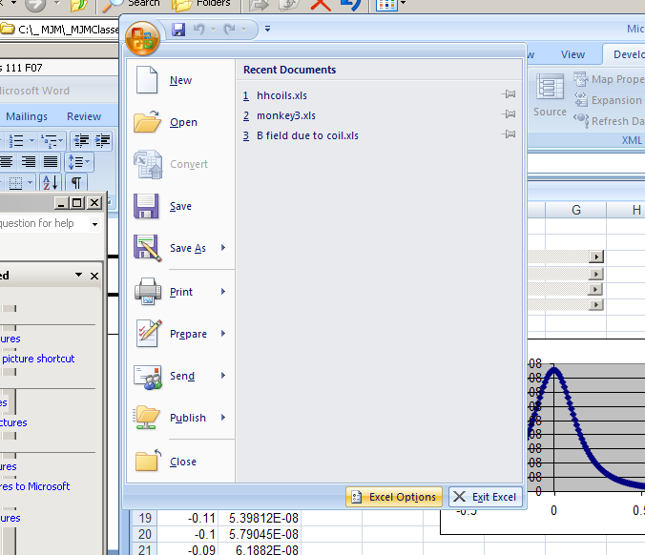

- Click Excel Options at the bottom

- Click to put the Developer tab on your top menu

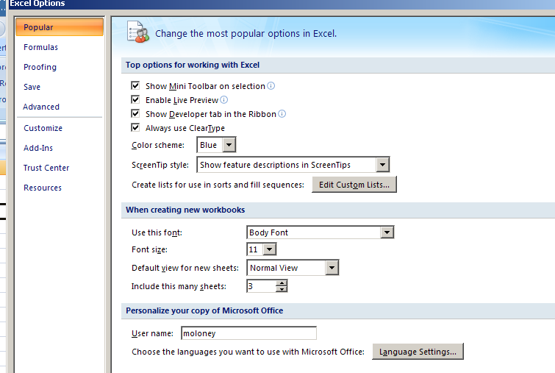

- Now click Developer on the top menu and select Insert
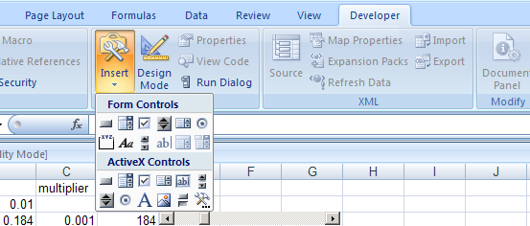
This is the scroll bar. Click it once then drag over a rectangular region on your spreadsheet. Doing this will put you into Design Mode (that panel will light up).

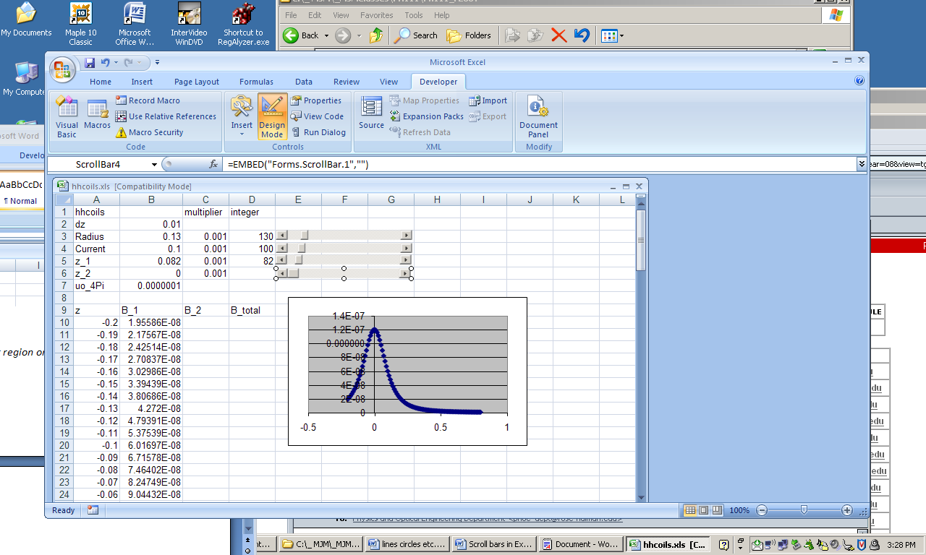

The screen above shows a newly installed scroll bar with handles around it.
Right-click on the new scroll bar within the handles. Then select Properties from the drop-down menu
(Picture of the Properties menu on next page)
Enter a Linked Cell address (like D6 or something). This is where the integer goes.
I always use a Large change of 10, for when you click in the gray area (goes 10 times faster than with the triangles at either end of the scroll bar.)
A Max value of 1000 or 2000 is usually fine.
Now click Design Mode again to get out of Design Mode.
Try out your new slider (scroll bar) by dragging the button and seeing the integer change.

