Homework Set 29B
PH 113 – 10
Q1. Two circular loops lie side by side in the same plane. One is connected to a source that supplies an increasing current; the other is a simple closed ring. (A) Is the induced current in the ring in the same direction as the current in the loop connected to the source, or opposite? Explain. (B) What is the direction of the current in the ring (relative to the direction in the loop) if the current in the source ring is decreasing? Explain.

P1. A circular loop of wire is in a region of spatially uniform magnetic field, as shown below. The magnetic field is directed into the plane of the figure. Determine the direction (clockwise or counterclockwise) of the induced current in the loop when (A) B is increasing; (B) B is decreasing; (C) B is constant with value B₀. Explain your reasoning in each case.
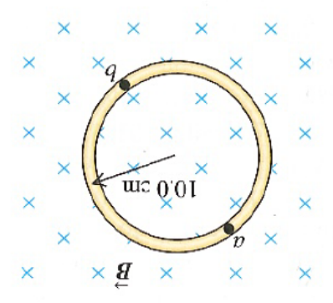

P2. The current in the figure below obeys the equation $I\left(t\right)=I_{0}e^{-bt}$, where b > 0. Find the direction (clockwise or counterclockwise) of the current induced in the ring for t > 0.
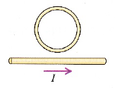

P3. Using Lenz’ Law, determine the direction of the current in resistor ab in the figure below when (A) switch S is opened after having been closed for several minutes; (B) coil B is brought closer to coil A with the switch closed; (C) the resistance of R is decreased while the switch remains closed.
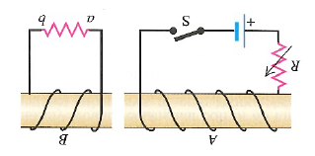

P4. A rectangle measuring 30.0 cm by 40.0 cm is located inside a region of a spatially uniform magnetic field of 1.25 T, with the field perpendicular to the plane of the coil, as shown in the figure below. The coil is pulled out at a steady rate of 2.00 cm/s traveling perpendicular to the field lines. The region of the field ends abruptly as shown. Find the emf induced in this coil when it is (A) all inside the field; (B) partly inside the field; (C) all outside the field.
