PH 113 Spring Term 2016
Physics III

Practice Problems – Set B

- List the three ways that a current can be induced in a loop of wire (without the use of a battery or capacitor).

- Describe how a generator works.

- A demonstration of eddy currents consisted of an aluminum pendulum and a permanent magnet. Describe what happened when the pendulum was displaced from its equilibrium position and released to move between the poles of the magnets and explain why it happened.

(Continued on the back)
- When a bar magnet is moved away from a conducting ring, does the direction of the induced current in the ring depend on the orientation of the magnet? Explain.

- When a circuit that contains an inductor has been running for a long time after the switch has been closed, what does the inductor behave effectively as? Explain.

- At the instant that the switch in a circuit that contains an inductor is closed, what does the inductor behave effectively as? Explain.

- Explain why the current in a simple circuit does not instantaneously jump to its maximum value.

- Describe the differences between the effects of a resistor and an inductor in a circuit?

(Continued on the next page)
- A 500-turn circular-loop coil 15.0 cm in diameter is initially aligned so that its axis is parallel to the earth’s magnetic field. In 2.77 ms, the coil is flipped so that its axis is perpendicular to the earth’s magnetic field. (A) If an emf of 0.166 V is thereby induced in the coil, what is the value of the earth’s magnetic field? (B) If the loop is rotated in this region with a constant frequency of 10 Hz, what is the emf induced in the loop?

- Find the direction of the current through the resistor in the situation shown below, (A) at the instant the switch is closed, (B) after the switch has been closed for several minutes and (C) at the instant the switch is opened.
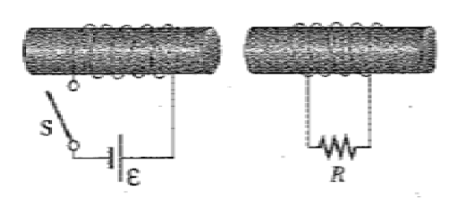

(Continued on the back)
- Consider the arrangement shown below. Assume that the resistance is 6.00 Ω and l = 1.20 m, and that a uniform 2.50 – T magnetic field is directed into the page. (A) At what speed should the bar be moved to produce a current of 0.50 A in the resistor? (B) If the bar is moved to the right in the figure, what is the direction of the current through the sliding bar? (C) What is the rate at which work must be done to maintain the velocity of the bar? (Assume that friction is negligible)
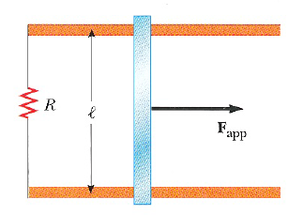

- Let the following values be assigned to the components shown in the figure below. The emf is 6.00 V, the inductor is 24.0 mH and the resistor is 10.0 Ω. (A) Determine the maximum current possible in this circuit and indicate its direction. (B) Determine the inductive time constant for this circuit. (C) Calculate the current in the circuit 0.50 ms after the switch is closed?
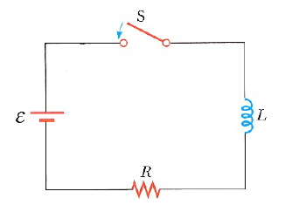

(Continued on the next page)
- A 10-V battery, a 5-Ω resistor and a 10-H inductor are connected in series (similar to the figure shown for problem 12). After the current in the circuit has reached its maximum value, calculate (A) the power supplied to the circuit by the battery, (B) the power dissipated in the resistor, (C) the power dissipated in the inductor, and (D) the energy stored in the magnetic field of the inductor.

- A 2.00 – H inductor carries a steady current of 0.500 A. When the switch in the circuit is opened, the current disappears in 0.010 s. What is the induced emf that appears in the inductor during this time?

(Continued on the back)
- A single-turn, circular loop of radius 0.050 m is coaxial with a long solenoid with a radius of 0.030 m, length of 0.750 m and 1500 turns as shown in the figure below. The variable resistor is changed such that the solenoid current decreases linearly from 7.20 A to 2.40 A in 0.300 s. (A) Calculate the induced emf in the circular loop. (B) Determine the inductance of the solenoid when the current is 6.90 A. (C) Determine the inductance of the solenoid when the current is 3.00 A.

