PH 111 Fall Term 2016
Physics I

Practice Problems – Set D

- As a ball falls toward the earth, its momentum increases. How would you reconcile this fact with the law of conservation of momentum?

- A skater is standing still on a frictionless ice rink. Her friend throws a Frisbee straight at her. In which of the following cases is the largest momentum transferred to the skater: (A) the skater catches the Frisbee and holds onto it. (B) The skater catches the Frisbee momentarily, but then drops it vertically downward. (C) The skater catches the Frisbee, holds it momentarily and throws it back to her friend. Explain your answer.

(Continued on the back)
- In an inelastic collision between a wall and a blob of clay, is momentum conserved? Explain your answer.

- Briefly describe the principle upon which rocket propulsion works. Explain why a rocket works in the vacuum of space.

- A garden hose is held parallel to the ground as shown below. What force is necessary to hold the nozzle stationary if the discharge rate of the water is 0.600 kg/s with a speed of 25.0 m/s?
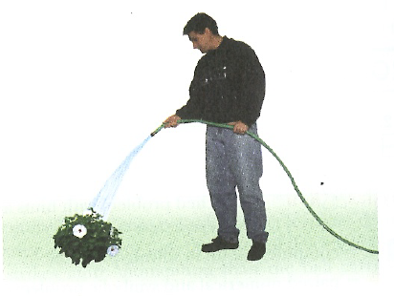

(Continued on the next page)
- The force, F_{x}, acting on a 2.00-kg particle varies in time as shown in the graph below. Find (A) the impulse of the force, (B) the final velocity of the particle if it is initially at rest and (C) the final velocity of the particle if it is initially moving along the x-axis with a velocity of –2.00 m/s.

(Continued on the back)
- An 8.00-g bullet is fired into a 2.50-kg block that is initially at rest at the edge of a 1-m-high table, as shown below. The bullet remains in the block and after the impact, the block lands 2.00 m from the bottom of the table. Determine the initial speed of the bullet.
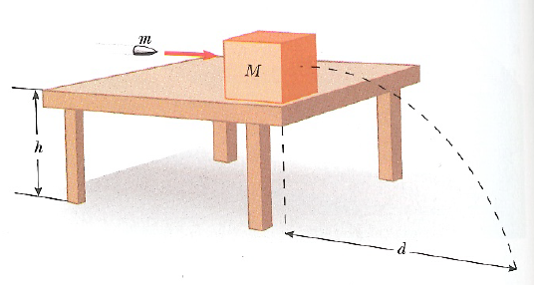

(Continued on the next page)
- The first stage of a Saturn V space vehicle consumes fuel at the rate of 1.50 × 10⁴ kg/s, with an exhaust speed of 2.60 × 10³ m/s. (A) Calculate the thrust produced by these engines. (B) Find the initial acceleration of the vehicle on the launch pad if its initial mass is 3.00 × 10⁶ kg.

- A 3000-kg rocket has 4000 kg of fuel on board. The rocket is coasting through space at 100.0 m/s and needs to boost its speed to 300.0 m/s. It does this by firing its engines and ejecting fuel at a relative speed of 650.0 m/s until the desired speed is reached. (A) How much fuel is left on board after this maneuver? (B) If the rocket motor consumes fuel at a rate of 100 kg/s, how long does the rocket motor fire? (C) What is the power developed by the rocket motor during the operation?

(Continued on the back)
- A 0.30-kg puck, initially at rest on a horizontal, frictionless surface, is struck by a 0.20-kg puck moving initially along the x-axis with a speed of 2.0 m/s. After the collision, the 0.20-kg puck has a speed of 1.0 m/s at an angle of 53˚ to the positive x-axis. (A) Determine the velocity of the 0.30-kg puck after the collision. (B) Find the fraction of kinetic energy lost in the collision.

