CamWorks Mold Plate Preparation

Before you start milling you mold plates for you projects there are a few basic holes etc. that you’ll need to prepare. If you choose to do some of this prep work using CamWorks, this document should help with some of the basic CamWorks features you can use. For the bottom mold plate you need to drill four holes 5/16th in diameter and you need to mill away four corner slot for the bolt head and Allen wrench. The locations of those holes should be made clear on the mold draft file from SolidEdge. So before you play with CamWorks you’ll need a CAD drawing of the mold plates. This document just talks about how to use some CamWorks features after you’ve done that step.

To prepare you for cutting your mold plates we’ll start with the mold plate called blank bottom plate.SLDPRT from the class drive. Shown here:

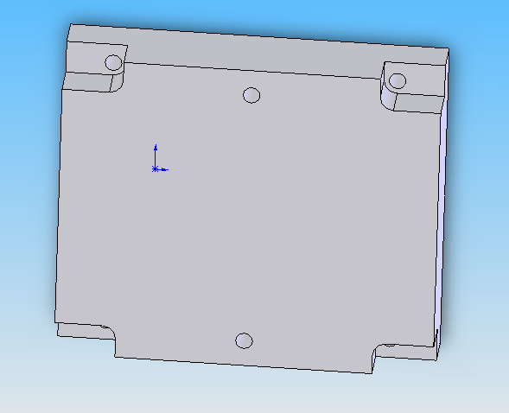

This file is pretty darn close to your mold plates, but not exactly. It’s 6” by 7” by 1.5” and the depths of the corner slots won’t work. You’ll notice that the material remaining is still 0.75” thick which is longer than the threaded length of the ¼-20 bolts we’re using. Also you don’t need to worry about the holes for the mold pins in the middle. You’ll ream those holes when you are making the rest of you mold cuts. They don’t need to be apart of this file.

In order to machine this part we’re going to perform 4 operations:
- Center drill the four holes
- Drill the four holes
- Mill the four corner slots

Then we’re going to remember to add a face mill (which we’ll move to the top)
4. Face the top of the plate (to make sure it’s perfectly flat and smooth)
In CamWorks there are many steps necessary to do this:
- Setup the machine and tool crib
- Setup the material
- Create a mill part setup
- Create the machinable features
- Generate and modify the operations plan
- Generate and simulate the toolpaths
- Go back and add the face mill
- Optimize the toolpaths and times

1. Setup the machine and tool crib
For this example we’ll use the older green CNC machine called the Milltronic Partner. Go into the machine edit definition and instead of using MilltronicsRW12, highlight the Milltronic Partner and hit Select. Notice that the Machine name below changed to Milltronics Partner. Also if you click on the Controller tab the controller is now set for the Milltronics Partner as well.

For this milling process we know what tools we want to use so we’ll add them to the tool crib now instead of letting CamWorks pick them for us. First we’ll need to add a Center Drill. Click on add and choose type Center Drill. No need to put in any diameter filters, just hit ok. There are about thirty different center drills, but a fairly standard one is a “#3 by 60 Deg.” It’s got a 0.25” body diameter and a 0.109” drill diameter, so it can be used effectively any hole between like 0.15” to 0.6”. We have many around the shop. After it has been added to the toolcrib, next add a 5/16th drill. It should be called a “DLS-5/16” and has a diameter of 0.3125”. Next we’ll add the end mill for the corner slots. I’m going to use a 0.5” flat end mill, but there is a wide range of cutters that will work. In general the biggest cutters we ever allow you to use are 3/4th of an inch. Ask if it’s okay if you use a ¾ inch even. Big cutters don’t break which means there is a greater chance of breaking the CNC or warping the head. Anyway I added that cutter and now I have 3 tools. Also feel free to make changes in the posting tab as appropriate.

2. Setup the Material
Setting up the material is easy. Just change the material to 6061-T6. No need to make any changes to the bounding box.

3. Create a mill part setup
Now that your machine and stock are ready, add a mill part setup. Just use the top face for the axis and make sure the red arrow points into your part. Also after creating my mill part setup, I like to go ahead and change my machine origin as well. Based on the organization of CamWorks, I think they expect you to do this after you create your features since the origin change is in the Operations tree, but I like to change it before I forget. Anyway click on the operations tree tab, then right click on the Mill Part Setup, Edit definition. In the origin tab, change the origin of the part to have (0,0,0) on the top of the part in the lower, left. It should look like this:

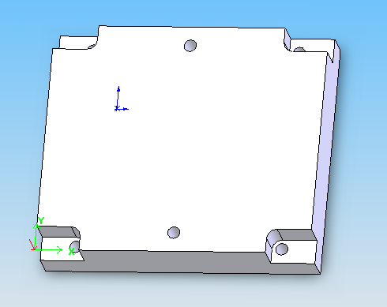

This is a fairly standard location for an origin. Notice that in the grayed out User defined area this should be X: -1.75”, Y: -3.83”, and Z: 0.1”. Don’t worry about the weird numbers that is based on the origin from SolidEdge and has no value here.

4. Create the machinable features
Now that the origin is set, go back to the CamWorks tab and add some 2.5 Axis features. Let’s add a feature of type Hole and choose the edge around the bottom of the four holes (don’t do anything with the two middle holes). I’m sure there is an option you could change to use the top of the hole, but the easiest method is to make your selected edge be either the top or the bottom of a feature. It’s probably easiest to change the drawing to a wireframe to select the bottom edge of the hole. Select the Multiple option instead of single then you can create all four holes in a single feature. If you make a mistake that’s no problem, just delete the inadvertently selected edge from the list. When you have all four edges selected it should say Edge <1> through Edge<4> in the list. Click on the next button and make the end condition “Upto Stock” and reverse the direction. Also since this is a through hole go ahead and select the Through checkbox. Through is an interesting checkbox because it will override other depth limitations. Be careful with it. Since it’s a through hole don’t leave your parallels in the machine when you cut. There is a chance you’ll be drilling your parallels after you go through. Click finish.
Next we’ll add the four corner slots. CamWorks will put you back into the 2.5 Axis Wizard and this time you’ll need to add a feature of type Corner Slot. Again make sure the Multiple button is selected and click on the four lowered horizontal faces around the holes. It should say Face <1> through Face<4> in the list. Click Next and set the end condition type to Upto Face and click on the top face of the part. The regions you’ve selected should look like this:

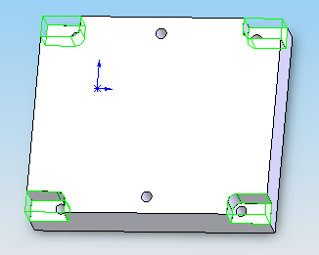

5. Generate and modify the operations plan
Now that we’ve got the hole and corner slot features we need to generate the operations plan. Just for the sake of variety instead of right clicking on the Mill Part Setup let’s us the CamWorks toolbar.

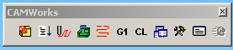

The second icon is used to generate a operation plans for your selected operations. Move your mouse over each icon to see what each does. Personally I like to use the right click method instead of the CamWorks toolbar. Don’t know why.

Anyway this should create 4 operations: A center drill, a drill, a rough mill, and a finish mill. I’m guessing that the Drill operation has a warning and is using a 0.31” drill bit instead of the 0.3125” drill bit. My guess is that since this file got imported in from SolidEdge and the digits in the decimal got truncated to only 0.31.” No worries.

Right click on the Drill operation, edit definition and go into the Tool Crib tab. Select the 5/16th drill bit that you added earlier. If you go to the right of the table the last column has a comment about the tools. Should be obvious which one you want. Highlight the 5/16th drill bit and hit Select. Say sí to changing the holder (wish that just defaulted to yes so I didn’t always have to say yes). Click ok. Then it’s funny even though you just changed the tool you still need to clear the error message via right clicking on the operation, what’s wrong, clear. Really it should’ve cleared the warning when you switched the tool. Oh well.

Anyway let’s start modifying the operation plans. The order in the list should be center drill, drill, rough mill, finish mill. If it is not, drag and drop the operations into that order. Right click on the center drill, edit definition. Under the NC tab Link to the F/S library make the rapid and clearance plane 0.1 in from the top of stock. Then under the features tab see if the depth is 0.23in and the diameter created is 0.25 in. Center drills sometimes go nuts. If those numbers don’t appear, click on the override machining depth button (red arrows with an M). Type 0.25 for the Dia. Created and click Set Diameter. This should make the depth get set to 0.23 in. It’s really nice that CamWorks knows every little detail about the exact shape of the cutter. Click ok.

Next edit the definition of the drilling pattern. Under the Drill hole parameters change the type to Pecking and set the peck amt to around 0.4” ish. Under the NC tab Link to the F/S Library and set the rapid and clearance planes to 0.1” from the top of stock. Under the Feature Options tab notice that this drilling pattern is going 1.64in. This means there is a chance of drilling into the parallels unless you pull them out! I don’t like so much as a scratch on my parallels.

Next edit the definition for the rough mill. Some important options:

Roughing
Stepover: 30% to 40%
Bottom allowance: 0 in
First cut amount: 0.03 in
(for some reason mine defaulted to like .2”)
Max cut amount: 0.03 in

NC tab
Link to the F/S library
Set the rapid and clearance planes to 0.1” above top of stock
CNC compensation Off

Speed and feed sidenote:
For the F/S my numbers went to XY feedrate 9 ipm and Speed 2500rpm. Does that make sense? Well we know Aluminum has a CS of around 300 and speed equation is

$\text{Speed}=\frac{\text{CS}×4}{d}$. (1)

So the speed should be 300*4/0.5 = 2400rpm. 2500 rpm looks GREAT! Note that it probably picked 2500 because we’re using the Milltronic Partner and 2500 rpm is the top speed. That’s fine.

The chipload for a ½ in cutter in aluminum is a maximum of about 0.002 and

$\text{Feed}=\text{Chipload}×n×\text{SpindleSpeed}$ (2)

So the feed should be 0.002 times 2 times 2500 = 10 ipm. So 9 ipm looks GREAT too! Tools are interesting in that running them at their optimum performance works just fine. No reason to run a tool at half it’s optimum performance level. This conservative approach doesn’t really help the tool life much at all. If you know what a cutter can do, be at that level. Running cutters beyond that level is trouble though. These equations assume you’ve got a sharp cutter, an appropriate depth of cut and stepover, and a good coolant system that clears chips.

Next edit the definition of the finish mill. Ideally the finish mill is a single pass at the final depth. It can be a single pass at depth only if it is removing very little material 0.010” or less. In the Finish tab make the first and max cut amounts 0.75”. Finish passes are totally different than roughing passes. They shouldn’t be removing much material, just making the cut surface look pretty. It’s up to you to make sure the tool is definitely not cutting more than 0.010” anywhere. I assure you it can happen. Easily. Look carefully (especially at the simulation later) to see if the finish pass is getting into areas that haven’t been cut well yet. If you’re not sure, feel free to make finishing passes at more incremental depths if needed. It’s won’t look as uniformly pretty, but it’s safer for the cutter. Under the NC tab link to the F/S library (it maxed out the spindle speed again at 2500). Put the planes to 0.1” and turn compensation off. Click ok.

6. Generate and simulate the toolpaths
Now that the operations are all set, generate the toolpaths. Feel free to use the right click method or the toolbar. Then simulate the toolpaths. So it looks like you’re all set. Then all of a sudden you decide “You know what would make this mold look better? If the top were flat and smooth! Let’s add a face mill before we drill the holes!”

7. Go back and add the face mill
So it’s no problem doing things out of order and then changing the order of operations. We want to add a face mill so we will. First let’s add our face mill to the toolcrib. Go to the machine, toolcrib, add, then search for type FaceMill (at the bottom) and click ok. There are 6 sizes listed. Our face mill is 3 inches in diameter so select that one and hit okay.

Next we need to add a Face feature. So right click on the mill part setup and change the type to Face Feature. Click on the top surface and then click next. On the End condition select blind and make the depth something big enough to see (ie 0.3” temporarily). Figure out which direction you need to go to be cutting material and click reverse direction if appropriate. The green box should come down and be within your gray mold plate part. Now that you’ve got the correct direction, change the depth to 0.010”. You can see now why we used 0.3” temporarily. It’s hard to see the direction of cut with only 0.010” on there. Click Finish and Done.

Next generate an operation plan. For me it didn’t choose to use the 3 inch face mill, but selected a 5 inch face mill which we don’t have. No worries. Edit the definition of the operation, click on the tool crib tab, and select the 3 inch face mill (say yes to replacing the holder). Clear the warning message. Go back into edit definition and under the facing tab you’ll see some fun numbers like a 70% stepover and a 0.2” cut depth. There numbers are fine. A face mill can actually do that (it’s fun to watch). It’s almost a shame we’re only cutting 0.010”. Under the NC tab, link to library, set planes to 0.1”, click okay.

Next we want to reorder the operations to put the face mill first. Right click on the Mill Part Setup, choose Sort operations…, uncheck the process complete feature checkbox, then under the Sort tab click Apply. You’ll notice that the face mill went to the top because in the “Sort by” window, face milling operations come first. Click ok.

Right click on the face mill operation and generate toolpath. Just for fun click on the face mill operation and notice that it only does 3 passes to face the top of the plate. Then just for fun hold down the shift key and select the finish mill operation. This should show you the blue toolpaths for all the selected operations.

Right click on the Mill Part Setup and play with the Simulate Toolpath… You may need to slow it down some to even see the face mill going first. Also look at the center drill to make sure it looks correct. It should leave a nice countersink that looks like this before the drilling operation starts.



The finished the simulation should look like this:

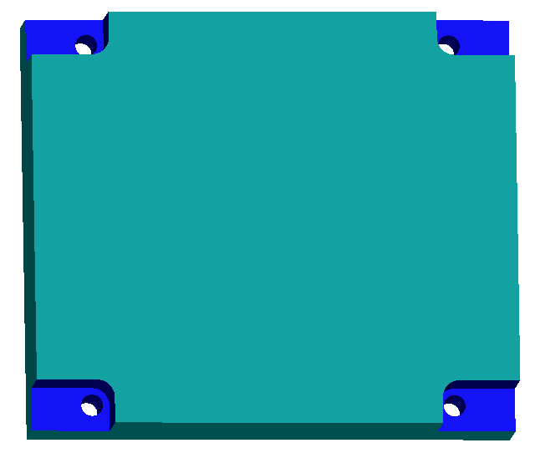

8. Optimize the toolpaths and times
So now it looks like everything is all done. All pretty. So it is done but it could be optimized for time a bit better. Let’s see how long it takes. Right click on Mill Part Setup, then edit definition, and go to the Statistics tab. Mine says 86 minutes. Personally I’m guessing we can do this a little faster than 86 minutes. Let’s see what we can optimize to save time!

So let’s start off by seeing where we’re spending our time. One way to do this is to right click on each operation individually and go to the optimize tab. The face mill for example takes 0.878 minutes.

Another option which has other advantages is to generate Setup Sheets. Right click on Mill Part Setup and choose Generate Setup Sheets. The defaults images, etc. are fine just hit ok and then give it a label like “bottom blank plate.” This will open the ReportDatabase in Microsoft Access. It will show you each tool operation, the tool holder it should be in, the time, the depth, the speed, all sorts of stuff. For example I didn’t think about the fact that the face mill ended up in tool #5 for me (I didn’t delete the unused drill and I added the face mill last). I needed to know to put the face mill in the 5th tool slot if I was using the MilltronicsRW12.

The operation times for me were:
Operation – Face Mill 0.88 minutes
Operation – Center Drill 0.51 minutes
Operation – Drill 1.63 minutes
Operation – Rough Mill 83.13 minutes
Operation – Finish Mill 0.63 minutes
Total time 86 minutes

So can we do anything to speed up the rough mill operation? Let’s go looking. I have the Stepover set to 33%. I’ll use 40%. I have the first cut amt set to 0.030” and the max cut at 0.030” this was a good conservative estimate but we can cut 0.050” with a ½ end mill. Bump those up to 0.050”. Under the NC tab it’d be nice if we could turn the spindle a bit faster to increase the federate, but we’re limited by the Partner max speed of 2500 rpm. We could’ve bumped it up to 3500 rpm and the feedrate up to 14 ipm if we used the MilltronicsRW12. That would still be within the acceptable range for surface cutting speed (CS) and chipload for aluminum. We’ll pretend like someone is working on there and we must use the Milltronic Partner.

If you do a simulation of just the roughing operation you’ll notice that it jumps up to the clearance plane of 0.1” above the top of the stock after every pass. Can we safely change that? Sure. Right click on edit definition and change the clearance plane to 0.1” above the Previous machined depth. That’ll still clear chips since we have an open corner and coolant can hit the tool from the open side. And it’ll save us some travel time up and down. Next what about the Z feedrate? Well look at the simulation from the top. When the tool plunges down the center is cutting air. We can plunge faster than 1.12 ipm in mostly air. Bump the 12.5% up to 40% since we’re plunging with only a small amount of the cutter in the part. The leading feedrate can also be about 50% since it’s coming in from an open air edge. That’ll save us a little time. Okay what have we got now? Regenerate the toolpaths.

49 minutes. We just saved 34 minutes of cutting time. That’s great. I realize that it took us 20 minutes to save 34 minutes but as you get better with machining it really becomes worth the effort to save time in places where you can. Sometimes you can’t do anything at all to speed things up, but for some operations like this you can. The total time is now 53 minutes. The rough milling still takes most of the time, but we’ve done what we can. If we wanted to cut a bit faster we maybe could’ve used a ¾ in end mill if we could find a good and sharp one. Don’t just grab big dull end mills from the other room. That’s hard on the spindle and causes warping with time.

Anyway the next steps are to regenerate the toolpaths, rerun the simulator, post process, verify in FastCam, print up the setup sheet (a good habit for multiple tools), saving the O file to disc, preparing the mill, zeroing the tools, doing a dry run 2 inches off the part, aiming the coolant, re-zeroing, and running this thing. I assure you it gets much easier the second time you do it.

