ME430 Design for Manufacturing

Lecture 05: Bulk Deformation Processes: Extrusion and Rolling

Bulk Deformation:
There are a number of different manufacturing processes which shape material by using pressure and forces to cause the material to flow into new shapes. When the flow causes major changes in thickness, diameter, length, and other major dimensions this is called bulk deformation.

Bulk deformation processes include:

Rolling--reducing the thickness of a long work-piece using compressive forces applied through a set or multiple sets of rollers

Forging--shaping of discrete work-pieces by use of compressive forces applied to pieces placed in stationary dies.

Extrusion--shaping a solid of constant cross-section by squeezing metal through a die.

Drawing -- shaping a solid of constant cross-section by pulling solid metal through a die.
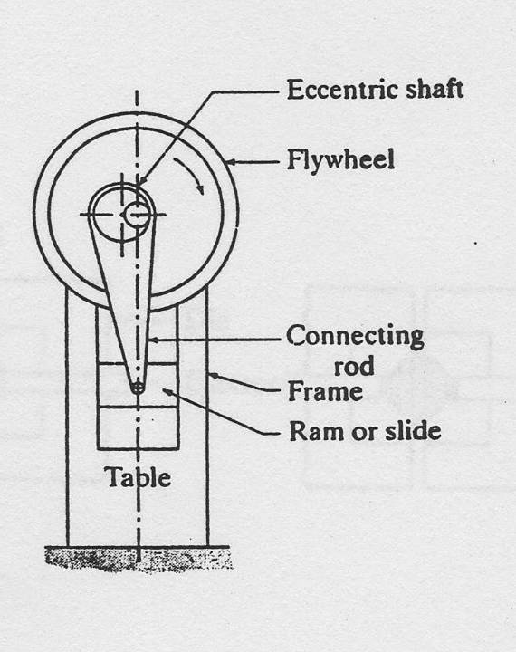
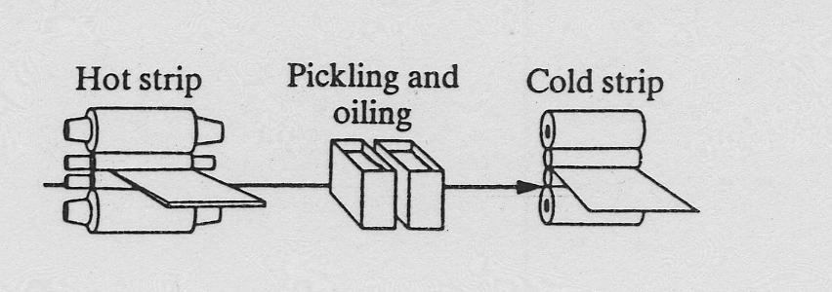
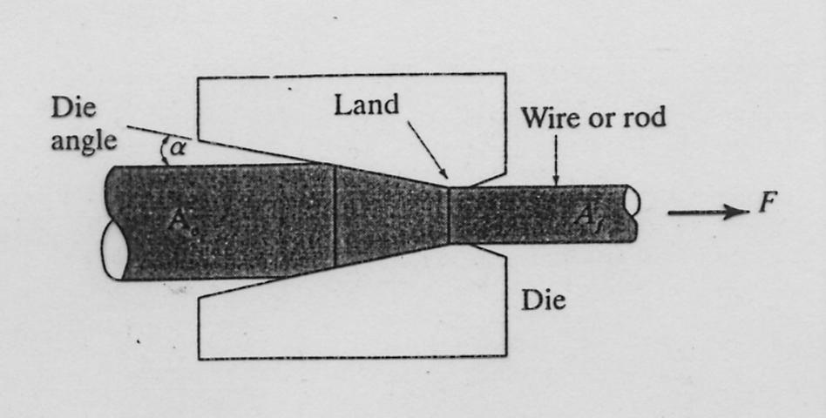
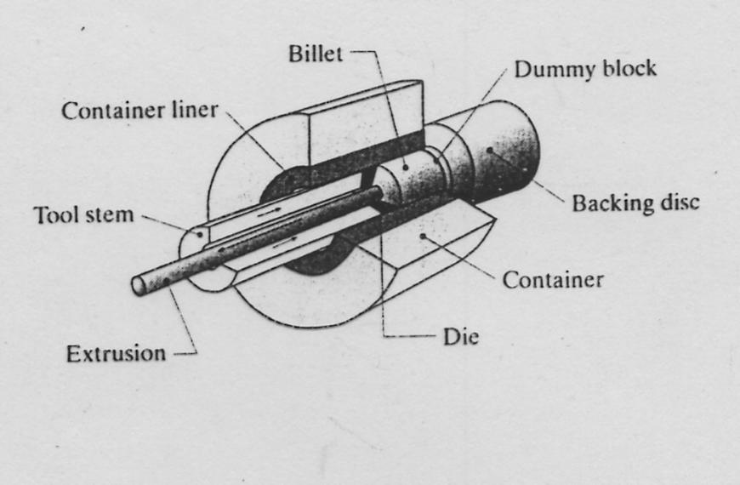

Extrusion:

There are two distinct forms of the extrusion process used:
Hot Extrusion and Cold Extrusion

Hot Extrusion: used to produce long, extended products with a wide variety of constant cross sectional shapes.
-- uses raw material at higher temperatures
-- pressure or force is usually applied horizontally.
-- usually produces parts up to 25 ft long (but in situations can be up to 100 ft)
-- product is then cut into desired lengths and ends are trimmed
-- can produce hollow shapes using special dies or insets
-- cost can be competitive with roll forming
-- moderate to high die and equipment cost
-- low to moderate labor cost
-- low to moderate operator skill
-- commonly used for aluminum, copper, steel, magnesium, and lead.
-- typical products include: railings, tubes, structural shapes, frame materials.

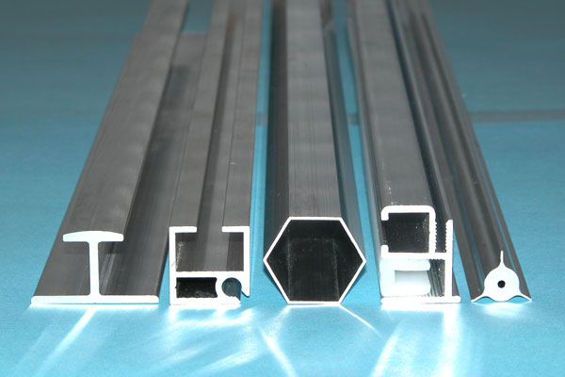

Table 1: Hot Extrusion Temperature Ranges for Various Metals
Metal ºC
Lead | 200-250
Aluminum and Aluminum alloys | 375-475
Copper and Copper alloys | 650-975
Steels | 875-1300
Refractory metals | 975-2200
Extrusion Process:
A round heated billet (raw material ) is placed in the extrusion chamber and a hydraulic ram is used to force the heated billet through the smaller die opening. As the material is forced through the opening, it takes on the constant cross sectional shape of the opening.

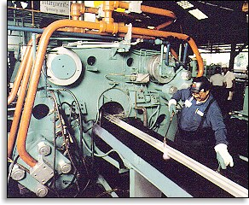
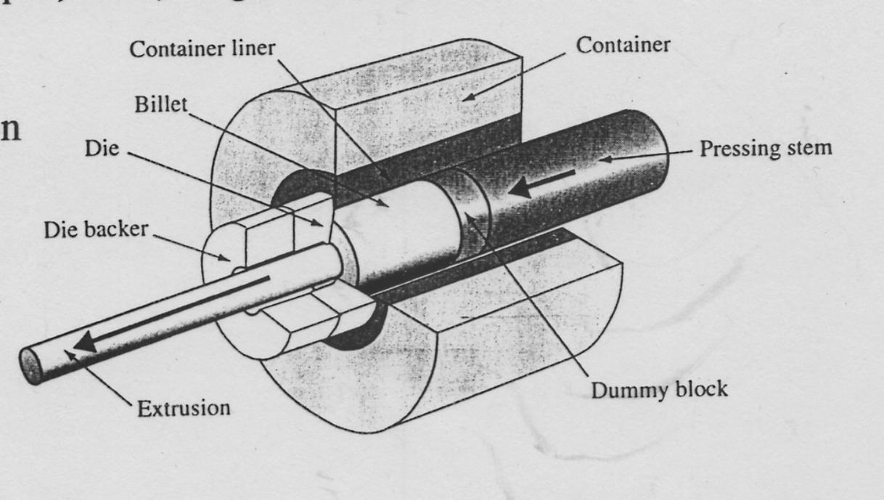
Softer materials such as lead, aluminum, and copper may be extruded without use of lubricants. Harder materials like steel require glass or ceramic lubricants to reduce friction along the sides of the chamber and to reduce the forces on the die.
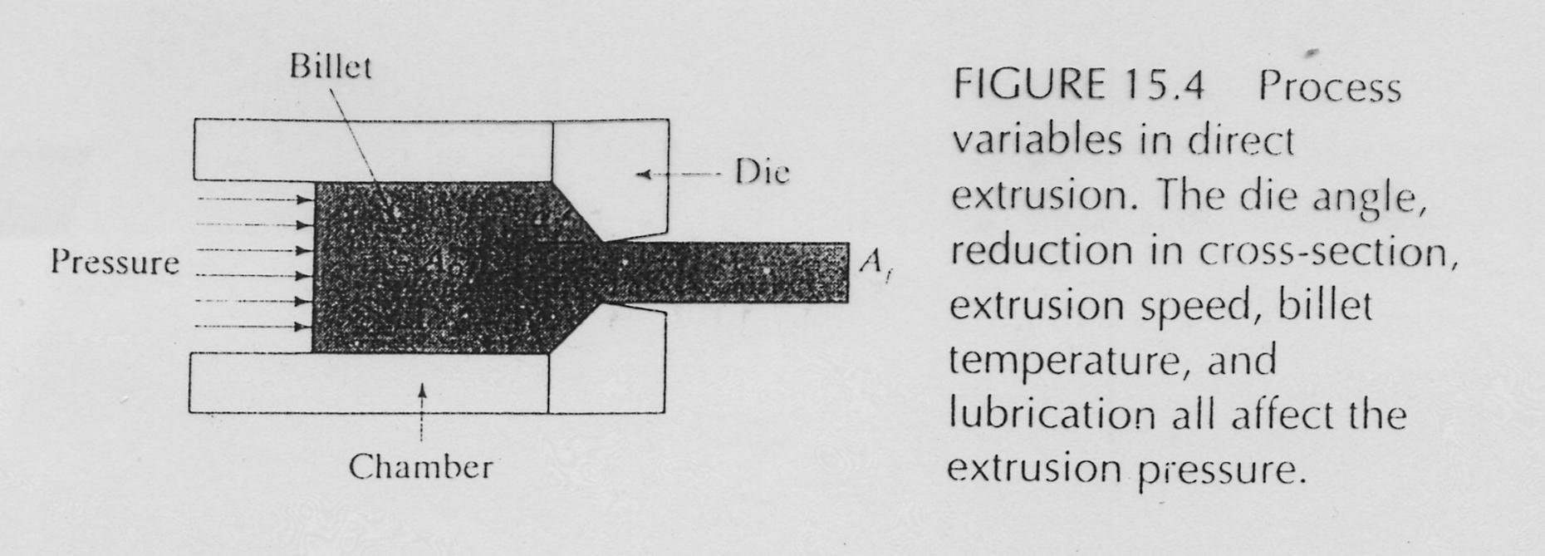
Parameters used to describe the extrusion process:
Circumscribing Circle Diameter (CCD): smallest diameter circle into which the
extruded cross section will fit.

Shape factor: Ratio of the perimeter of the extruded product to its cross-sectional area.
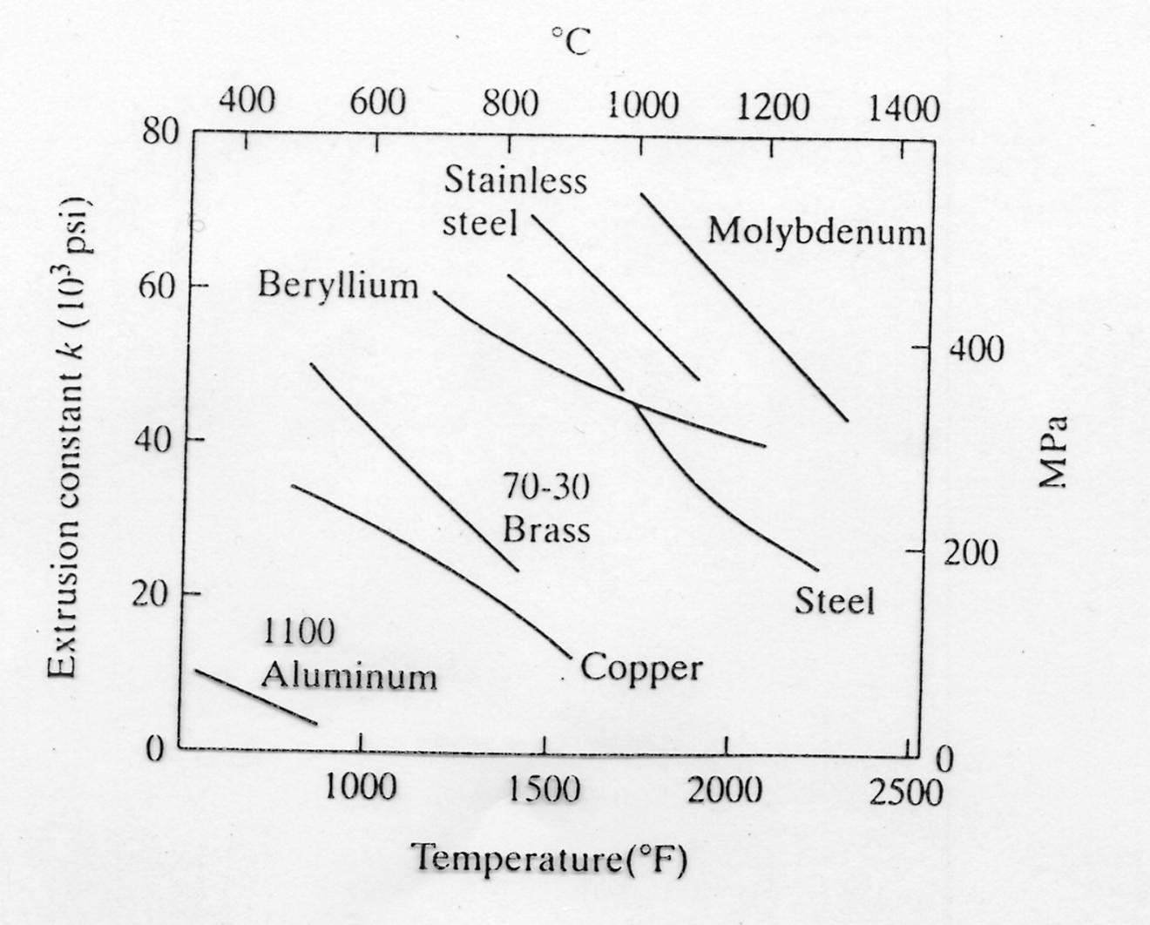
Extrusion Ratio: ratio of cross sectional area of
billet to that of extruded product, A_{o} / A_{f.}
Ratios usually range from 10 to 100 (although
can go as low as 4 and as high as 400).

Extrusion force: is estimated from the formula
F = A_{o} k ln (A_{o} / A_{f})
where k is the extrusion constant. A_{o} and A_{f} are
the billet and extruded product areas respectively.
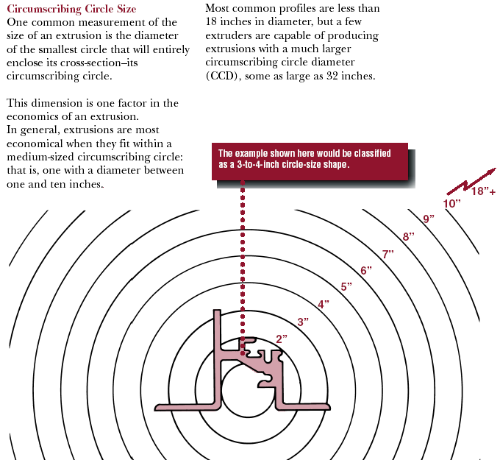
CCD values for Aluminum: 0.25 inch to 40 inches

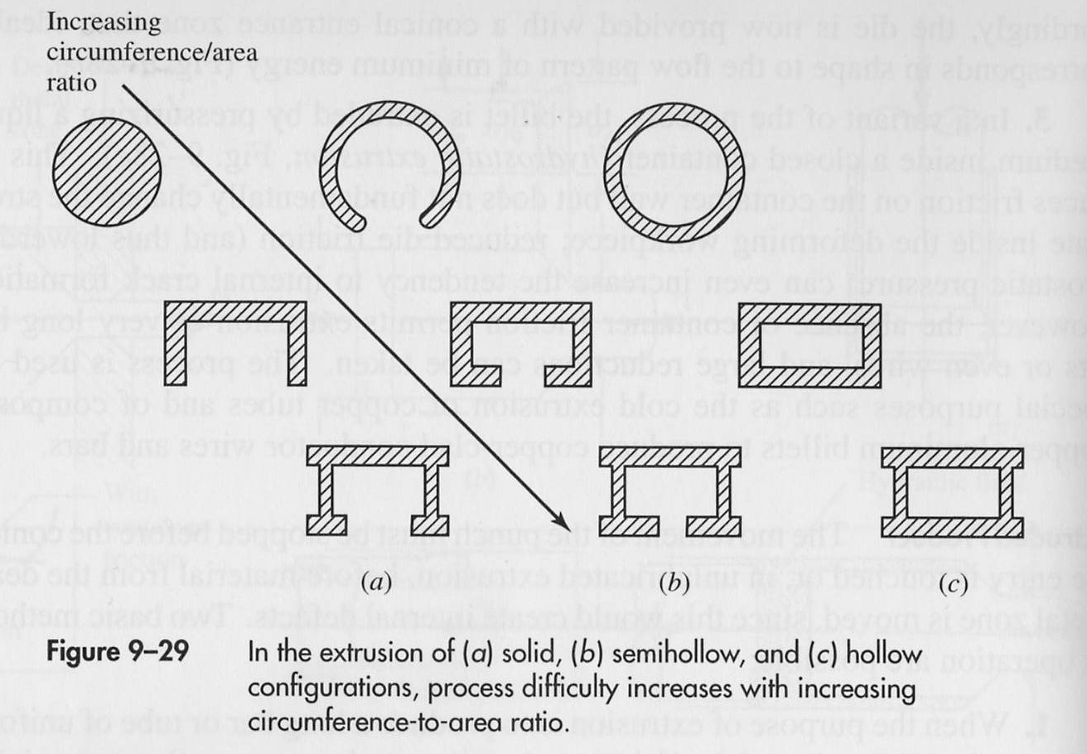
Most extrusion manufacturers have a common core of dies for shapes that they readily produce. Many manufacturers also advertise that they will custom make just about any shape you want, but at a higher cost than custom shapes. The shapes shown below are the core offered by one extrusion manufacturer.
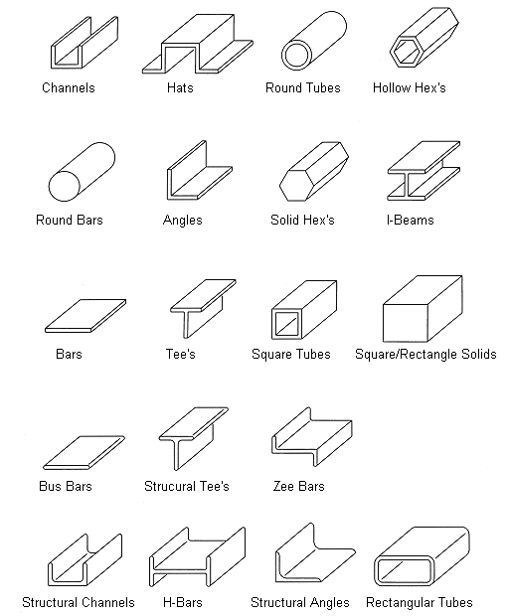

Examples of less standard shapes:
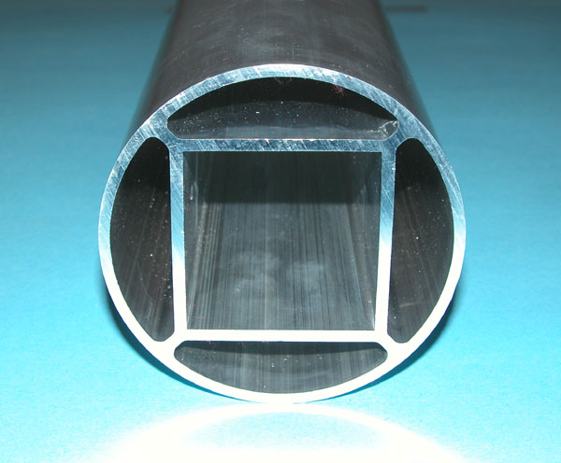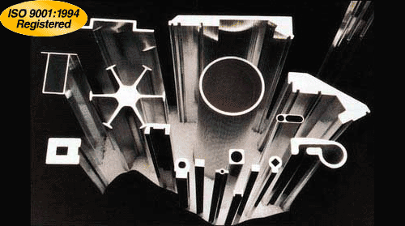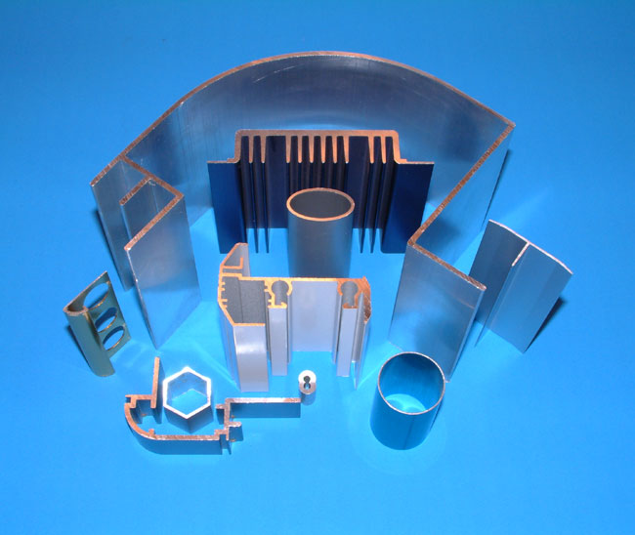
General Design Recommendations:
-- Use standard cross sectional shapes (stock shapes if possible)

-- Limit irregular shapes, sharp corners, and very thin sections.

-- Avoid thin walls sections. They are more difficult to produce and have
limited minimum thickness based on the material used.
Commonly specified minimum wall thicknesses include:
Aluminum 1 mm
Carbon steels 3 mm
Stainless Steel 5 mm

-- Extruded products, especially with small cross sections, require corrective
straightening and twisting which can be compensated for by adding
ridges and ribs to the design.

-- Use as large an internal and external radius as possible to reduce tool
wear, warping, and surface irregularities. Remember sharp corners
produce higher forces, material flow problems, and stress concentration.

-- Softer materials are more forgiving when requiring sharp or irregular features

-- Balance the design (make symmetrical if possible). Symmetrical sections
are preferred over nonsymmetrical sections.

-- Add ribs to act as stiffeners if flatness of a surface is important

-- Avoid extreme changes in the thickness of the section.

-- Holes (especially nonsymmetrical holes) in steels and other lubricated
materials and less easily extruded materials should generally be avoided.

-- Limit the ratio of length to thickness of the cross section.
for steel: L/T < 14:1
for magnesium: L/T < 20:1

Examples:
Poor Extrusion Features Good Extrusion Features
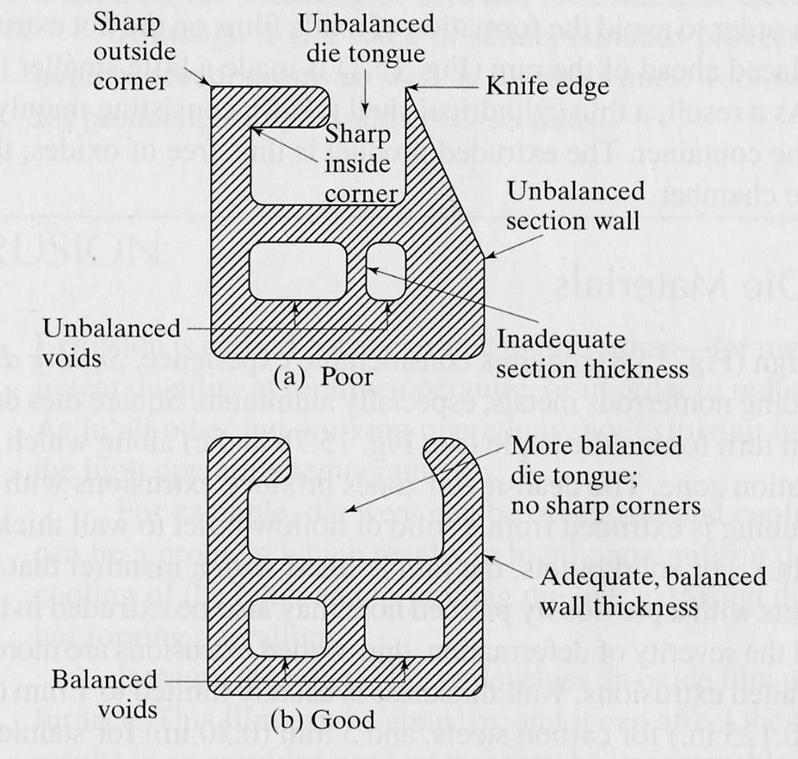
More Extrusion Design Examples:
Poor Better Why?

Poor Better Why?
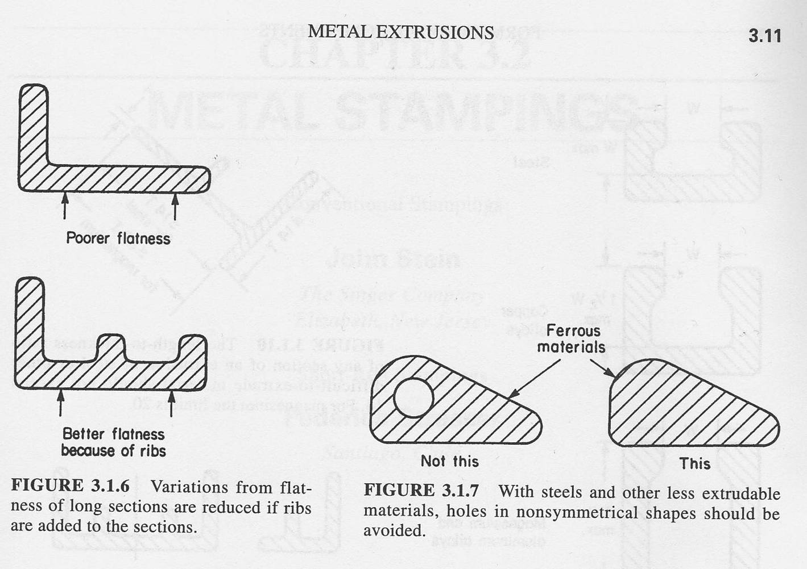

Poor Better Why?

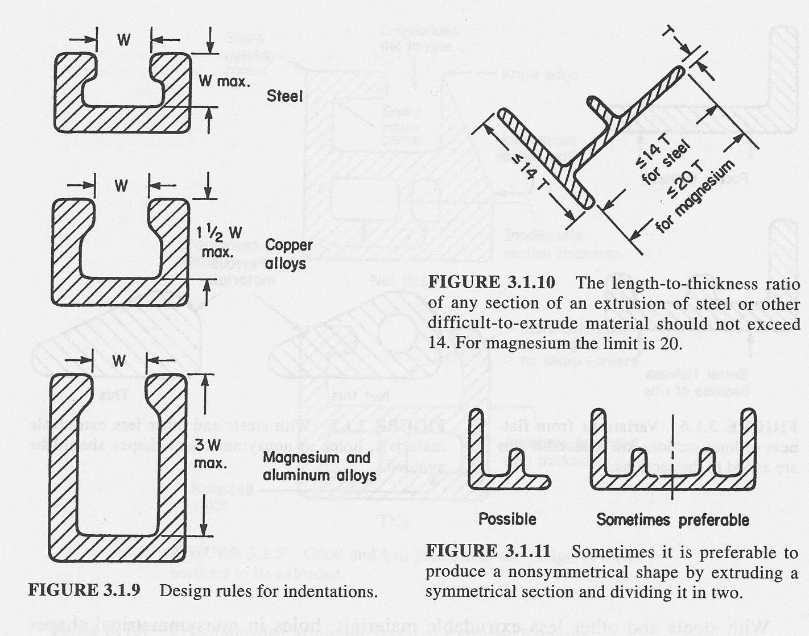
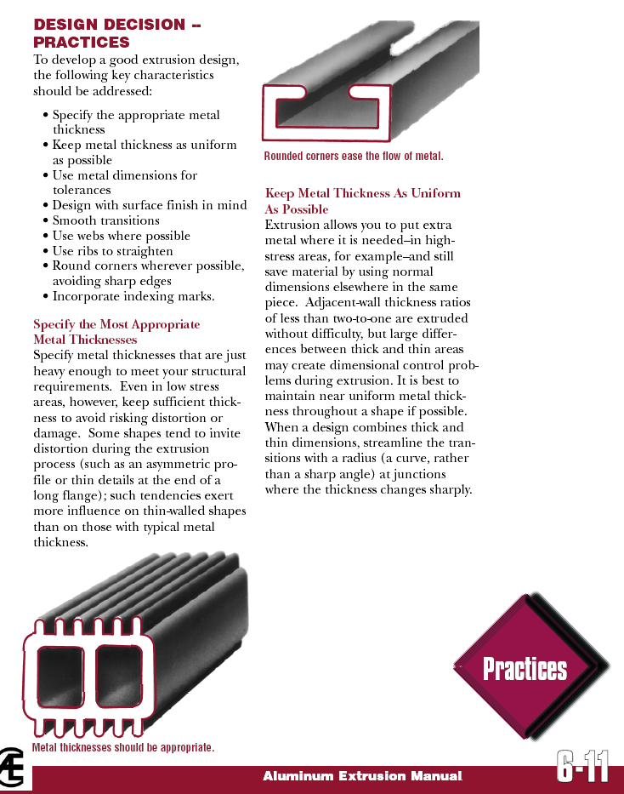

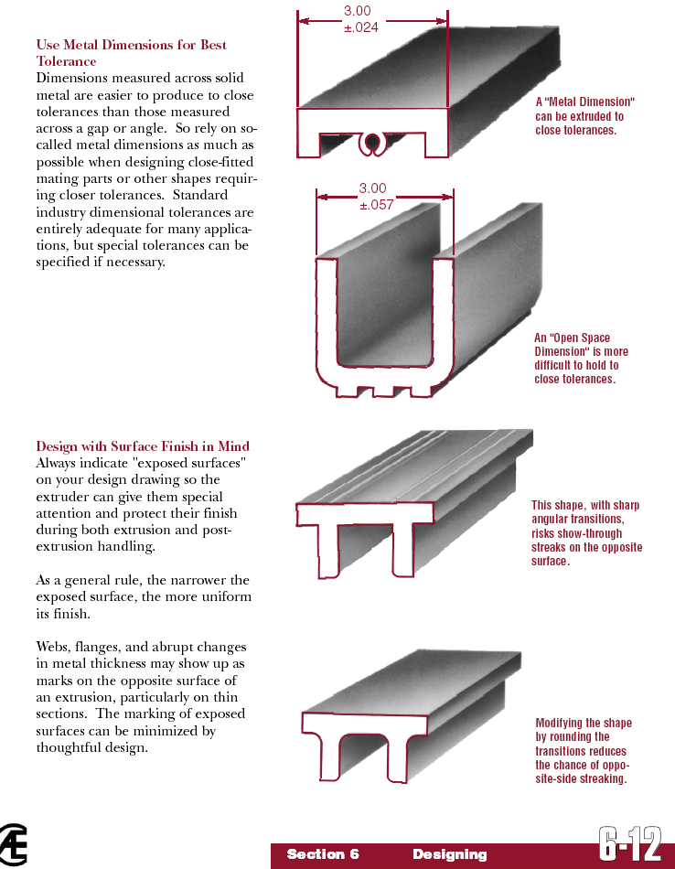

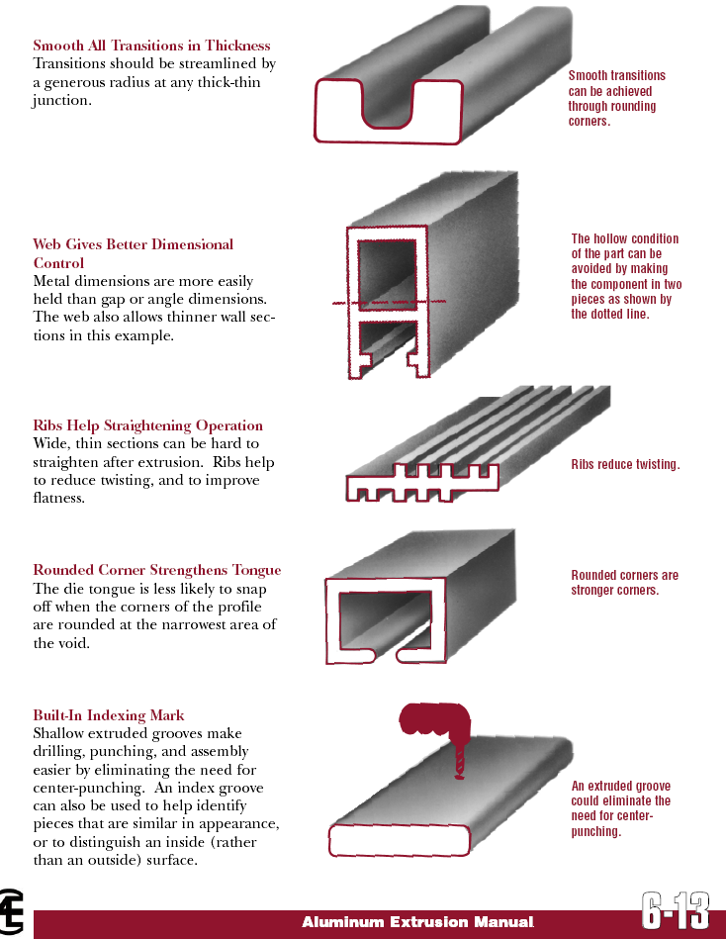

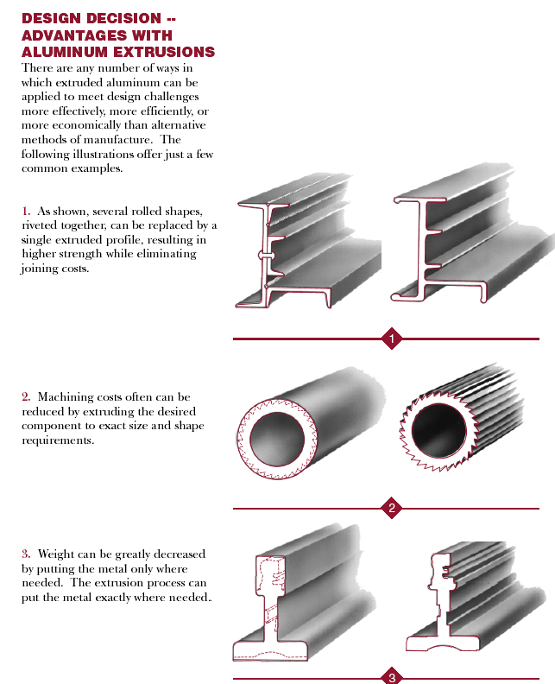

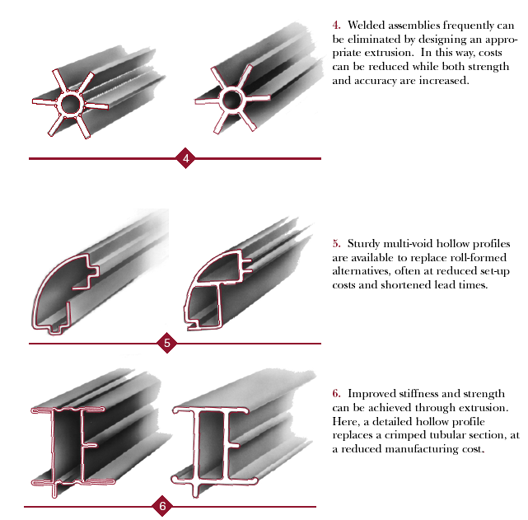

How internal cavities are made:
--porthole die -- spider dies -- bridge die
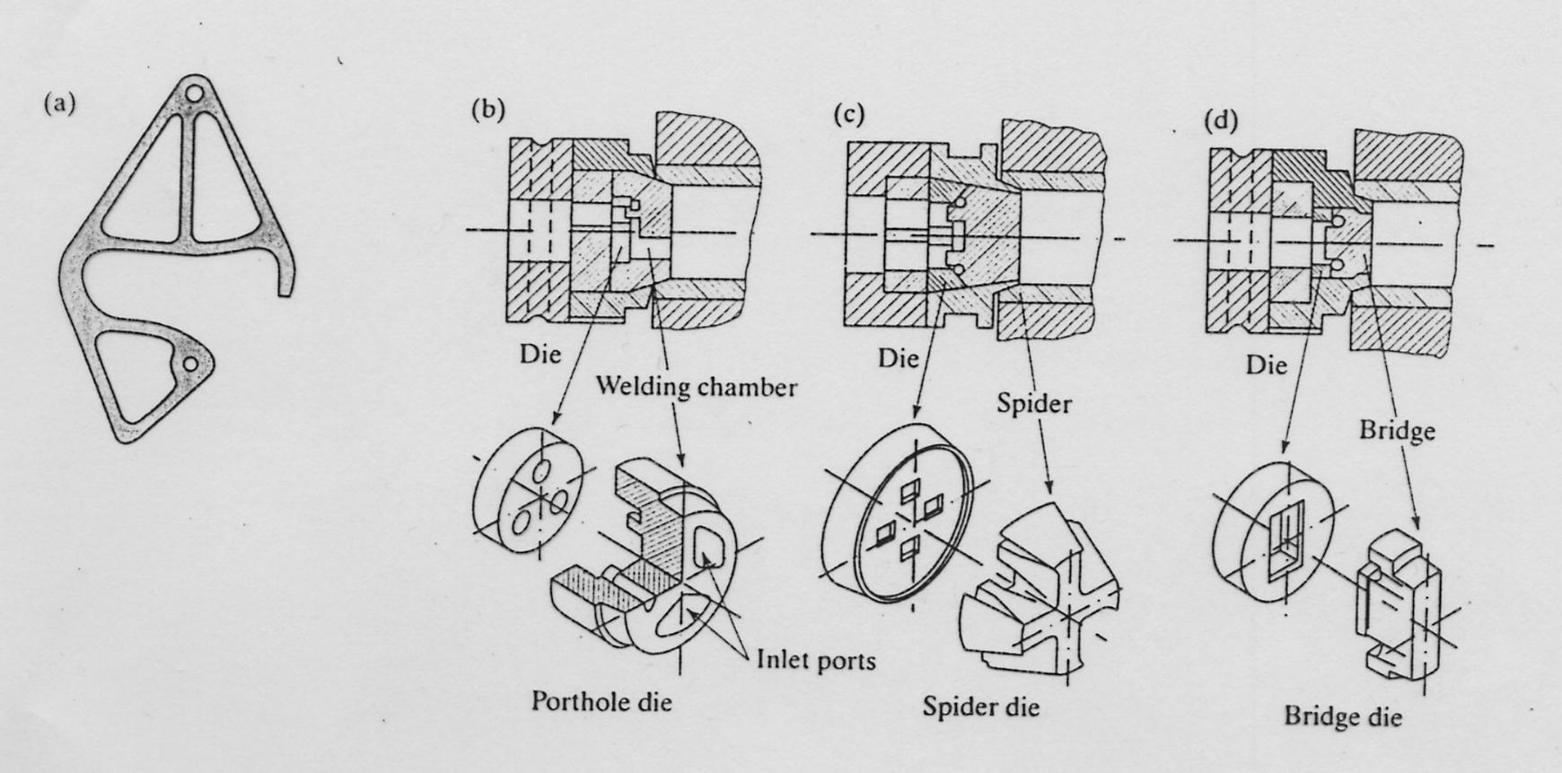

Dimensional factors and tolerances of the extruded parts:

from Bralla Table 3.1.2
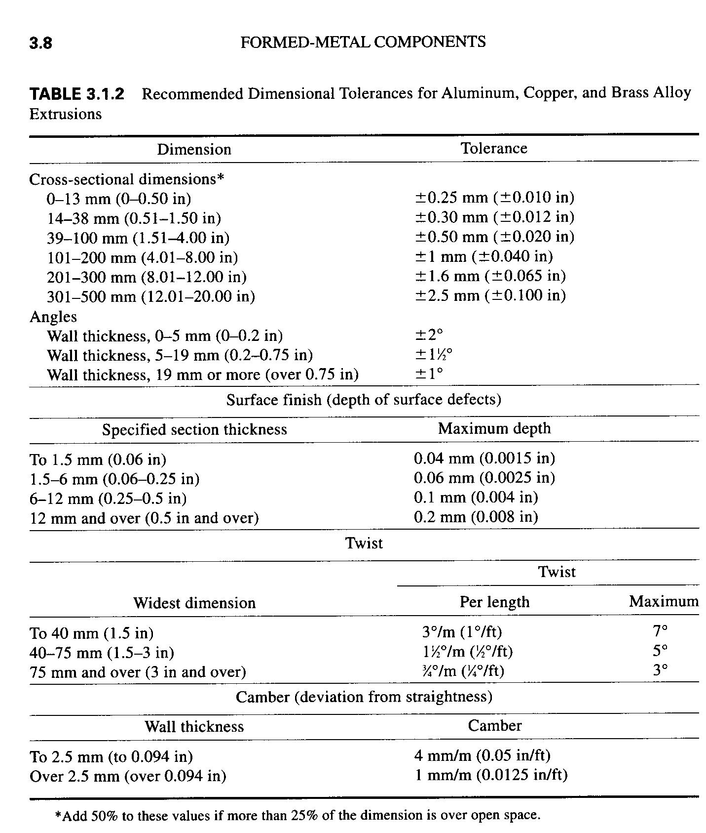

Cold Extrusion:
Cold or Impact Extrusion is used to produce shorter discrete finished parts where the residue of the billet becomes part of the finished part.
-- uses raw material (billets or slugs) at temperatures usually above room temperature.
-- material undergoes work hardening during the process
-- requires more lubrication
-- used to create a single piece at a time.
-- usually completed with a vertically applied load
-- commonly used for aluminum, copper, lead, tin, magnesium, zinc, and steel.

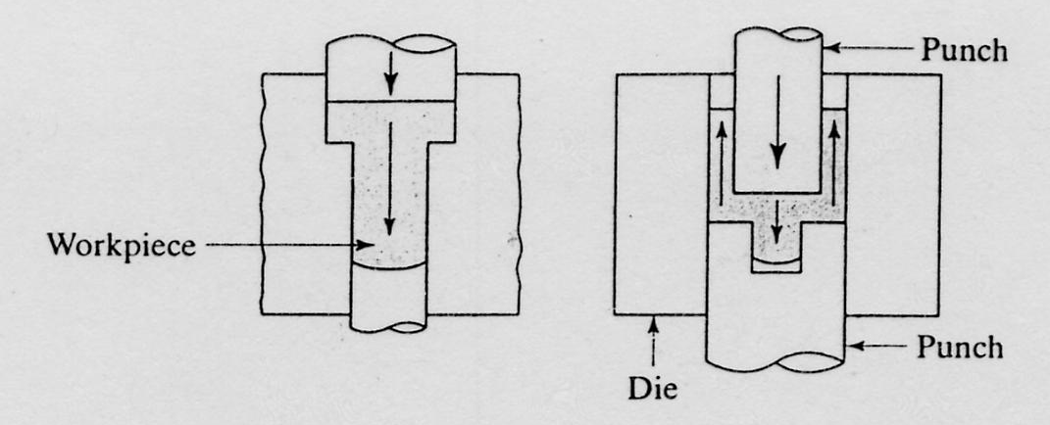
Advantages of Cold Extrusion:
-- improved mechanical properties
-- good control of dimensional tolerances
-- improved surface finishing
-- elimination of heating requirements
-- medium to high initial cost
-- competitive production rates
-- may have a variably shaped cross section

Disadvantages of Cold Extrusion:
-- very high stresses
-- extremely resistant and tough dies and punches required
-- quality, surface finish, and size of slug is important
-- lubrication is even more critical

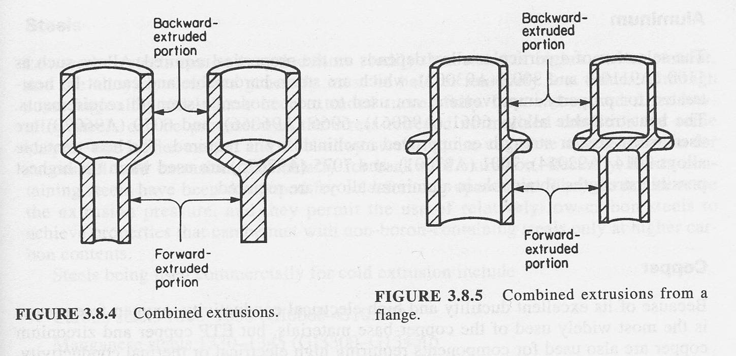
Typical characteristics of a part that might be made by Cold or Impact Extrusion:
-- part length is greater than 2 or 3 times the diameter
-- part is hollow with one end closed or partially closed
-- part would require considerable machining if made another way.
-- the base must be thicker than the sidewalls
-- zero draft is desired in the sidewalls
-- redesign will permit use of a one-piece part instead of an assembly
-- large quantity production is planned.
-- part has symmetry

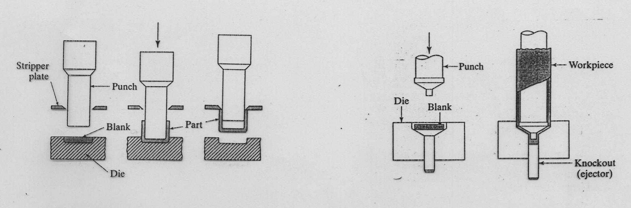

Design Considerations:
-- make part symmetrical about long axis
-- bottom of part should have greater or equal thickness to side walls
-- bottom should be tapered toward the center.
-- limit height of external ribs to less than 2 times the wall thickness
of internal ribs to less than 3 time the wall thickness
-- use rounded exterior corners; use relatively sharp inside corners
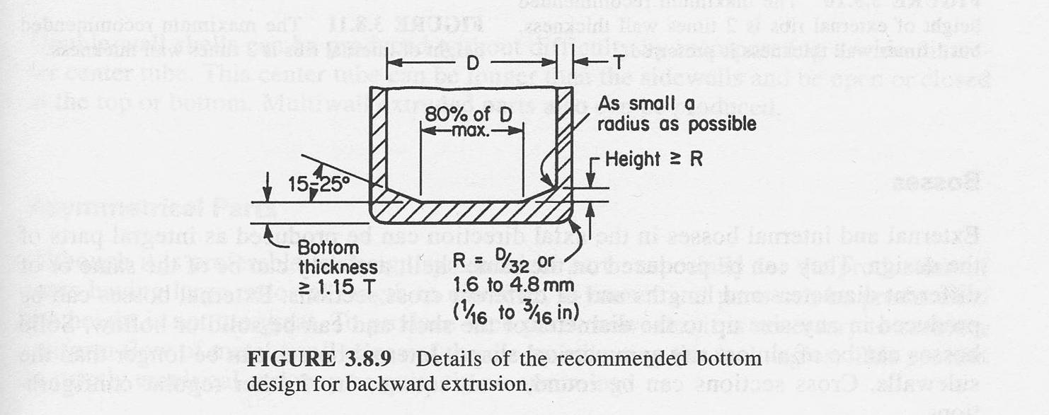

Drawing:

Drawing is a process which pulls metal through a die to reduce or change the cross-sectional shape.
-- used for production of long rod and wire
-- used for round or a variety of cross-sections
-- smaller cross-sections than extrusions
-- lubrication is required
-- good surface finish
-- low to moderate die, equipment, and labor costs
-- low to moderate operator skill required.
-- work hardens the material

Reductions in cross section by drawing range from near 0 to 45% per pass. Thin wires are usually drawn at 15% to 25%... Thicker sizes at 20% to 45%.
Reductions of more than 45% result in lubricants breaking down and poor surface finishes.

Annealing may be necessary between passes due to work hardening of materials.

Drawing Equipment:

Draw bench:
--uses a single die
-- used for drawing straight rods and tubes (up to 100 ft)

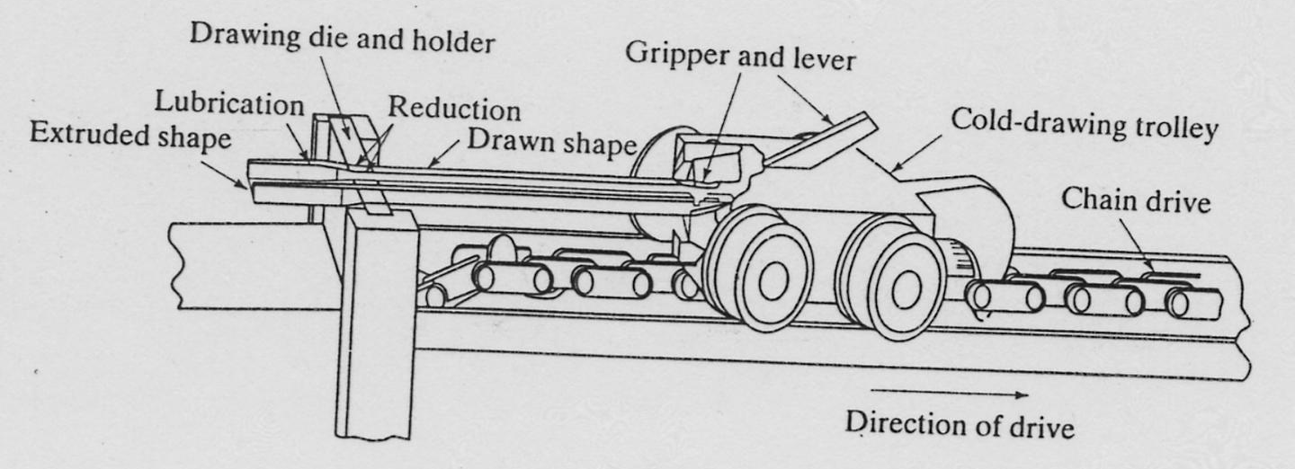

Rotating drums:
-- uses multiple dies
-- used for very long rod and wire and smaller cross sections.
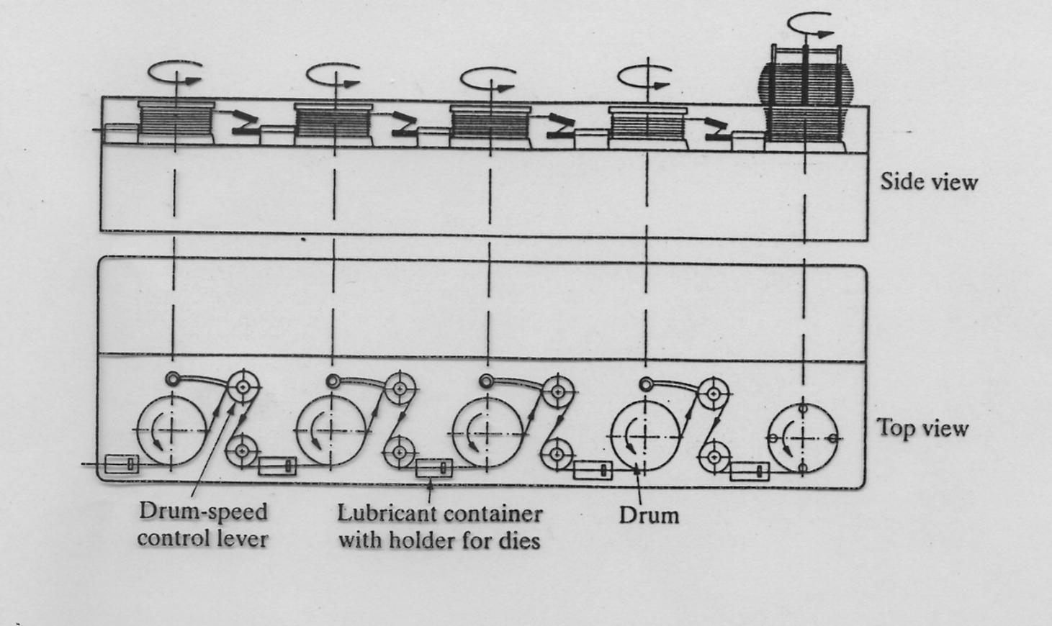

Rolling:

Rolling is the process of reducing the thickness of a long workpiece by compressive force applied through a set of rolls.

--used to produce flat plates, sheets and foil in long lengths, at high speeds and with good
surface finish in process called flat rolling.
plates: rolled materials have a thickness greater than 6 mm and used for
structural applications.
sheets: generally less than 6 mm thick supplied in either flat or coil form.
foil: extremely thin sheets of metal less than 1/100 of a mm thick
-- also used to produce structural shapes such as I-beams, Rails, and Channel in processs
called shape rolling.
-- high capital investment cost
-- low to moderate labor cost
-- moderate operator skill required

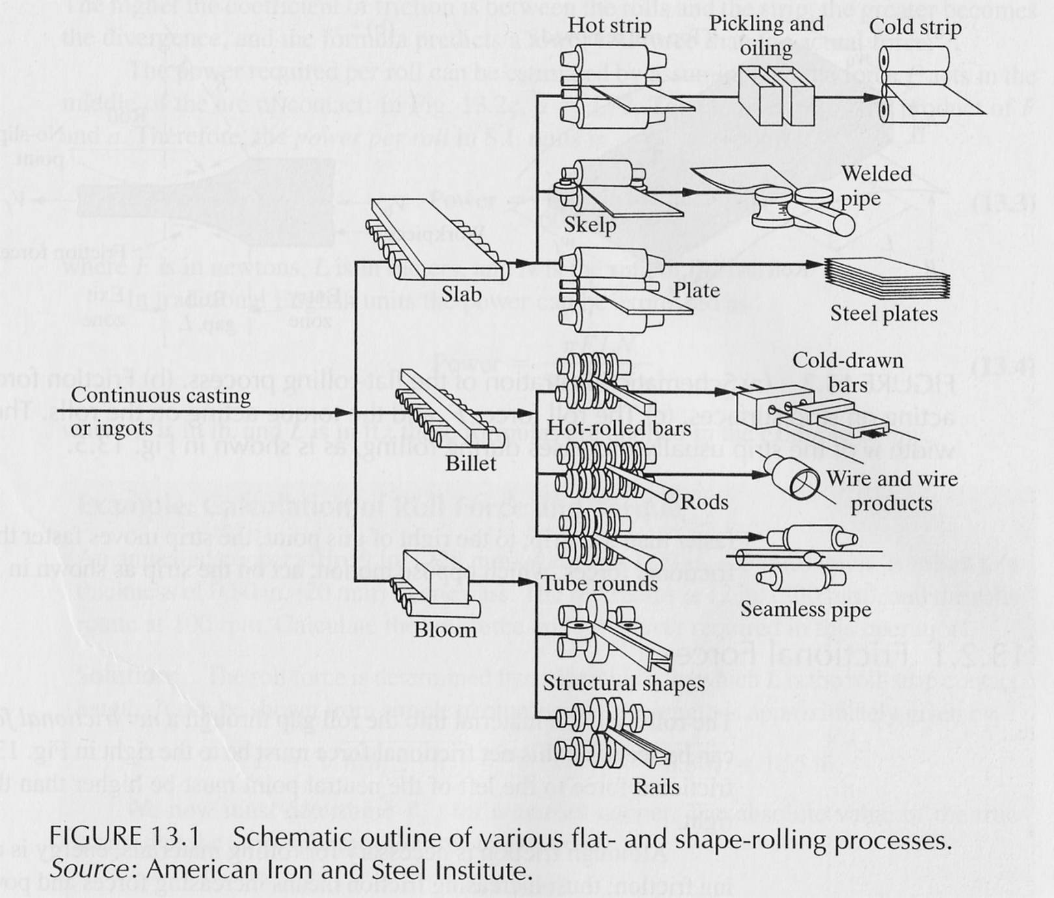

Hot Rolling: rolling that occurs at high temperatures.
-- used to break down cast ingot and also used in the continuous casting of metal.
-- produces finer grains and enhanced ductility
-- closes up internal defects and reduces porosity.

Cold Rolling: rolling that is done at room temperature.
-- produce sheets and strips with good surface finish
-- more accurate dimensional tolerances
-- stronger material, due to strain hardening.
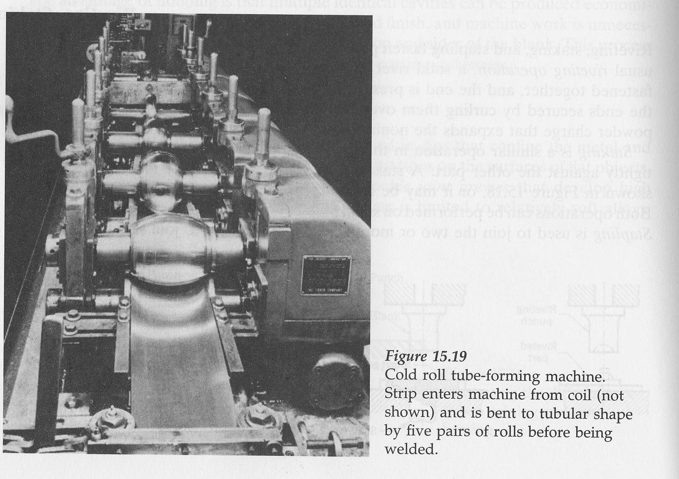
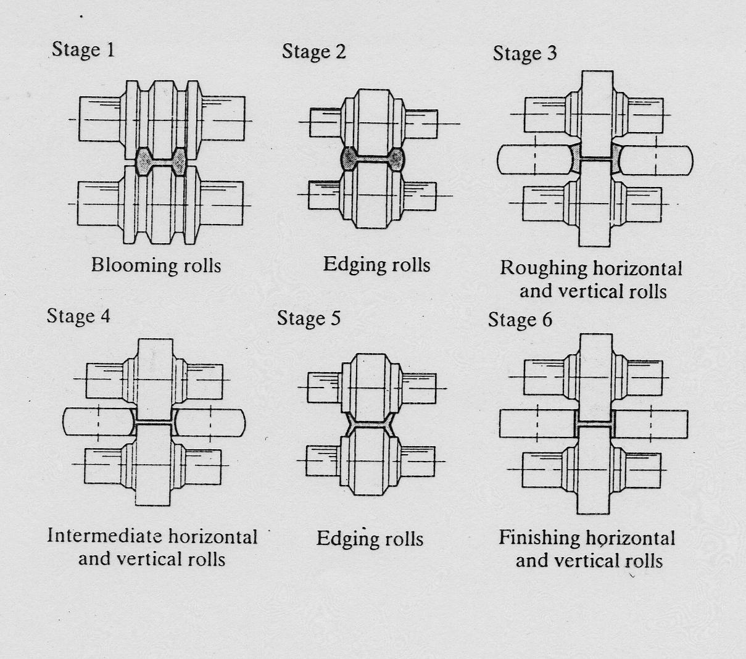

Ring Rolling: used to produce a ring of
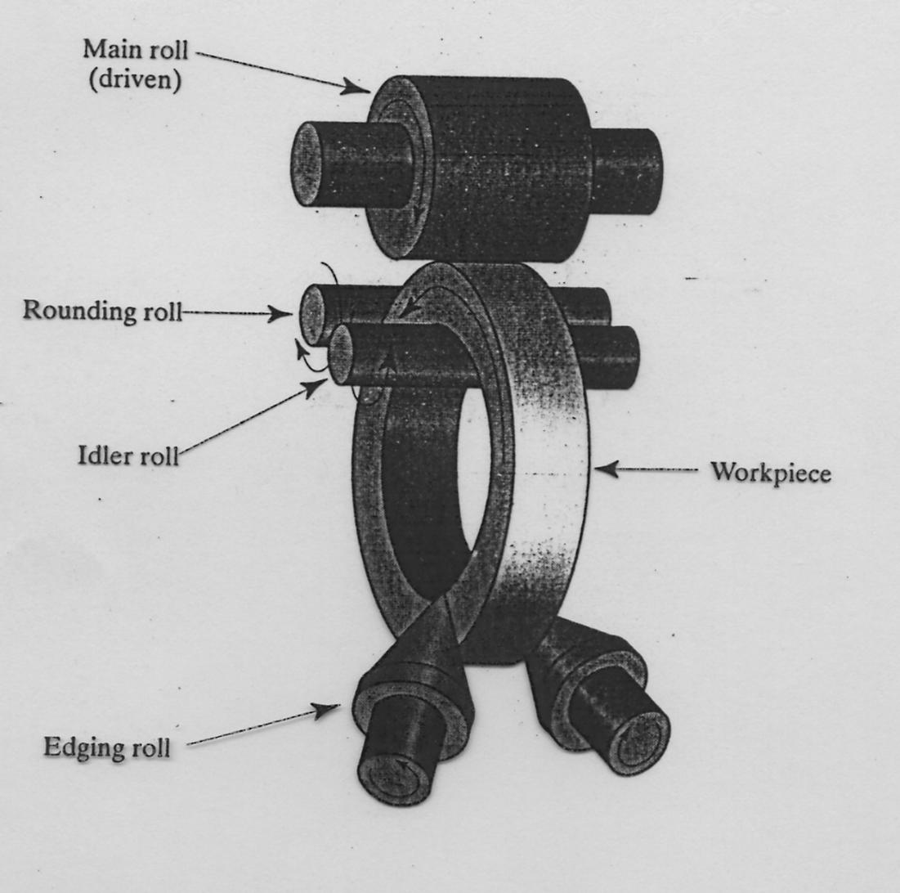
desired diameter and cross sectional shape.

Thread Rolling: a cold forming process used to make straight or tapered threads on round rods.
-- doesn't produce any metal scrap
-- strain hardens the threads in the process
-- sets up compressive residual surface stresses (resistant to fatigue)
-- produces smooth surface finish
-- better grain structure of threaded parts, than produced by cutting

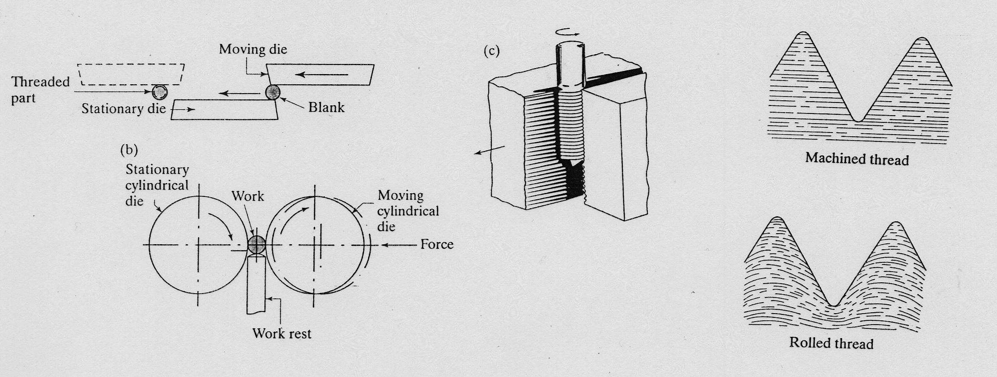
Seamless Tube Production: produces a seamless thick walled tube using rotatry tube piercing.
-- center-line crack is set up by rotating, radial pressure
-- a mandrel is used to expand the hole and size the inner liner as the slightly skewed roller draw the part forward.


