Review Problems - Final Exam

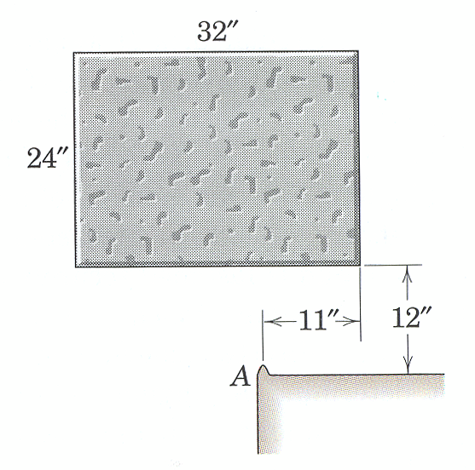
4. The uniform concrete block, which weighs 171 lb and falls from rest in the horizontal position shown, strikes the fixed corner A and pivots around it with no rebound. Calculate the angular velocity of the block immediately after it hits the corner and the percentage loss n of energy due to the impact.
(taken from Dynamics by Meriam and Kraige, Fourth Edition)

ans: $\bar{ω}=1\text{.}\text{593} \text{rad}/s \text{CCW}, n=\text{91}\text{.}7 \text{\%}$

Strategy: COE(FT) process 1 to 2
COAM, COLM (FT) process 2-3
Calculate KE at states 2 and 3

process 1-2

Kinetics:
COE(FT)
${ΔE}_{\text{sys}}=W ⇒ \left(E_{K2}+E_{G2}\right)−\left(E_{K1}+E_{G1}\right)=0$
$\begin{matrix}E_{K1}=0 & E_{K2}=\frac{1}{2}{\text{mv}}_{G}^{2} \\ E_{G1}=0 & E_{G2}=\text{mgh}\end{matrix}$
Solving
$v_{G}=\sqrt{2\text{gh}}=8\text{.}\text{02}\text{ft}/s$

process 2-3
unk eqs
v’_{Gx} 1
v’_{Gy} 2
F_{x}Δt 3
F_{y}Δt 4
ω’ 5
I_{G} 6

Kinetics:
COLM(FT)
x-dir: $−mv_{G_{x}}^{'}=F_{x}Δt$ (1)
y-dir: $−mv_{G_{y}}^{'}+{\text{mv}}_{G_{y}}=F_{y}Δt$ (2)
What assumptions have been made about the weight as an impulsive force?

COAM(FT) at G
$I_{G}ω^{'}=F_{x}Δt\left(\frac{\text{12}}{\text{12}}\right)+F_{y}Δt\left(\frac{\text{11}}{\text{12}}\right)$ (3)

Kinematics:
${\bar{v}}_{G}^{'}={\bar{v}}_{O}^{'}+{\bar{ω}}^{'}×{\bar{r}}_{G/O}$
Expanding and equating components knowing that the velocity at the point of contact is zero
$\begin{matrix}\hat{i}: & v_{G_{x}}^{'}=−ω^{'}r_{{G/O}_{y}} \\ \hat{j}: & v_{G_{y}}^{'}=ω^{'}r_{{G/O}_{x}}\end{matrix}$ (4,5)
Constraints and Geometry:
${\bar{r}}_{G/O}=−\frac{5}{\text{12}}\hat{i}+\frac{\text{12}}{\text{12}}\hat{j} ⇒ r_{{G/O}_{x}}=−\frac{5}{\text{12}}, r_{{G/O}_{y}}=\frac{\text{12}}{\text{12}}$
Other:
$I_{G}=\frac{1}{\text{12}}m\left(h^{2}+w^{2}\right)$ (6)
Solving:
$ω^{'}=1\text{.}\text{59}\text{rad}/s, v_{G_{x}}^{'}=1\text{.}\text{59}\text{ft}/s, v_{G_{y}}^{'}=0\text{.}\text{66}\text{ft}/s$

To find the percentage loss in energy:
Before: $E_{\text{Bef}}=\frac{1}{2}{\text{mv}}_{G}^{2}=\text{170}\text{.}8 \text{lb}⋅\text{ft}$
After: ${E_{\text{Aft}}=\frac{1}{2}mv_{G}^{}+\frac{1}{2}\text{IG \{}ω}^{}=\text{14} \text{lb}⋅\text{ft}$
Percent Loss: $\text{\%}\text{Loss}=\frac{E_{\text{Bef}}−E_{\text{Aft}}}{E_{\text{Bef}}}\text{100}=\text{91}\text{.}7\text{\%}$

