Review Problems - Final Exam

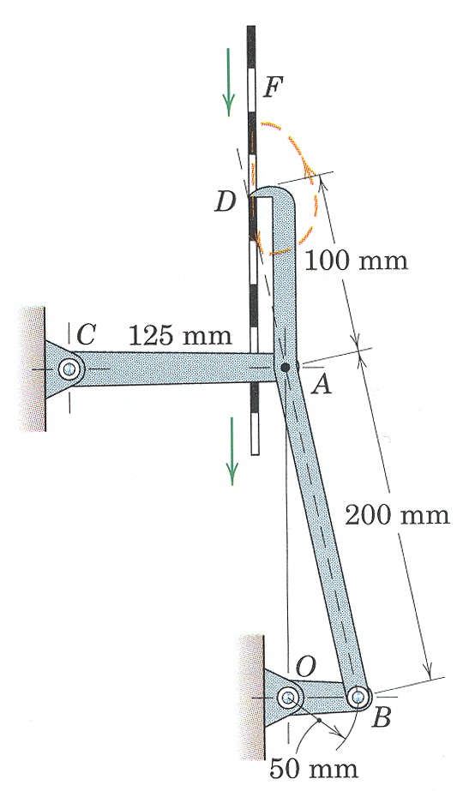

3. An intermittent-drive mechanism for a perforated tape F consists of the link DAB driven by the crank OB. The trace of the motion of the finger at D is shown by the dashed line. Determine the magnitude of the acceleration of D at the instant shown when both OB and CA are horizontal. Crank OB has a constant clockwise angular velocity of 120 rpm.
(taken from Dynamics by Meriam and Kraige, Fourth Edition)

ans: $a_{D}=\text{1997} \text{mm}/s^{2}$

Strategy: pure kinematics!

Relate the acceleration at D to the acceleration at A as we work our way through member ABD:
$\begin{aligned}{\bar{a}}_{D}={\bar{a}}_{A}+{\bar{a}}_{D/A} \\ {\bar{a}}_{A}+{\bar{α}}_{\text{ABD}}×{\bar{r}}_{D/A}−ω_{\text{ABD}}^{2}{\bar{r}}_{D/A}\end{aligned}$
Expanding and equating components
$\begin{matrix}\hat{i}: & a_{D_{x}}=a_{A_{x}}−α_{\text{ABD}}r_{{D/A}_{y}}−ω_{\text{ABD}}^{2}r_{{D/A}_{x}} & (1) \\ \hat{j}: & a_{D_{y}}=a_{A_{y}}+α_{\text{ABD}}r_{{D/A}_{x}}−ω_{\text{ABD}}^{2}r_{{D/A}_{y}} & (2)\end{matrix}$
unk eqs
a_{Dx} 1
a_{Dy} 2
a_{Ax} 3
a_{Ay} 4
α_{ABD} 5
ω_{ABD} 6
a_{Bx} 7
a_{By} 8

Relate the acceleration at A to the acceleration at B
$\begin{aligned}{\bar{a}}_{A}={\bar{a}}_{B}+{\bar{a}}_{A/B} \\ {\bar{a}}_{B}+{\bar{α}}_{\text{ABD}}×{\bar{r}}_{A/B}−ω_{\text{ABD}}^{2}{\bar{r}}_{A/B}\end{aligned}$
Expanding and equating components
$\begin{matrix}\hat{i}: & a_{A_{x}}=a_{B_{x}}−α_{\text{ABD}}r_{{A/B}_{y}}−ω_{\text{ABD}}^{2}r_{{A/B}_{x}} & (3) \\ \hat{j}: & a_{A_{y}}=a_{B_{y}}+α_{\text{ABD}}r_{{A/B}_{x}}−ω_{\text{ABD}}^{2}r_{{A/B}_{y}} & (4)\end{matrix}$

We can’t get another two equations by relating the acceleration at D to the acceleration at B. Why?
We can’t make any assumptions about the acceleration at A. Why?

Relate the acceleration at B to the acceleration at O since we know something about OB:
$\begin{aligned}{\bar{a}}_{B}={\bar{a}}_{O}+{\bar{a}}_{B/O} \\ {\bar{a}}_{O}+{\bar{α}}_{\text{OB}}×{\bar{r}}_{B/O}−ω_{\text{OB}}^{2}{\bar{r}}_{B/O}\end{aligned}$
Expanding and equating components knowing${\bar{α}}_{\text{BO}}={\bar{a}}_{O}=\bar{0}$
$\begin{matrix}\hat{i}: & a_{B_{x}}=−ω_{\text{OB}}^{2}r_{{B/O}_{x}} & (5) \\ \hat{j}: & a_{B_{y}}=−ω_{\text{OB}}^{2}r_{{B/O}_{y}} & (6)\end{matrix}$

Constraints and Geometry

Examining the velocity at points B and A, we see that member ABD is in translation at this instant. Thus the angular velocity is zero but we can draw no conclusions about the angular acceleration.

$ω_{\text{ABD}}=0$ (7)

Examining the motion of point D (the dashed line), we see that has been in translation for more than an instant. We may therefore conclude that the acceleration of point D is in the y direction only.

$a_{D_{x}}=0$ (8)

And for the position vectors:
${\bar{r}}_{D/A}=−\text{25 \{}\hat{i}+\text{96}\text{.}8\hat{j} ⇒ r_{{D/A}_{x}}=−\text{25}\text{mm}, r_{{D/A}_{y}}=\text{96}\text{.}8\text{mm}$
${\bar{r}}_{A/B}=−\text{50 \{}\hat{i}+\text{193}\text{.}6\hat{j} ⇒ r_{{A/B}_{x}}=−\text{50}\text{mm}, r_{{A/B}_{y}}=\text{193}\text{.}6\text{mm}$
${\bar{r}}_{B/O}=\text{50 \{}\hat{i}+0\hat{j} ⇒ r_{{B/O}_{x}}=\text{50}\text{mm}, r_{{B/O}_{y}}=0\text{mm}$

