Review Problems - Final Exam

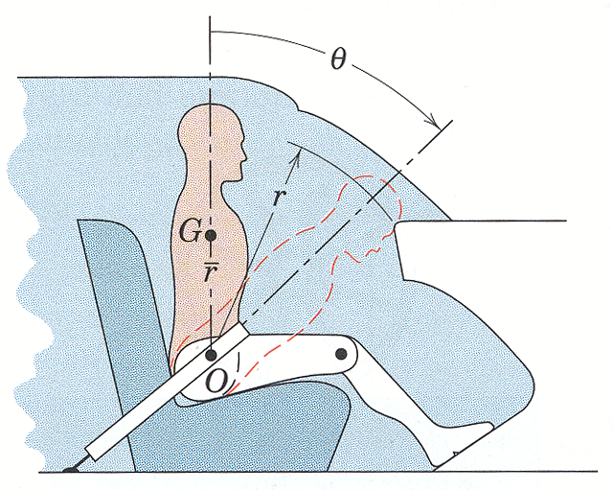

2. In a study of head injury against the dashboard of a car during sudden or crash stops where lap belts without shoulder straps are used, the segmented human model shown in the figure is analyzed. The hip joint O is assumed to remain fixed relative to the car and the torso above the hip is treated as a rigid body of mass m pinned at O. The center of mass of the torso is at G with the initial position of OG taken as vertical. The radius of gyration about O is k_{O}. If the car is brought to a stop with a constant deceleration a, determine the velocity v relative to the car with which the model’s head strikes the dashboard.
Substitute the values:
$m=\text{50} \text{kg} \bar{r}=\text{450} \text{mm} r=\text{800} \text{mm} k_{O}=\text{550} \text{mm} θ={\text{45}}^{∘} a=\text{10}g$
(taken from Dynamics by Meriam and Kraige, Fourth Edition)

Hint: $I_{O}=I_{G}+m{\bar{r}}^{2}$

ans: $v=\text{11}\text{.}\text{73} m/s$

Strategy: Since the car is moving at a non-constant velocity, we can’t use COE to obtain a solution. We’ll therefore apply the rate form equations in the displaced position (right before the head hits the dashboard) and work backward.
unk eqs
v_{H} 1
W 2
a_{Gx} 3
a_{Gy} 4
α_{GO} 5
ω_{GO} 6
a_{Ox} 7
a_{Oy} 8

Kinetics:
COAM(RF) at O
$−W\bar{r}\text{sin}θ=−I_{G}α_{\text{GO}}+{\text{ma}}_{G_{y}}\bar{r}\text{sin}θ−{\text{ma}}_{G_{x}}\bar{r}\text{cos}θ$ (1)

Kinematics:
$\begin{aligned}{\bar{a}}_{G}={\bar{a}}_{O}+{\bar{a}}_{G/O} \\ {\bar{a}}_{O}+{\bar{α}}_{\text{GO}}×{\bar{r}}_{G/O}−ω_{\text{GO}}^{2}{\bar{r}}_{G/O}\end{aligned}$

$\begin{matrix}\hat{i}: & a_{G_{x}}=a_{O_{x}}+α_{\text{GO}}r_{{G/O}_{y}}−ω_{\text{GO}}^{2}r_{{G/O}_{x}} \\ \hat{j}: & a_{G_{y}}=a_{O_{y}}−α_{\text{GO}}r_{{G/O}_{x}}−ω_{\text{GO}}^{2}r_{{G/O}_{y}}\end{matrix}$ (2,3)

Note the signs in (2,3) preceeding the angular acceleration terms. What has happened?

Some early kinematics reminds of the relationship between angular acceleration and angular velocity
$α=ω\frac{dω}{dθ}$ (4)

and once we know the angular velocity
$v_{H}=ω_{\text{GO}}r$ (5)

Constraints and Geometry:
${\bar{a}}_{O}=−\text{10}g\hat{i}+0\hat{j} ⇒ a_{O_{x}}=−\text{10}g, a_{O_{y}}=0$ (6,7)
${\bar{r}}_{G/O}=\bar{r}\text{sin}θ \hat{i}+\bar{r}\text{cos}θ \hat{j} ⇒ r_{{G/O}_{x}}=\bar{r}\text{sin}θ, r_{{G/O}_{y}}=\bar{r}\text{cos}θ$

Other:
$W=\text{mg}$ (8)

Solving:
Substituting (2,3,6,7,8) into (1) along with the position vector components and rearranging gives:

$α_{\text{GO}}=\frac{\text{mg \{}\bar{r}}{I_{G}+m{\bar{r}}^{2}}\left(\text{sin}θ+\text{10}\text{cos}θ\right)$
What happened to the angular velocity?

Substituting the hint and relating the mass moment of inertia to the radius of gyration
$α_{\text{GO}}=\frac{g\bar{r}}{k_{o}^{2}}\left(\text{sin}θ+\text{10}\text{cos}θ\right)$
Substituting into (4) and integrating
$\int_{0}^{ω_{\text{GO}}}{ωdω=\int_{0}^{θ}{α_{\text{GO}}dθ}}$
gives
$ω_{\text{GO}}=\text{14}\text{.}\text{66} \text{rad}/s$

which, when substituted into (5)
$v_{H}=\text{11}\text{.}\text{73} m/s \left(\text{26} \text{mph}\right)$

