Review Problems - Final Exam

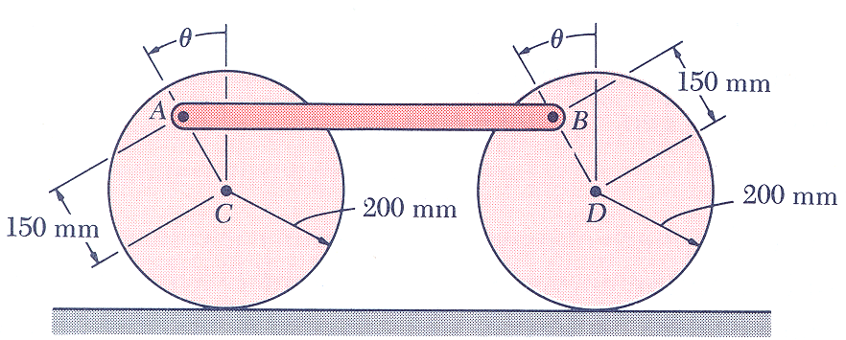
1. The 8 kg rod AB is attached by pins to two 5 kg uniform disks as shown. The assembly rolls without sliding on a horizontal surface. If the assembly is released from rest when θ=60 deg, determine
a) the angular velocity of the disks when θ=180 deg
b) the force exerted by the surface on each disk at that instant
(taken from Dynamics by Beer and Johnston, Fifth Edition)

ans: $\bar{ω}=8\text{.}\text{44} \text{rad}/s \text{CCW}, \bar{N}=\text{122}\text{.}5 N↑$

