Review Problems - Final Exam

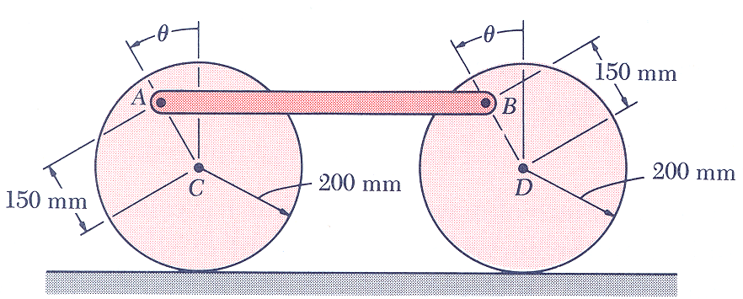
1. The 8 kg rod AB is attached by pins to two 5 kg uniform disks as shown. The assembly rolls without sliding on a horizontal surface. If the assembly is released from rest when θ=60 deg, determine
a) the angular velocity of the disks when θ=180 deg
b) the force exerted by the surface on each disk at that instant
(taken from Dynamics by Beer and Johnston, Fifth Edition)

ans: $\bar{ω}=8\text{.}\text{44} \text{rad}/s \text{CCW}, \bar{N}=\text{122}\text{.}5 N↑$

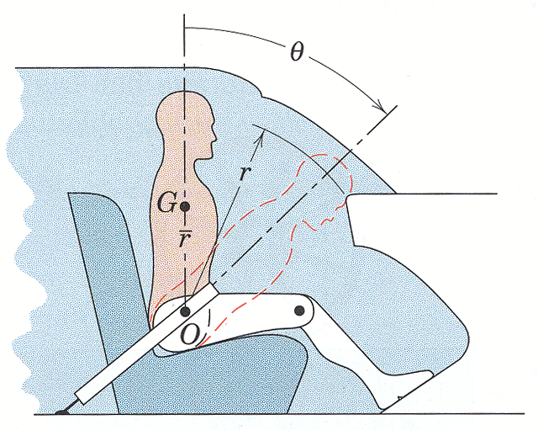

2. In a study of head injury against the dashboard of a car during sudden or crash stops where lap belts without shoulder straps are used, the segmented human model shown in the figure is analyzed. The hip joint O is assumed to remain fixed relative to the car and the torso above the hip is treated as a rigid body of mass m pinned at O. The center of mass of the torso is at G with the initial position of OG taken as vertical. The radius of gyration about O is k_{O}. If the car is brought to a stop with a constant deceleration a, determine the velocity v relative to the car with which the model’s head strikes the dashboard.
Substitute the values:
$m=\text{50} \text{kg} \bar{r}=\text{450} \text{mm} r=\text{800} \text{mm} k_{O}=\text{550} \text{mm} θ={\text{45}}^{∘} a=\text{10}g$
(taken from Dynamics by Meriam and Kraige, Fourth Edition)

Hint: $I_{O}=I_{G}+m{\bar{r}}^{2}$

ans: $v=\text{11}\text{.}\text{73} m/s$

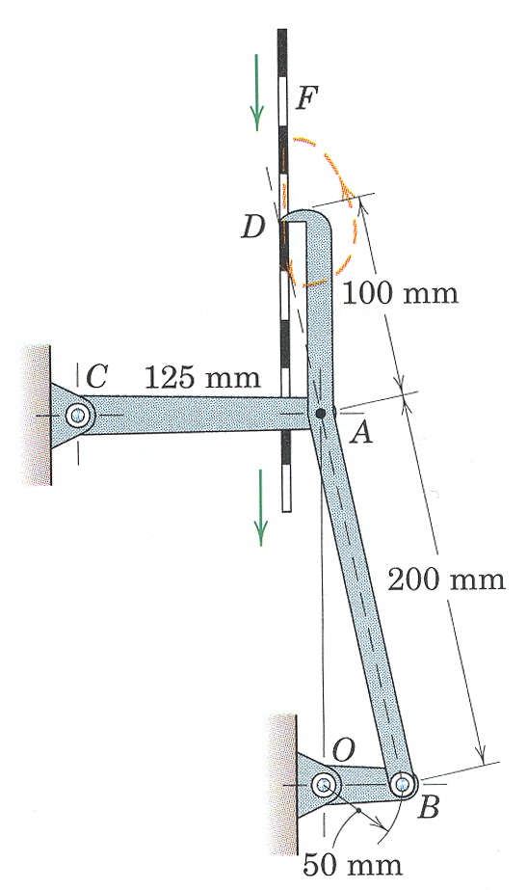

3. An intermittent-drive mechanism for a perforated tape F consists of the link DAB driven by the crank OB. The trace of the motion of the finger at D is shown by the dashed line. Determine the magnitude of the acceleration of D at the instant shown when both OB and CA are horizontal. Crank OB has a constant clockwise angular velocity of 120 rpm.
(taken from Dynamics by Meriam and Kraige, Fourth Edition)

ans: $a_{D}=\text{1997} \text{mm}/s^{2}$

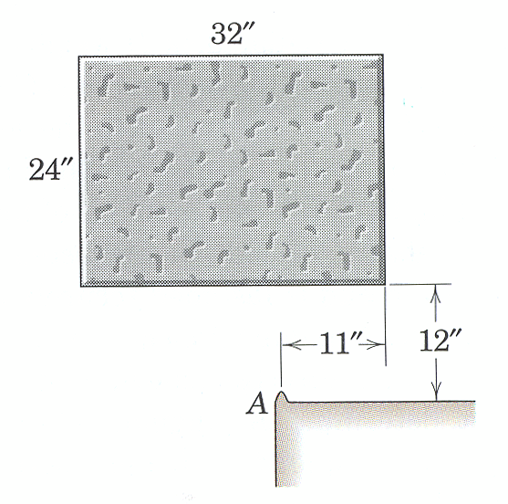
4. The uniform concrete block, which weighs 171 lb and falls from rest in the horizontal position shown, strikes the fixed corner A and pivots around it with no rebound. Calculate the angular velocity of the block immediately after it hits the corner and the percentage loss n of energy due to the impact.
(taken from Dynamics by Meriam and Kraige, Fourth Edition)

ans: $\bar{ω}=1\text{.}\text{593} \text{rad}/s \text{CCW}, n=\text{91}\text{.}7 \text{\%}$

