Quiz - Le 14 Name: ____________________

1. Sketch the location of the IC for the rigid bodies marked with arrows. Do not worry about figuring out the exact locations.
a)  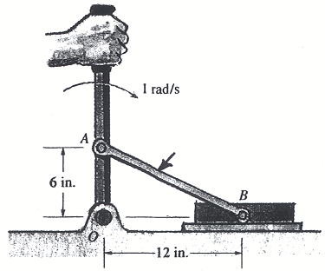 | b)  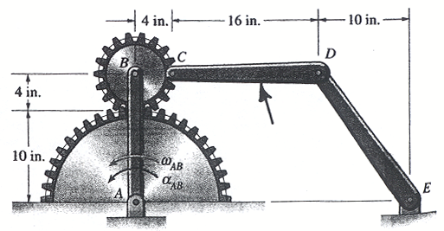
2. A 10 kg object has a radius of gyration about its center of gravity equal to 0.2 m. What is the mass moment of inertia of the object about its center of gravity?

3. What is the finite time form of conservation of energy for a closed system?

4. What is the work of a constant moment (or torque), M=100 N-m, if it causes an object to rotate through an angle of 45 degrees?

5. An 10 kg object rolls without slipping on a horizontal fixed surface. What is the:
a) velocity of the point of contact?

b) work done by the friction force?

