Quiz - Le 12 Name: ____________________

Sketch the location of the instantaneous center of velocity for the rigid bodies marked with arrows. Do not worry about figuring out the exact locations.

1.  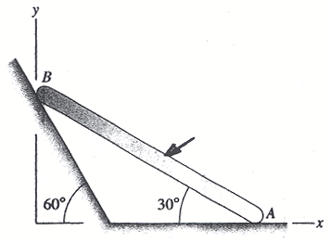 | 2.  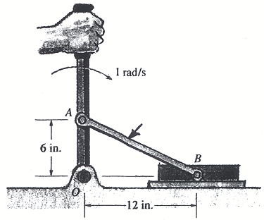
3.  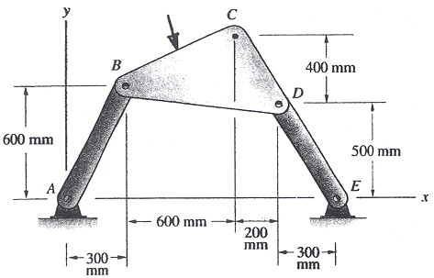 | 4.  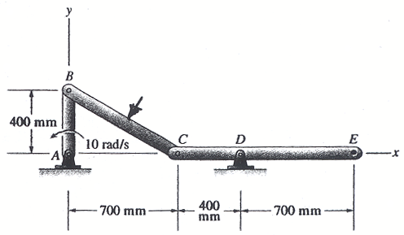
5.  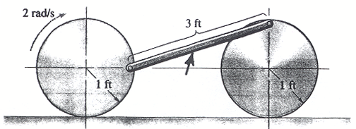  Assume the disks roll without slipping | 6.  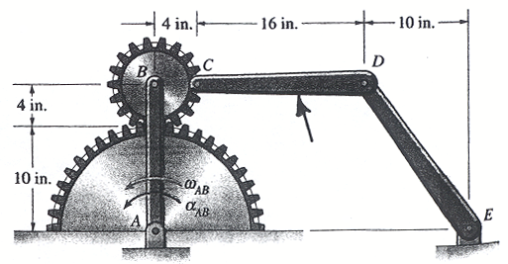  The lower gear is fixed

