ES204
Mechanical Systems Lab 02

In this lab, we will investigate the swinging rod device and compare angular velocity of two rods with weights attached that demonstrate rotation about a fixed axis. As you try to predict which rod will rotate faster, you will soon realize that it is not easy to predict and that it is somewhat non-intuitive.

Next, we will model the swinging rods using Working Model. You will be able to understand the swinging rod a bit better and you will use the model to help predict the behavior of the swinging rod. At the same time, you will increase your ability to use Working Model.

Finally, we will analyze the weighted swinging rod using principles that you have learned in ES204. At that point you will have a much better chance of predicting the behavior of the swinging rod device.

Working Model Instructions

1. Set units to SI(degrees).

2. Create two rectangles that are 1 m long by 0.05 m wide (height = 1, width = 0.05). Use a round pin joint and pin the top middle of each rectangle to the background.

3. Make a slider to control the initial angle of both rectangles. To do this, highlight one of the rectangles and choose define - new control - initial rotation. Double click on the word “rectangle” above the control and set the min to 0, the max to 90 and the number of snaps to 90. Double click on the second bar and add the appropriate equation, i.e. Input[?], for the initial angle.

4. Create a 0.1 by 0.1 square to act as an adjustable weight. Place a square point element in the center of the square. Place a square point element in the middle of one rod and, while the point element is highlighted, create another control by choosing, Define - New Control - Offset. Delete the x-offset control. Double-click on the word “y-offset” and set the min and max values to 0 and 1.

5. Highlight the two square point elements using shift-click and then click on JOIN.

6. Select the square point element and change the y equation from “Input[?]” to “0.5 – Input[?]”.

7. Repeat steps 4, 5 and 6 for the second rotating rod.

8. Create controls for the mass of the adjustable weights. Highlight a square and choose Define - New Control - Mass. Double click on the word “mass” and set the minimum mass to 0.1 kg and the maximum mass to 10 kg. Repeat for the second mass. Give each of the rods a mass of 1 kg.

9. Create a meter to measure the angular velocity of one of the rods. Choose Measure-Velocity-Rotational Graph. Click twice on the white arrow in the upper left of the meter and you will have a digital meter rather than a graph. Double click on the graph and add a plot for the angular velocity of the other bar and the position of both bars. The equation for position should be something like: Body[1].p.r

10. Add a pause control for each body. Choose World - Pause Control - New Condition and then type following condition for each body:
body[?].p.r < 0

11. Eliminate all contact by selecting all the masses you have drawn and then go to Object/Do not collide.

12. Set the initial rotation to 90 degrees and put a 1 kg mass at the end of the bar on the left, a 2 kg mass at the end of the bar on the right and run the model. Does the rod used in the pause control stop very close to the vertical position? If not, you may need to increase the accuracy of the model. Choose World - Accuracy and type in a smaller animation step if necessary.

A snapshot of what you model may look like is shown below.

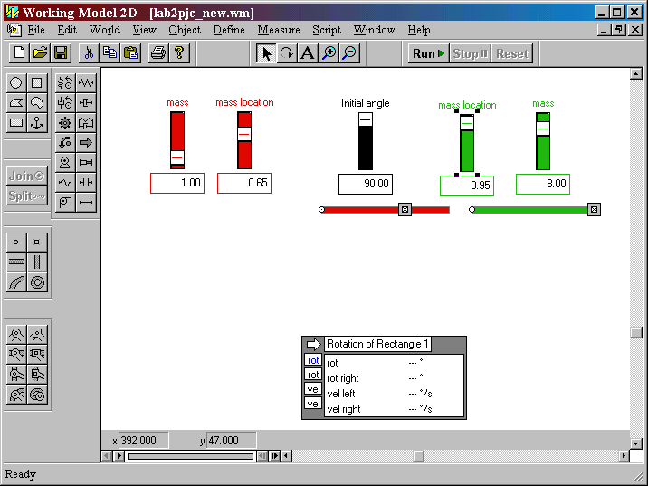

Worksheet – ES204 Lab 02 (page 1 of 2)

Names __________________________ __________________________ __________________________

- Place a 5 kg mass at the bottom position of the left rod and at the center of the right rod. Set the starting angle to 90 degrees for both rods. Which rod rotates faster?

Left Right

- Place a 10 kg mass at the bottom position of the left rod and a 1 kg mass at the bottom of the right rod. Which rod rotates faster?

Left Right

- Place a 10 kg mass at the middle of the left rod and a 1 kg mass at the middle of the right rod. Which rod rotates faster?

Left Right

4. Place a 10 kg mass at the center of the left rod and at the top of the right rod. Which rod rotates faster?

Left Right

5. Do you understand the behavior of the swinging rods?

Is a rod with the lighter weight always faster? yes no
Is a rod always faster if the mass is closer to the rod bottom? yes no
Is a rod always faster if the mass is closer to the pivot? yes no

6. Using a 2 kg mass try to locate the position for which the rod will have a maximum angular velocity at the bottom? One way to do this is to put a 2 kg mass on both rods and then run a series of races. Show your results below.

Location from the pivot | Velocity at the bottom
Final estimate for the location:

Attach a snapshot of your Working Model simulation to this worksheet.

Worksheet – ES204 Lab 02 (page 2 of 2)

Names __________________________ __________________________ __________________________

Analytical Model

Draw a model of the system below labeling all the system parameters

Derive an equation for the angular velocity of the rod at the bottom. Determine the location for the point mass for the angular velocity to be maximum at the bottom. If you use Maple please attach a Maple printout otherwise show all your work below. How does your answer compare to the result you found using Working Model.

