Linkages and Relative Acceleration
(by Z. Chambers)

Recalling our earlier discussion of relative velocity for objects undergoing general plane motion, we developed three techniques for relative the velocity of any two points.
1. Instantaneous Center : if you know the direction of the velocity of two points on the body, you can locate the IC and use a scalar analysis to obtain the velocity via
$v_{A}=ω_{\text{AB}}r_{A/\text{IC}} ; v_{B}=ω_{\text{AB}}r_{B/\text{IC}} \text{etc}\text{.}$
2. Vector Algebra : define all velocities in terms of $\hat{i},\hat{j},\hat{k}$ components and then equate the components to obtain two equations

$\begin{aligned}{\bar{v}}_{B}={\bar{v}}_{A}+{\bar{v}}_{B/A} \\ {\bar{v}}_{A}+{\bar{ω}}_{\text{AB}}×{\bar{r}}_{B/A}\end{aligned}$

3. Vector Diagram : draw a vector triangle and measure the results (we don’t do this anymore!)

The rate form equations we will be applying to solve linkage problems will introduce the angular acceleration of the body along with the accelerations at common points, thus we need to develop a technique to relate accelerations for points on rigid bodies undergoing general plane motion. We shall begin by time-differentiating the vector algebra equation for relative velocity:
$\frac{d}{\text{dt}}\left({\bar{v}}_{B}\right)=\frac{d}{\text{dt}}\left({\bar{v}}_{A}+{\bar{v}}_{B/A}\right)$

where
${\bar{a}}_{A}$ corresponds to the translational acceleration of A
${\bar{a}}_{B/A}$ corresponds to the rotational (relative) acceleration about A

Note:
$\begin{matrix}{\bar{a}}_{B/A}=\frac{d}{\text{dt}}\left({\bar{v}}_{B/A}\right)=\frac{d}{\text{dt}}\left({\bar{ω}}_{\text{AB}}×{\bar{r}}_{B/A}\right) & {\bar{α}}_{\text{AB}}×{\bar{r}}_{B/A}+{\bar{ω}}_{\text{AB}}×{\bar{v}}_{B/A} \\ & {\bar{α}}_{\text{AB}}×{\bar{r}}_{B/A}+{\bar{ω}}_{\text{AB}}×\left({\bar{ω}}_{\text{AB}}×{\bar{r}}_{B/A}\right)\end{matrix}$

Thus the relative acceleration ${\bar{a}}_{B/A}$ has two components:
${\bar{α}}_{\text{AB}}×{\bar{r}}_{B/A}$ is the tangential component of the relative acceleration
${\bar{ω}}_{\text{AB}}×\left({\bar{ω}}_{\text{AB}}×{\bar{r}}_{B/A}\right)$ is the normal component of the relative acceleration

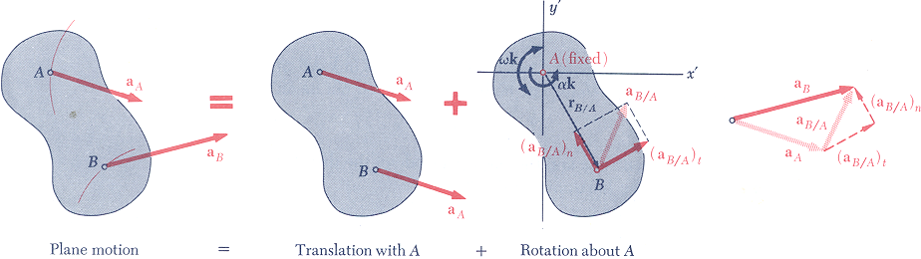
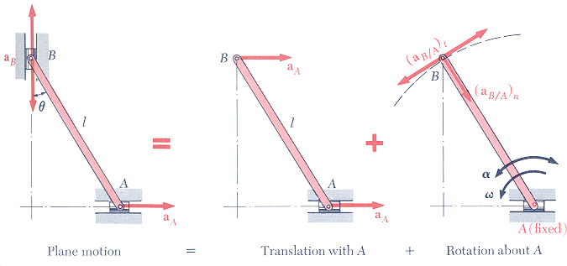
Thus, for general plane motion
$a_{{B/A}_{t}}={\bar{α}}_{\text{AB}}×{\bar{r}}_{B/A}$ mag = $α_{\text{AB}}r_{B/A}$; direction is to ${\bar{r}}_{B/A}$
$a_{{B/A}_{n}}={\bar{ω}}_{\text{AB}}×\left({\bar{ω}}_{\text{AB}}×{\bar{r}}_{B/A}\right)$ mag = $ω_{\text{AB}}^{2}r_{B/A}$; direction is towards A

Notes on Solving Problems:
Plane Motion: in 2d, $\bar{ω}=ω\hat{k}$ so ${\bar{ω}}_{\text{AB}}×\left({\bar{ω}}_{\text{AB}}×{\bar{r}}_{B/A}\right)=−ω^{2}{\bar{r}}_{B/A}$
Pinned Joints: the pin has the same absolute acceleration regardless of the body you isolate
Gears : tangential components of acceleration are equal, normal components are different

