General Plane Motion
(by Z. Chambers)

General Plane Motion: General Plane motion of an object can always be considered as a sum of a translation and a rotation
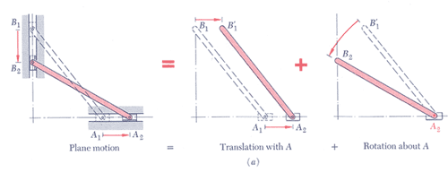
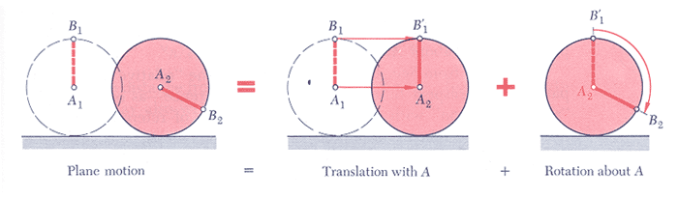

$$\begin{aligned}{\bar{v}}_{B}={\bar{v}}_{A}+\bar{ω}×{\bar{r}}_{B/A} \\ {\bar{v}}_{A}+{\bar{v}}_{B/A}\end{aligned}$$

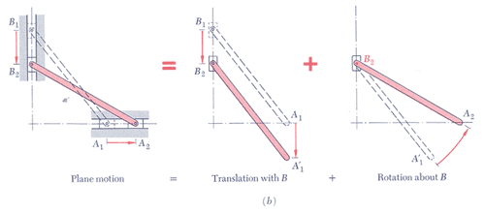
$$\begin{aligned}{\bar{v}}_{A}={\bar{v}}_{B}+\bar{ω}×{\bar{r}}_{A/B} \\ {\bar{v}}_{B}+{\bar{v}}_{A/B}\end{aligned}$$

So if A and B are on the same rigid body
magnitude = ω r_{B/A} for plane motion
direction is perpendicular to ω and r_{B/A}

so for general plane motion
equation to relate the velocity of any two points on the same rigid body

