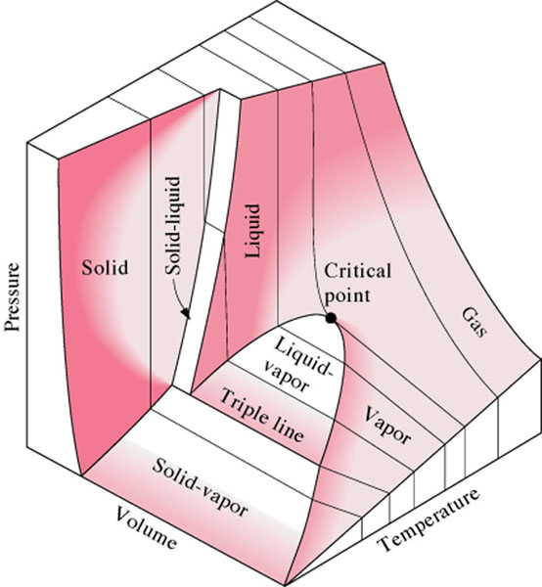
Fig 4-26, CTC Pressure-Volume-Temperature Surface – R-134a

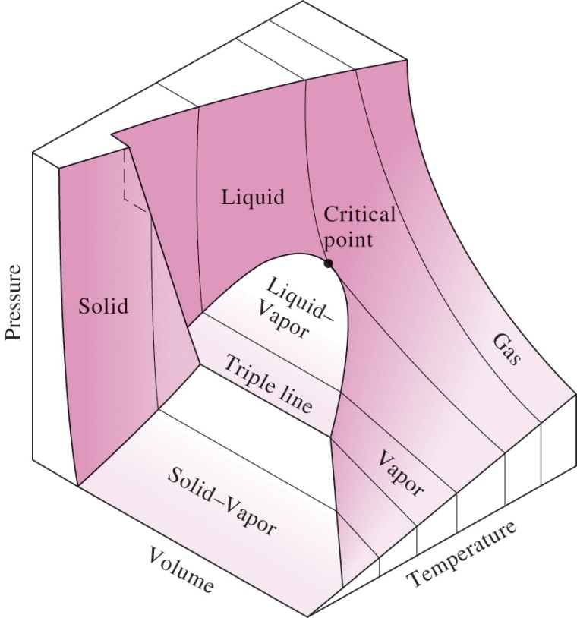
Fig 4-27, CTC Pressure-Volume-Temperature Surface – Water

