EM121: Statics and Mechanics of Materials I
Spring 2009-2010 Project
Weight Lifting Equipment Re-Design

Objective:
Your objective is to design a lightweight, safe link for a piece of weight-lifting equipment that will allow users to raise the arms of the equipment to a specified angle.

Background
Figure 1 shows a weight-lifting machine that is similar to one that is currently available in the SRC. In this machine, the entire structure is made of welded square tubing, and the equipment is quite expensive. (You can find it, used, for around $1000 on ebay.)

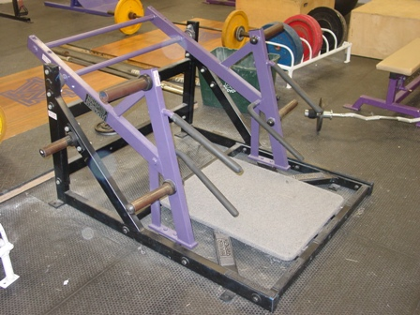
Figure 1. The “Life Fitness Hammer Strength Squat Lunge” Weight Lifting Machine.
(Picture from http://www.safe-usa.com/usedgear.html)

We hope to compete in this market by creating a similar machine that performs a similar function, but which weighs less, is less expensive, and is easier to ship. As a first prototype, we have built one-half (one side) of the mechanism. Figure 2, on the next page, shows a schematic of the prototype mechanism.

Weight
Frame
Arm
Your Link
16 possible hole locations on arm

Figure 2: Prototype of One-Half of the Redesigned Weight-Lifting Machine.

One part of the redesign has been left to your team. You will design the link that connects the arm to the weight frame, and allows the weights to be raised by the user. One end of the link is pinned to the arm by a shoulder screw at one of 16 possible hole locations. You will get to choose which hole you will use. The other end of the link is joined (again by a shoulder screw) to the weight frame. The diameter of the shoulder screws is 0.250”. The arm must be horizontal to within ±5º at the start of the lift, and it must be possible to raise the arm 15º above the horizontal without breaking the link.

The SolidEdge files and drawings that describe the geometry of the weight frame are provided on the “Labs” page on the course website. The prototype mechanism is in the ME machine shop (EL202). You are encouraged to visit the machine shop to view the mechanism, but remember that long pants, closed-toe shoes, and safety glasses are required in the shop.

The material that you will use to create the link is Nylon 6/6 sheet (a rigid plastic). We supply the material, and the thicknesses available to you are 0.062 inches, 0.094 inches, and 0.124 inches. The manufacturer’s material property data sheet has been posted on the “Labs” page of the course website, along with tensile test results for specimens fabricated from Nylon sheets purchased for these projects over the last three years.

Deliverables
- An email to your instructor (due Sunday, May 9 by 11:30 PM). The email must include
  - A CAD file in the dxf format that defines the outline of your link in a way that is appropriate for our laser cutting machine (see instructions on the “Labs” webpage). The name of the file must be given as Sec#_teamname_thickness.dxf (for example: “Sec3_ATeam_062.dxf”)
  - An indication of which arm hole to use with the link.
- Technical Report (due by email, Friday May 21, 5 pm). A technical report following our template, providing documentation of your analysis and design process. The template for the technical report will be provided later in the quarter.

Testing (Contest):
Date: Wednesday May 19
Location: Meyers M137 Lecture Hall
Times: by section
Section 3 (Olson): 1st hour
Section 4 (Olson): 2nd hour
Section 6 (Adams): 3rd hour
Section 7 (Adams): 4th hour
Section 5 (Mosely): 5th hour
Section 1 (Toohey): 6th hour
Section 2 (Toohey): 7th hour
If your team cannot have at least two team members present during the assigned section time, we can move your group to compete with a different section. However, this must be arranged in advance-- not later than Monday May 17.

Grading:
Technical Report (Documentation): 75%

Performance: 25%
Does it Function Safely?
No: your performance score is 55.
Yes: your performance is based on the weight of your link (light is good)
- Top in section: 100
- Top third of section: 95
- Middle third of section : 85
- Bottom third of section: 75
Special cases:
- If your link cannot be assembled onto the machine, you automatically receive a 25 for your performance score.
- If your link can be assembled and tested, but does not meet the handle angle specification (horizontal to ±5º), it will be tested. The highest score it can receive for performance is 65.

