Final Exam - Spring 2009-2010
Name : ____________________________ Section Number : __________
Record all your answers to the multiple choice problems (1-15) by filling in the appropriate circle. All multiple choice answers will be graded from these markings, not the marking on the problem pages. Therefore, carefully transcribe your answers. No guessing on the multiple choice problems - you must show all your work for full credit.

Problem | Answers | Score
1 | ○ a ○ b ○ c ○ d ○ e ○ f | /5
2 | ○ a ○ b ○ c ○ d ○ e ○ f | /5
3 | ○ a ○ b ○ c ○ d ○ e ○ f | /5
4 | ○ a ○ b ○ c ○ d ○ e ○ f | /5
5 | ○ a ○ b ○ c ○ d ○ e ○ f | /5
6 | ○ a ○ b ○ c ○ d ○ e ○ f | /5
7 | ○ a ○ b ○ c ○ d ○ e ○ f | /5
8 | ○ a ○ b ○ c ○ d ○ e ○ f | /5
9 | ○ a ○ b ○ c ○ d ○ e ○ f | /5
10 | ○ a ○ b ○ c ○ d ○ e ○ f | /5
11 | ○ a ○ b ○ c ○ d ○ e ○ f | /5
12 | ○ a ○ b ○ c ○ d ○ e ○ f | /5
13 | ○ a ○ b ○ c ○ d ○ e ○ f | /5
14 | ○ a ○ b ○ c ○ d ○ e ○ f | /5
15 | ○ a ○ b ○ c ○ d ○ e ○ f | /5
16 |  | /20
17 |  | /40
18 |  | /40
19 |  | /40
Total |  | /215

Show all work for credit

For problems 1-15, circle the best answer and then copy it to the coversheet. You must show all work for full credit.
8 m
7 m
x
y
Problem 1
The projection of force vector $−3\hat{i}+2\hat{j}$ N in the direction of the position vector $\bar{r}$ shown at right is:

a) 10 N
b) 0.94 N
c) -0.94 N
d) -10 N
e) None of the above

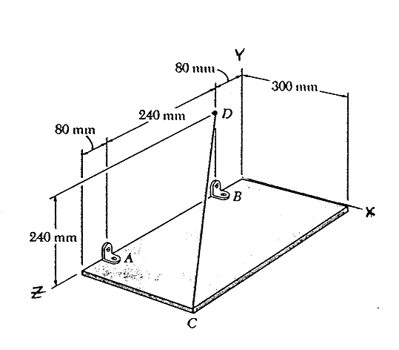
Problem 2
A rectangular plate is supported as shown at right. The tension in cable CD is expressed in vector form as $T_{\text{CD}}=−\text{120 \{}\hat{i}+\text{96 \{}\hat{j}−\text{128 \{}\hat{k}$ N. The moment about point A created by this force is:

a) $\text{38}\text{.}4\hat{i}−\text{48}\text{.}0\hat{j}+\text{28}\text{.}8\hat{k}$ N⋅m
b) 65 N⋅m
c) 68 N⋅m
d) $−7\text{.}\text{68 \{}\hat{i}+\text{28}\text{.}8\hat{j}+\text{28}\text{.}8\hat{k}$ N⋅m
e) None of the above

Problem 3
75 lb
A
B
C
D
E
For the system shown at right, identify the correct free body diagram for the frictionless pulley

a)
75
Dx
Dy
b)
75
Dx
Dy
c)
75
75
Dx
Dy
d)
75
75
Dx
Dy
M
e) none shown

Problem 4

We push on a cabinet of weight, W with horizontal force, P. From the analysis shown, we have found the critical height “h” that is the transition between slip and tip. (If the force is above h the cabinet will tip and below h the cabinet will slip). If we are able to lower the center of gravity of the cabinet, the critical height, h, will

ΣF_{x}=0
f=N
P
W
N
FBD
Center of Gravity
b
h
P-μN=0

ΣF_{y}=0
W-N=0

ΣM_{corner}=0

(b/2)(W)-Ph=0

a) increase b) decrease c) stay the same d) can’t tell from given

Problem 5
Consider the glued joint shown below:

25o
1.5”
1”
5000 lb
5000 lb

What is the normal stress in the glue?

(a) 1410 psi
(b) 2740 psi
(c) 595 psi
(d) 251 psi
(e) 1160 psi
(f) None of the above.

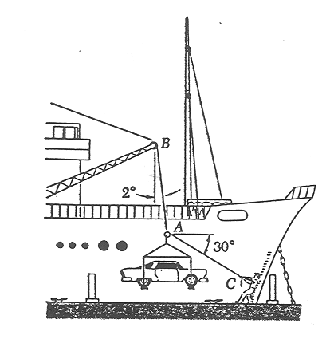
Problem 6
In a ship unloading operation, a 3500-lb automobile is supported by a cable. A rope is tied to the cable at A and pulled in order to center the automobile over the intended position. The angle between the cable and the vertical is 2°, while the angle between the rope and the horizontal is 30°. If the tension in the cable is 3574 pounds, what tension is needed in the rope for equilibrium?

a) 125 lb
b) 144 lb
c) 249 lb
d) 2490 lb
e) None of the above

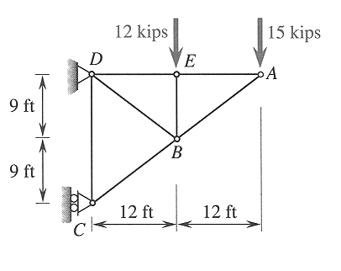
Problem 7
The external reaction at C on the simple cantilever truss shown at right is:

a) 28 kips →
b) 28 kips ←
c) 36 kips →
d) 36 kips ←
e) None of the above

Problem 8
W
W
h
A
B
C
D
E
F/2
F/2
F
w
w
For the truss with external reactions shown at right, the force in member BC is

a) Zero
b) $\text{wF}/2h$ (compression)
c) $\text{wF}/h$ (tension)
d) $\text{wF}/2h$ (tension)
e) None of the above

Problem 9
A uniform bar, ABCD, whose cross sectional area is 0.5 in² is loaded with the forces shown.
500 lb
1000 lb
3000 lb
A
B
C
D
The tensile stress in section BC of the bar is
- 2000 psi
- 1000 psi
- 6000 psi
- 4000 psi
- 8000 psi
f) None of the above

Problem 10
In a tug of war contest between two fraternities, each of the two teams is pulling with 600 pounds of force. Assume that the cross-sectional area of the rope is 0.1 in² and is made of a material with a failure strength of 15000 lb/in². The factor of safety (FOS) is

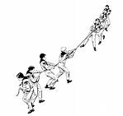 | - 25  - 5  - 2.5  - 1.25  - 0.8  - None of the above

Problem 11
x
y
3 in
3 in
3 in
2 in
What is the y coordinate of the centroid of the object shown at right?

a) 1.85 in
b) 1.67 in
c) 1.33 in
d) 1.15 in
e) None of the above

Problem 12
A bar (A=0.4 in², L = 40 in, E = 10x10⁶ psi) fits into a gap between two rigid supports because its length is
0.01 in less than the gap. The temperature is increased in a way that would cause the bar to increase in length by 0.015 in due to thermal expansion if the wall was not present.
NOT TO SCALE

L = 40 in, A = 0.4 in2, E=10 x 106 psi
Initial gap = 0.01 in
The stress in the bar after the full temperature increase is:
- 0 psi
- 1250 psi C
- 1250 psi T
- 2500 psi C
- 2500 psi T
- None of the above

Problem 13
Consider the rigid beam supported by two elastic bars as shown. It pivots about a pin support on its left end.
A
B
10 in
20 in
20 in
P, the load
Which statement is true regarding the forces in IDENTICAL members A and B?
- F_{A} = F_{B}
- F_{A} = (0.5) F_{B}
- F_{A} = (2.0) F_{B}
- F_{A} = (0.2) F_{B}
- None of the above

Problem 14

A 100 lb block sits on a rough horizontal surface. A 20 lb force acts horizontally as shown. The frictional force between the block and the ground is
P
s=0.4
k=0.3

a) 0lb b) 10lb c) 20lb d) 30lb e) 40lb f) none of these/can’t tell from given

Problem 15

We have a block on a slope that is at incipient (impending) slip. The correct equation for the friction force is

a) f=μ_{s}N b) f=μ_{k}N c) f<μ_{s}N d) f>μ_{s}N e) can’t tell from given

Problem 16 (20 pts)
A tension joint has the basic layout shown in the diagram below. (All dimensions on the diagram are in inches.) A single pin of diameter 0.5 inches (A = 0.2 in²) holds together the yoke and bar as shown. The material has an ultimate strength in tension of 80 ksi, and an ultimate strength in shear of 45 ksi. The load P has a value of 10000 lb. By examining the shear stress in the pin, the normal stress in the yoke, and the normal stress in the bar, find the overall factor of safety for the joint.

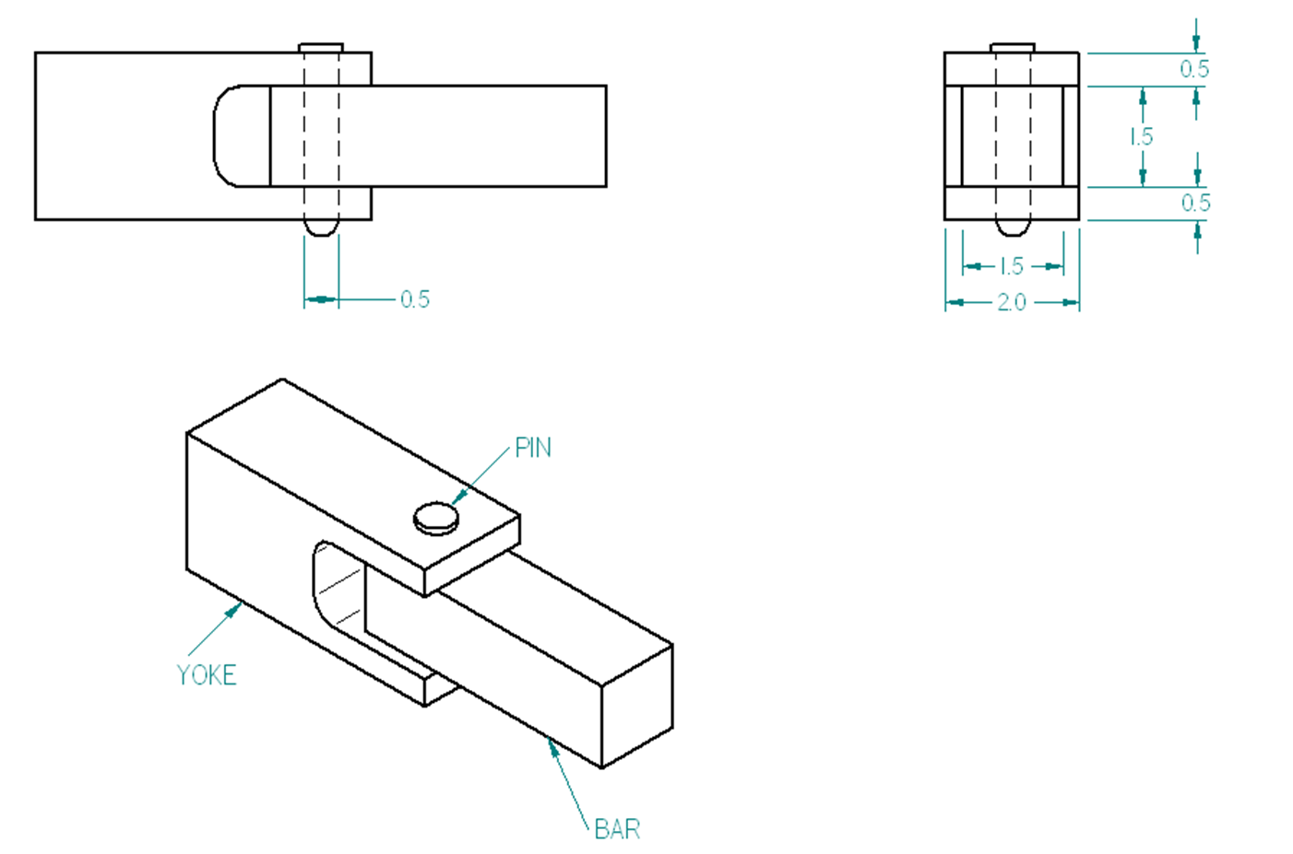
P=10,000 lb
P=10,000 lb

Problem 16 (cont.)

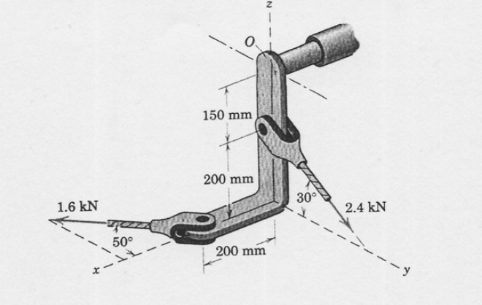
Problem 17 (40 pts)
For the system shown at right, determine the reactions at the fixed support O (assume it is welded there).

Problem 17 (cont.)

Problem 18 (40 pts)
A landing gear mechanism is shown in the accompanying figure. You may assume that it is in static equilibrium in the configuration shown. You may neglect all of the weight except that of the strut and wheel (225 lb) which is located at point G. The force F, applied to member BCD, drives the retraction.
Find:
- The force in link AB. (Hint: Use a coordinate system aligned with the wheel strut.)
- The magnitude of the pin force at the pin at P.
- The force F required for static equilibrium. (Hint: Now a use a coordinate system aligned with the BC axis.)

a | 2.5”
b | 36”
c | 6”
d | 16”
e | 4”

20º
d
D
F
e
B
C
70º
A
P
a
c

b
G

225 lb
40º

Problem 18 (cont.)

Problem 19 (40 pts)

Consider the A-frame shown. Note: ABC is a single member, CDE is a single member, and BDF is a single member. This is not a truss.
1.5 ft
1.5 ft
1.5 ft
1.5 ft
2.0 ft
2.0 ft
A
B
C
D
E
F
5000 lb
I am NOT a truss. I am a frame!
(a) Calculate the pin forces at B, C and D. (You can neglect the weight of the structural members.)

(b) The pins joining the A-frame are in single shear. The pins at B, C, and D have cross-sectional areas of 0.25 in². They will fail when the shear stress reaches 20,000 psi. The other pins have much larger cross-sectional areas and will not fail first. Determine whether failure occurs, and whether the failure is at pin B, C, or D.

Problem 19 (cont.)

