Exam 1
Spring 2009-2010
Name: _____________________________ CM: ______

Problem 1 (22 pts) ________

Problem 2 (34 pts) ________

Problem 3 (44 pts) ________

Total ________

Be sure to show all work to receive full credit. However, “given” and “find” are not necessary.

Problem 1 – Short Answer -- 22 points

(a) For each term on the right, list the appropriate label on the figure below (A, B, C, slope, or none):

Breaking strength _________
A
C
slope
ε
σ
0.2%
B
Yield strength__________
Poisson’s Ratio____________
Young’s Modulus__________

(b) The structure below should be designed with a factor of safety of 3. Find the appropriate cross-sectional area of the bar such that the bar does not fail, and the flower is safe. Assume that the bar will fail in shear at a shear stress of 10 ksi. The load P = 4 kip is applied to the bar as shown.
P

(c) A rope is pulled between point A (2 m, 5 m, 7 m) and point B (4 m, 0 m, 3 m). Define (write out) the unit vector, ê_{AB}, which points along the line from point A to point B.

(d) A steel roller bearing needs to be placed on the outside of a shaft, as seen in the assembly image below. At room temperature (25°C), the inner diameter of the bearing is 10.25 cm and the outer diameter of the shaft is 10.3 cm, therefore the bearing needs to be heated to assemble the two components. Assuming the shaft remains at room temperature, to what minimum temperature does the bearing need to be heated to make this assembly possible? The coefficient of thermal expansion for the bearing is 17.3 x 10⁻⁶ /°C.
Bearing
Shaft

Problem 2 – 34 points
Two identical pipes of weight W are stacked against a wall and an inclined surface as shown in the figure. All surfaces are smooth. If the incline angle is α,
- find the forces exerted by the incline on each pipe,
- the force exerted by the wall on Pipe 2, and
- the force between the pipes.
Clearly list your unknowns and number your equations, but do not solve the equations.
α
Pipe 1
Pipe 2

Problem 3 – 44 points
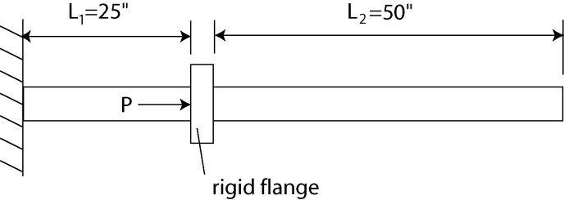

(a) Consider the rod shown in the diagram above. We apply a force P=1000 lb to the rigid flange. If the rod has a cross-sectional area A=1 in², and a Young’s modulus of E = 10,000 ksi, how far does the flange move when the force is applied?

(b) Now suppose that the far end of the rod is touching a wall, as shown in the diagram below. (Before the force was applied, the rod just barely touched the wall.) For this new configuration, how far does the rigid flange move when the force is applied?

