Exam 2
Spring 2008-2009
Name: _____________________________ CM: ______

Section:_____________

Problem 1 (31 pts) ________

Problem 2 (37 pts) ________

Problem 3 (32 pts) ________

Total ________

Be sure to show all work to receive full credit.

Problem 1 – 31 points

- (8 pts) A force, $\vec{F}=300\vec{i}+180\vec{j}−240\vec{k}$ lb acts at a point (2,0,0). An axis is described by the unit vector $\vec{e}=0.6\vec{i}+0.8\vec{k}$ and passes through the point (0,3,0). Distances are in inches. Calculate the moment of the force about the axis.

- (6 pts) The figure below shows a bar which is 10.0 in long at a temperature of 40ºF. The temperature rises to 100ºF. Calculate (a) the strain in the bar at 100ºF and (b) the stress in the bar at 100ºF. (Hint: we suggest you check to see whether the gap closes.)
Bar Area 0.3 in²
10 in.

E = 10 x 10⁶psi
α= 20 x 10⁻⁶ /ºF

Gap = 1.0 in

- (8 pts) Four forces are applied to the corners of a rectangle. Replace these forces with a single couple.

$\vec{C}=$______________________________________
12 N
8 m
90º
30º
5 m
20 N

90º
12 N
30º
20 N

- (9 pts) We need to calculate the centroid of the area bounded by the parabola$y=0.5x^{2}$, the horizontal line AB, and the y-axis. We use integration. Use the differential area shown.
B
A
x
dx
To calculate the centroidal y-coordinate we need the integral,
$$y=\frac{1}{A}\int_{a}^{b}{\tilde{y}dA}$$

The differential area, dA, may be written as
- 0.5 dx
- 0.5 x² dx
- (0.5 – 0.5 x²) dx
- 0.5 x² dy
$\tilde{y}$ is equal to
- $$0.5x^{2}$$
- $$x$$
- $$0.5−0.5x^{2}$$
- $$0.25+0.25x^{2}$$
The limits of integration are
- a=0, b=1.0
- a =0, b=0.5
- a = x b = 0.5
- a = 0, b = x

Problem 2 – 37 points
A 5mm thick aluminum link is loaded by forces applied to two aluminum pins and one other force as shown. Relevant dimensions of the link are shown in the figure on the right. The pin is 6mm in diameter. The material property information for this aluminum is shown in the table below. Show clear Free Body Diagrams for all forces that are used in stress calculations.
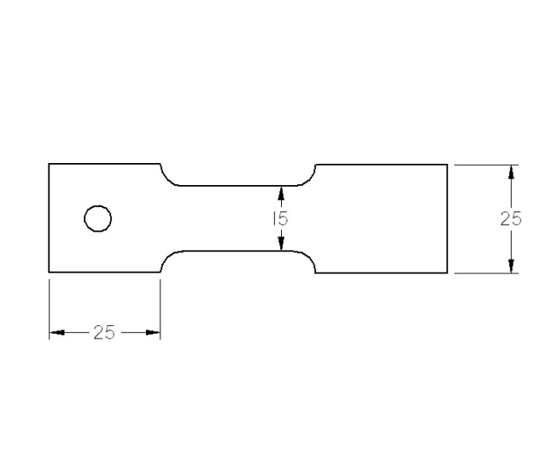
A
B
C

3kN
B
3kN

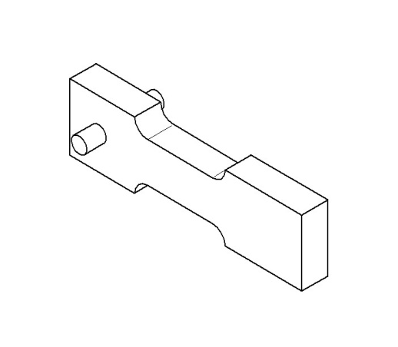
A
A
1kN
4kN
2024-T3 Aluminum
Ultimate Tensile Strength | 480 MPa
Yield Strength | 340 MPa
Shear Strength | 200 MPa
Elastic Modulus | 70 GPa
Poisson’s Ratio | 0.33
Density | 2.77 gm/cm³
1kN
C
1kN

- Determine the normal stress in the link at section A.

- Determine the Factor of Safety, FOS, with respect to shear failure for the pin.

- The average normal stress at cross section A is_________________ the average normal stress at section B. (Circle one of the following choices.)
higher than lower than the same as

- For a different loading configuration (a set of applied forces that are different than the set shown in the figure) a normal strain of 0.003 was measured at location C. The normal stress at that location is

- 210 MPa
- 23.3 MPa
- 42.8 MPa
- It is not possible to determine the answer from the given information

Problem 3 – 32 points
Locate the x and y centroids of the shaded region.
y
x
50mm
30mm
100mm
50mm
25mm
Hint: A table of the centroids of simple shapes is on the back of your equation sheet.

