MA/CSSE 474 Homework #15 45 points
See some Piazza questions and answers from a previous term at the end of this document.
Key:
(No symbol) Not required to be turned in. Just be sure that you can do it.
(t -7) To be turned in and graded, worth 7 points.

- (t-9) 18.1a
- (t-9) 18.1b
- (t-9) A TM M has tape alphabet { , a, b} (this is the order used in the encoding <M>).
<M> = (q00,a00,q00,a00, →), (q00,a10,q01,a10,→), (q00,a01,y10,a10, ←), (q01,a01,q00,a10,→), (q01,a10,n11,a01, ←)
- (6) Provide a transition diagram or a transition table for the TM M.
- (3) For each of the following outcomes of running M, provide a short string of a's and b's that is
accepted by M,
rejected by M,
neither.

- (t 6) 19.1 (3 points, 3 points) For part b, don't just say "yes" or "no"; explain.
- (t-12) 19.2 (6 points, 6 points)

Piazza questions and answers from a previous term
Pay no attention to the problem numbers in these questions; things have been rearranged.

Q: When is epsilon/empty string needed for NDFSMs?
I've noticed that we sometimes use epsilon/empty string in NDFSMs to go from state to state and sometimes not.
How do we know when we need the empty string and when we don't?

A: t is never necessary to use include epsilon transitions when we create a NDFSM .
In fact we can easily prove that given a NDFSM that includes epsilon transitions, we can make an equivalent DFSA that does not include any epsilon transitions.

So epsilon transitions are simply a matter of convenience, as is non-determinism itself. Use them when they make it easier to create a machine that accepts a particular language.

This question is about problem 1.
There has been some renumbering since this question was asked.
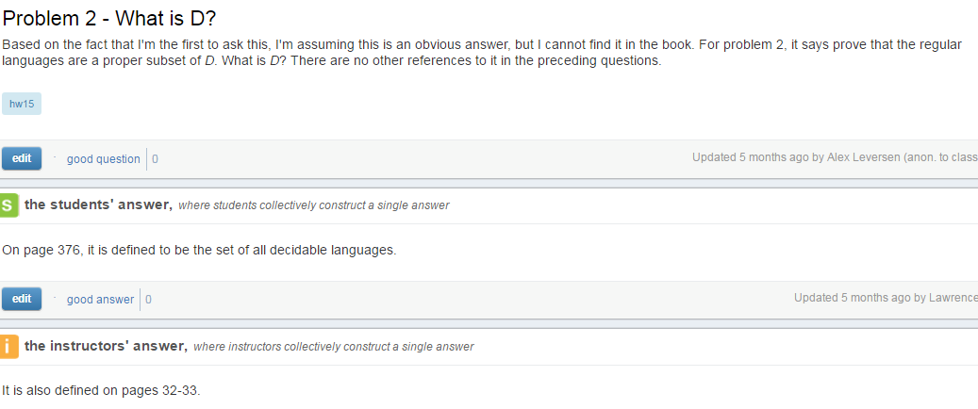

HW15 2a) input form?
So is the input of M' something of the form [x,y] where x would be the input for M and y is what we'd check with the output of M.
OR
Is the input of M' supposed to be the whole graph, ie, the input of the form [x1,y1], [x2,y2]...?
I wasn't really sure from the question since it seems that M' decides the graph of the function, which I thought meant the whole language L's input and output would be the input for M

Answer: It is the former, a single pair. It can't be the entire graph, since that is infinite.

Hint for HW15 (Problem 2c)
You might find the concept of "dovetailing" helpful for this problem. If you have not seen that technique before, this reference will probably help:

http://lambda-the-ultimate.org/node/322

HW15 #6 and #7 Approach?
What is the expected format for these two problems? Do we need to actually create a decision procedure that decides whether the description of the language satisfies the given constraints? Or are we doing something more vague, like some sort of proof that shows that the language is in D without actually defining a decision procedure? In either case, how do we go about doing this?
Answer: Your answer should be the decision procedure.

