MA/CSSE 474 Homework #3 (42 points total)
Submit to drop box on Moodle.
2.1 means Exercise 1 from Chapter 2.
You only have to turn in the problems that are highlighted in yellow, but you should still think about the others.
Please reread the instructions that precede the problem list in the HW1 assignment sheet. They apply here also.
- (t-6) 5.2(j) aa and bb as substrings [If you need simpler practice (and you probably do!), do some other parts of 5.2 first]. For this and other similar problems, you do not need to give the entire formal definition of your FSM.
A transition diagram or transition table is sufficient.
- (t-6) 5.2(l) no more than one pair of consecutive 0’s and 1’s (that’s part el, the letter that comes between k and m in the English alphabet)
- 5.3 Rock, Paper, Scissors
- (t-3) 5.4 L(M) contains ε The answer is simple and straightforward, so don't look for anything complicated or tricky.
- (t-6) divisible by 3 Let L be {w∈{0, 1}* : ∃n,k∈ℕ (w = <n> ∧ n = 3k)}. I.e. the set of binary representations of natural numbers that are divisible by 3. Leading zeroes are allowed. Recall that 0∈ℕ.
Draw the transition diagram or a transition table for a DFSM that accepts L. [Hint: think about remainders mod 3. Another hint: There are not many states].
- 5.5 determine membership in L(M)
- 5.6(a) FSM to accept a simple language
- (t-6) 5.6(c) decimal encoding of integer with a substring divisible by 3 Note that this one is decimal, while problem 5 is binary. Also notice the “contains a substring” part.
- (t-6) 5.7 three identical symbols in a row
- (t-9) How many strings of length k? The finite automaton on the next page accepts no strings of length zero, no strings of length one, and only two strings of length two (01 and 10). There is a fairly simple recurrence relation for the number N(k) of strings whose length is k that this automaton accepts. Discover and write down this recurrence relation. Note: the recurrence's solution does not have an easy-to-use closed form, so you will have to compute the first several values by hand. You do not have to compute N(k) for any k greater than 14. To help you determine whether you have the correct recurrence, I will tell you that N(8)=10 and N(9)=12. Show the "recursive" part of the recurrence relation.
Use your recurrence relation to answer this question: What are the values of N(13) and N(14)?
You are not required to explain how you get the recurrence relation.
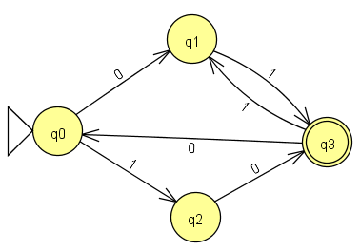
Note that before Summer of 2020, this was problem 15 from HW3; if you look at the past survey results for HW2, you will see that many students said this was the hardest problem on that assignment.
Some past questions and answers from Piazza:

Minimize FSM?
Q: Should we try to minimize our FSM on the homework or does it matter?
A: Trying to write your DFSMs with as few states as you can is a good idea, but it is not required for this assignment. Later this week we will look at an algorithm for doing that.

Pair of consecutive 1s/0s Problem 2
Q: For Problem #2 in HW 3 (2 l), does 111 constitute as 1 or 2 pairs of consecutive 1s? You could count the 2nd 1 as the 2nd 1 in the 1st pair or the 1st 1 in the 2nd pair.
A: There are indeed two pairs in the three 1's.

HW3 Problem 5: Are the binary strings fed with the most significant bit first?
Q: Does it not matter?
A: Unless a specific problem specifies otherwise, assume that binary strings are written with the most significant bit/digit first.

Empty string in HW 3 problem 5
Q: For problem 5 (binary representations of integers divisible by 3), can we consider the empty string a representation of 0, or should we avoid this?
A: The machine should not accept the empty string.

Last problem in HW3 (this is the problem that was moved from HW2 in Summer 2020)
During VOH today, multiple students have asked the same question. Do you need to explain how you get the recurrence relation, or is it sufficient to simply show the recurrence relation and the results for 13 and 14.
Answer: You do not have to include an explanation.

Natural numbers definition
In homework 3, for problem 5, it says "Recall that 0∈N".
I learned from MA275 that N started at 1, so 0∉N. (Apologies that this is on a separate line, Piazza doesn't like displaying equations on the same line for whatever reason.)
For this class, should we always assume that 0∈N, i.e. the natural numbers are all integers starting from 0?

Instructor answer. The short answer is “yes.”
From Wikipedia:
Some definitions, including the standard ISO 80000-2,^{[1][2]} begin the natural numbers with 0, corresponding to the non-negative integers 0, 1, 2, 3, …, whereas others start with 1, corresponding to the positive integers 1, 2, 3, …,^{[3][4]} while others acknowledge both definitions.^{[5]} Texts that exclude zero from the natural numbers sometimes refer to the natural numbers together with zero as the whole numbers, but in other writings, that term is used instead for the integers (including negative integers).^{[6]}
From Wolfram\Alpha:
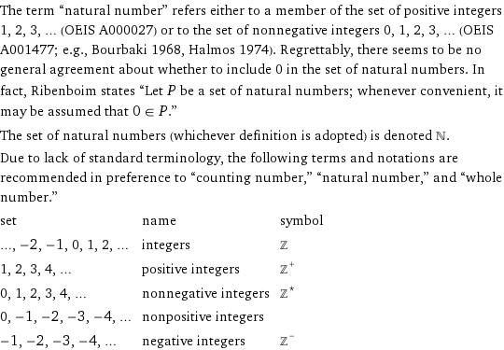

In this course, assume the "0 is a natural number" version.

Is 0 divisible by 3?
I've been having all my states disallow 0 as being divisible by any numbers.
the students' answer:
Yes, 0 is divisible by 3. Specifically, this is because the definition of divisibility is: an integer x is divisible by another number y iff you can express it like x=k*y where k is an integer.
So 0=k*3, if k=0

