474 HW 2 problems (highlighted problems are the ones to turn in)
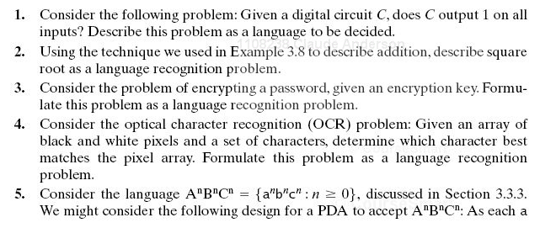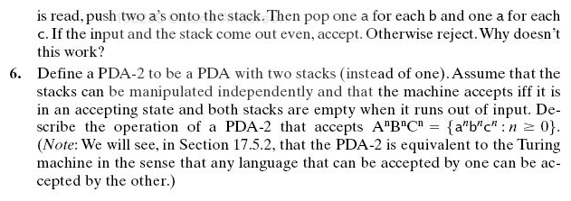
3.1
3.2

3.4
3.5

3.6

4.1
4.2

4.3, 4.4

4.4c

5.2
5.2a
5.2b

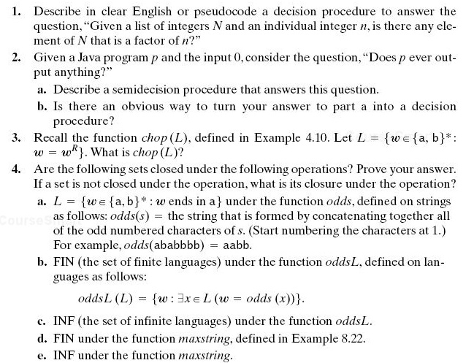
One more problem, not from the textbook:
#14 is described in detail on the assignment document, so I do not repeat that description here.
#15 was moved to HW3

