MA/CSSE 474 Day 39 Announcements and Summary
- HW16 Feb 21 (nothing to turn in).
- Final Exam Wednesday Feb 26, 8:00 AM. (A-M: G315, O-Y: G317)
  - Covers the entire term, but heavier emphasis on Turing Machines and decidability.
  - You may bring four sheets of paper, plus the handout on TM macros.
  - A note on the R CF D | SD ¬SD questions. Partial credit for an answer that is both
    - Immediately adjacent to the correct answer, and
    - On the correct side of the line.
Main ideas from today Example: L₂ = {<M, q> : M reaches q on some input}
- Example: A_{anbn} = {<M> : L(M) = A^{n}B^{n}}
  - Rice's Theorem says "not in D". We want to show it's also not in SD. Reduce ¬H to A_{anbn}
  - Reduction 1: Reduction 2: Reduction 3:
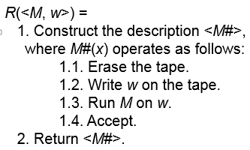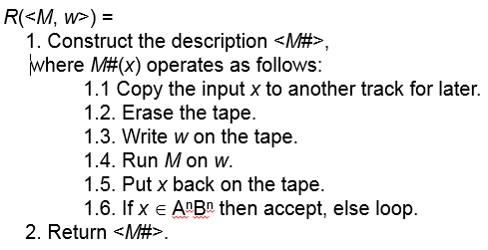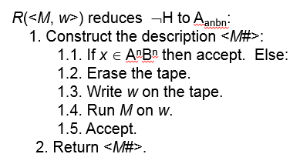

- H_{ALL} = {<M> : TM halts on Σ*}

- EqTMs = {<M_{a}, M_{b}> : L(M_{a}) = L(M_{b})} details on slides
- Details matter:
  - L₁ = {<M>: M has an even number of states}.
  - L₂ = {<M>: |<M>| is even}.
  - L₃ = {<M>: |L(M)| is even}.
  - L₄ = {<M>: M accepts all even length strings}.
- {<M, w>: M is a Deciding TM and Rejects w} (details on slides)
  - What about these?
L₁ = {a}.
  - L₂ = {<M> : M accepts a}.
  - L₃ = {<M> : L(M) = {a}}.

- {<M_{a}, M_{b}> : ε ∈ L(M_{a}) – L(M_{b})}

