DFSM canonical form
Motivation: First, the reason for canonical form is to determine if two minimal DFAs are equivalent. In general determining whether two graphs are isomorphic is widely believed to be an NP-complete problem (we’ll define that concept at the end of the course). But for two minimal DFSMs, there is a much more efficient algorithm.
Firsts, if the two minimal DFSMs M1 and M2 with states q₁, …, q_{n} and r₁..r_{m} have different numbers of states, they are not equivalent. If they have the same number of states, they are equivalent iff and there is a way to number the r states in such a way that for every input symbol a, δ(r_{i}, a) is the state that corresponds to δ(q_{i}, a).
Canonical form is a way of numbering the states of a minimal DFSM in such a way that this will be easy to do. First we order the input symbols. We number the start state as q₀, then to a breadth-first traversal of the graph, always following the transitions in the order of the input symbols. Details of the algorithm are given on page 95 of the textbook.
Example
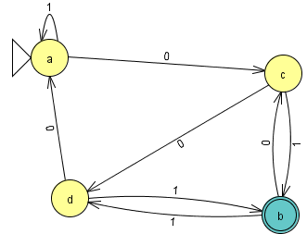

q₀ is the start state
δ(q₀, 0) = c, so c becomes q₁.
δ(q₀, 1`) = q₀, which we have already seen.
δ(q₁, 0) = d, so d becomes q₂.
δ(q₁, 1) = b, so d becomes q₃.
This is sufficient to number all of the states, but if there were more states, we would look at them in this order: δ(q₂, 0), δ(q₂, 1), δ(q₂, 0), δ(q₂, 1),

