474 HW 6 problems (highlighted problems are the ones to turn in)
Not from textbook

6.5

6.7a

6.8

Not from textbook
1. (p-10) This could have been on the previous assignment, but I wanted you to some time to think about it after you got the basics of regular expressions down.
Use the Myhill-Nerode theorem (instead of the pumping theorem)to show that the language
Σ = {a}, L= {a^{p} : p is a positive prime integer }
is not regular. In particular, show that for any pair of positive prime integers p and q, the
strings a^{p} and a^{q} are in different equivalence classes of ≈_{L}. This is not trivial.]
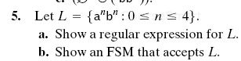
Show how you use the construction form the textbook
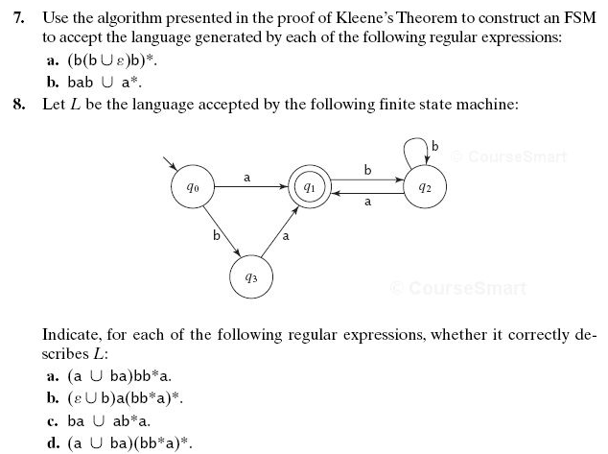
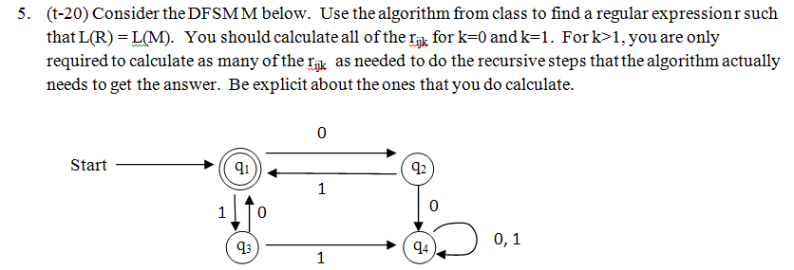
This link is primarily for summer students for which there is no “in-class”, but it may be helpful to winter term students as well. The proof of the “in-class” algorithm and a complete example are given on the bottom of p33 and on pages 34-35 from this document, taken from “introduction to Automata Theory, Languages, and Computation by Hopcroft and Ullman (Addison-Wesley, 1979).

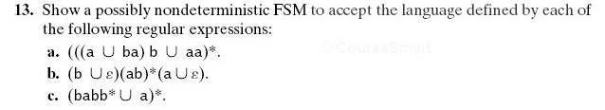
6.13d

6.15

6.20

8.6a
8.7a
8.7d

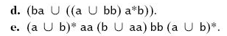
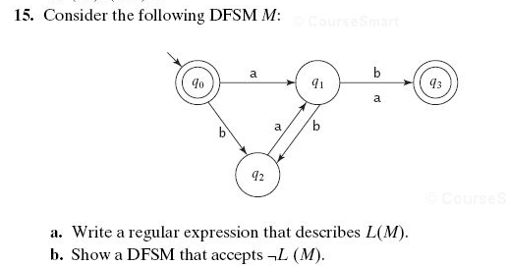
There is an error in this diagram in the book. The b-transition from q₁ to q₃ should not be there. Remove it before doing the problem.
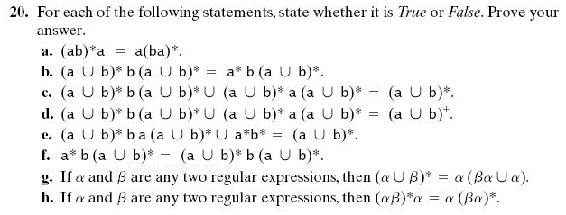
6a. That is, if M₁ is a DFSM that accepts L₁, and M₂ is a DFSM that accepts L₂, show how to construct a DFSM that accepts L₁∩L₂. . More specifically, if M₂ = (K₂, Σ₂, δ₂, s₂, A₂) and M₁ = (K₁, Σ₁, δ₁, s₁, A₁), describe using mathematical notation the five parts of the machine M that accepts L₁∩L₂.
7a. I recommend doing it by construction, starting with a FSM that accepts L.
