474 HW 4 problems (highlighted problems are the ones to turn in)
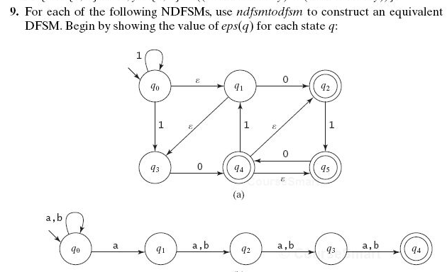
5.9a

5.9c

5.10

5.11 a,
5.11d

5.11 (b) (e)

5.12

