Some 474 HW 1 problems (highlighted problems are the ones to turn in
Shaded problems are to be turned in.
2-2
2-4
2-5

2.6
2.6c

2-7, 2-8

2-8 acdgl

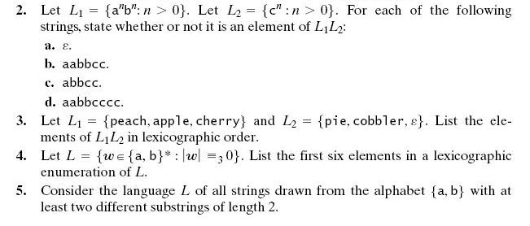
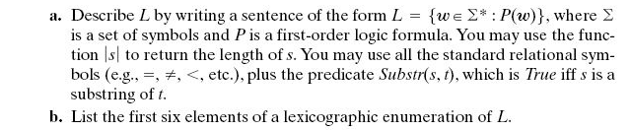
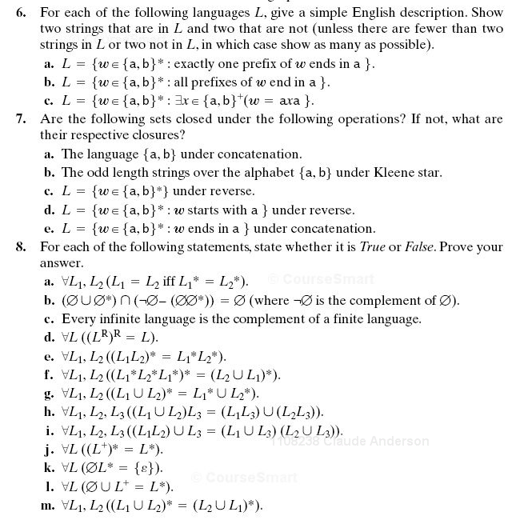

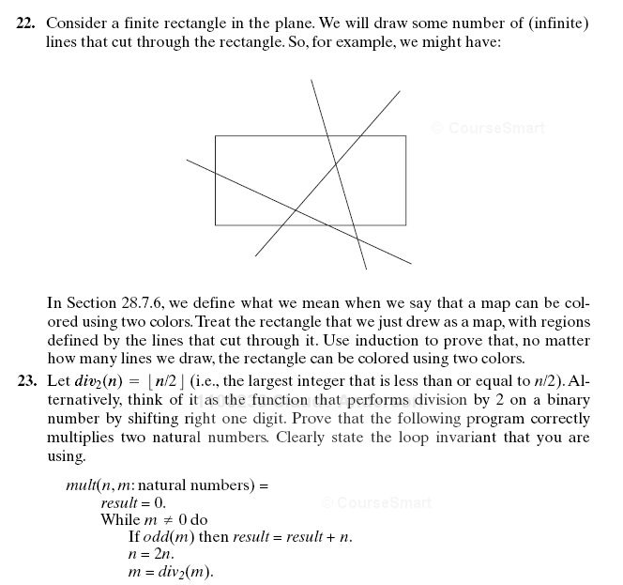
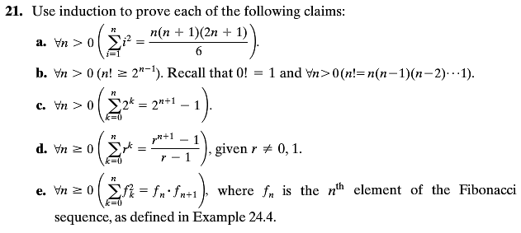
A.22 (colored in such a way that no two regions that share a common edge are assigned the same color). Hint: Induction on the number of lines. How do you get from a correct coloring with n lines through the rectangle to a correct coloring with n+1 lines?

A 21 de

A 22

A 23

There is also a required problem (#12)
described on the assignment page itself that is not from the textbook.

Note that the last problem (a turnin problem, induction problem about counting parentheses in expressions) is not from the textbook. It is stated directly on the HW 1 assignment page, so I did not repeat it here.

