HW 12 textbook problems and hints
Problem 1. 8.4.3 [8.2.3] (5) (Warshall with no extra memory use)
Explain how to implement Warshall’s algorithm without using extra memory
for storing elements of the algorithm’s intermediate matrices.

Author's hints:

Problem 2. 8.4.4[8.2.4] (10) (More efficient Warshall inner loop)
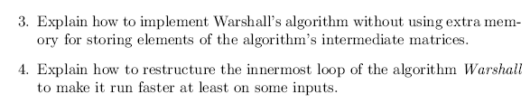
Author's hints:
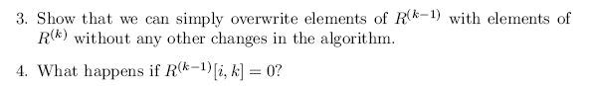

Problem 3. OptimalBST problem (25 points plus extra credit)
Not from the textbook. Description is in the assignment document
Problem 4. 8.3.3 (10) (Optimal BST from root table)
Author's hint:
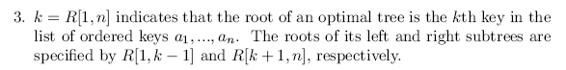

Problem 5. 8.3.4 (5) (Sum for optimalBST in constant time)
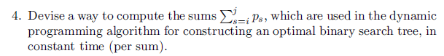
Author's hint
: 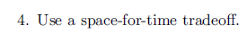
Problem 6. 8.3.6 (10) (optimalBST--successful search only--if all probabilities equal)
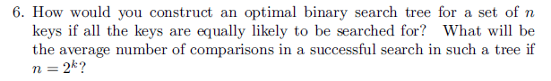
Author's hint:
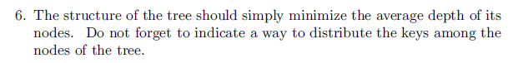

Problem 7. 8.3.10a (5) (Matrix chain multiplication)
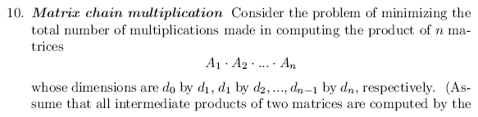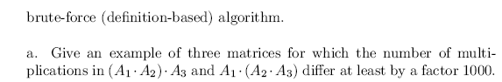
Author's hint:
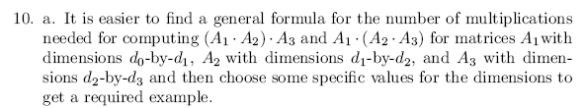

Problem 8. 8. 4.7 [8.2.7] (10) (Floyd algorithm example)
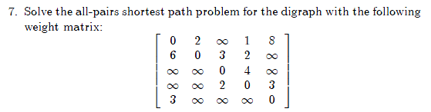
Author's hint:
See an example of applying the algorithm to another instance of the problem in the section.

Problem 9. 8. 4.8 [8.2.8] (8) (Floyd algorithm matrix overwrite)
Prove that the next matrix in sequence (8.14) of Floyd’s algorithm can be
written over its predecessor.

Instructor's notes:
Here is the sequence that the problem refers to (I think it is 8.8 in the second edition):

Author's hint:
