HW 11 textbook problems and hints
Problem 1 7.2.3 (6) (Horspool for binary strings)
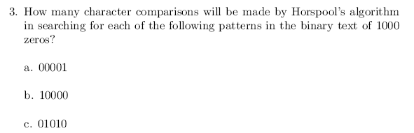
Author's hint:
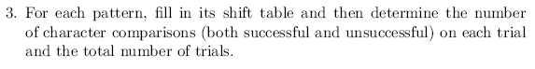
Problem 2 7.2.7 (9) (Boyer-Moore for binary strings)
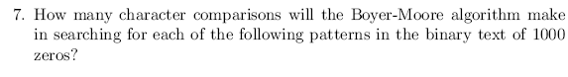
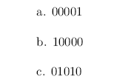
Author's hint:
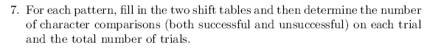

Problem 3: 7.2.8 (4) (does Boyer-Moore still work with just one table?)
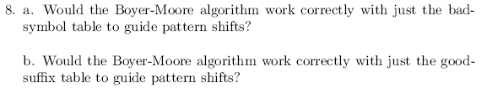
Author's hint:
Problem 4: 7.2.11 (3, 5) (right cyclic shift)
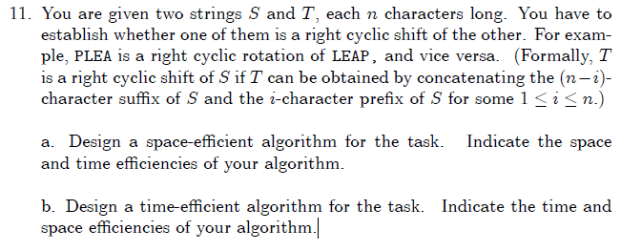
Author's hint:
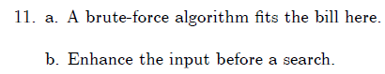

Problem 5: 7.3.4 (5) (probability that n keys all hash to the same table location)
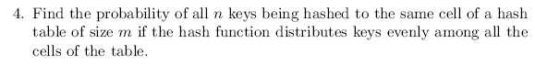
Author's hint:

Problem 6: 7.4.3 (6)
(minimum order of a B tree that guarantees no more than 3 disk accesses in a tree with 10⁸ elements)
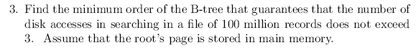
Author's hint:
Problems 7-8 : 8.1.10, 8.1.11 (12 each) (Longest path in a dag, Maximum square submatrix) Note that the material from Section 8.1 of the 3rd edition of Levitin is not in the 2nd edition. I have posted that section on ANGEL in the Reading Materials folder.
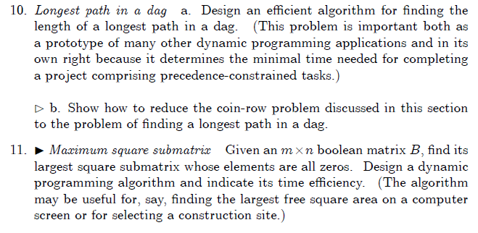
Author's hint:
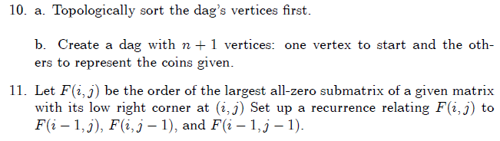

- Problem 9: 8.1.12 (10) (World Series odds) Show your work.
Note from Claude: In a 7-game series (such as the real American baseball World Series), the first team to win 4 games wins the series. 7 is the maximum number of games that can be played before one of the teams must win four games. But if one team wins 4 games sooner, the series ends immediately.
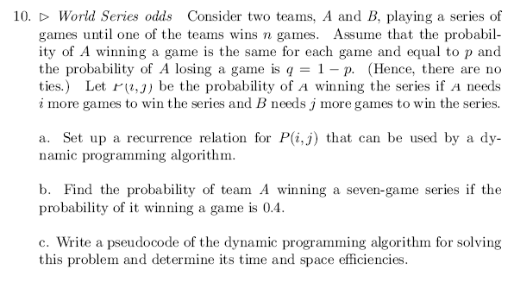
Author's hint:
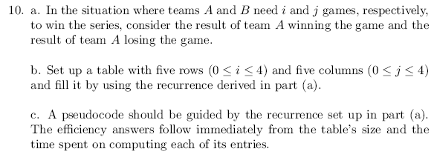
Instructor note:
In a 7-game series (such as the real American baseball World Series), the first team to win 4 games wins the series. 7 is the maximum number of games that can be played before one of the teams must win four games. But if one team wins 4 games sooner, the series ends immediately.

