473 Levitin problems and hints HW 09

Problems 1 and 2 are not from the textbook.
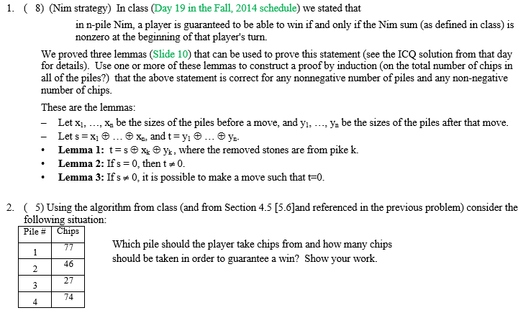
Problem 3: 4.4.8 [5.5.2]
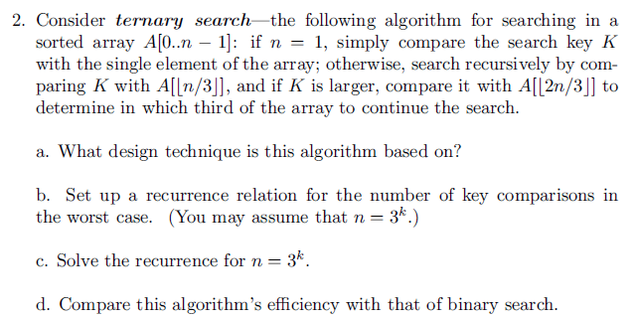
Author's Hints:
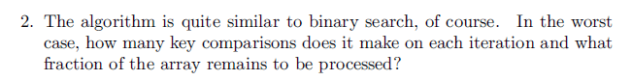

Problem 4: 4.4.10[5.5.3]
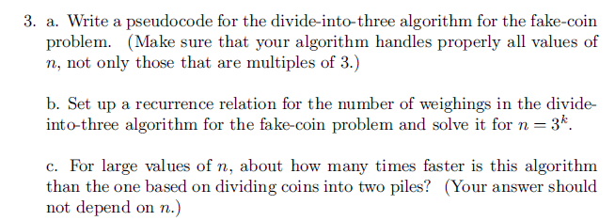
Author's Hints:
Problem 5: 4.4.13 [5.5.7] Find J(40)–the solution to the Josephus problem for n = 40
Author's Hints: The fastest way to the answer the question is to use the formula that exploits the binary representation of n, which is mentioned at the end of the section.

Problem 6: 4.4.15 [5.5.9] For the Josephus problem,
- compute J(n) for n = 1, 2, …, 15. (Instructor note: We started this table in class)
- discern a pattern in the solutions for the first fifteen values of n and prove its general validity.

Author’s hints:

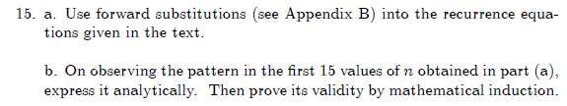
4.5.11a: This problem may be harder than first appears to be. You should provide an analysis in terms of m, n, and the (i, j) position of the moldy square For some values of (m, n, i, j), the first player can always win; for others the second player can always win. What is the winning strategy?
However, if you can't solve the general case, you may get some partial credit by solving the cases that you can solve, and writing about what you tried for other cases.
"Transform and conquer" is a good way to find a complete solution, so you may want to look ahead to Chapter 6 to give you some ideas of how “T & C” works.
In the past, several students said that this problem took them longer than any previous problem in the course.

Problem 7: 4.5.11a[5.6.10a]
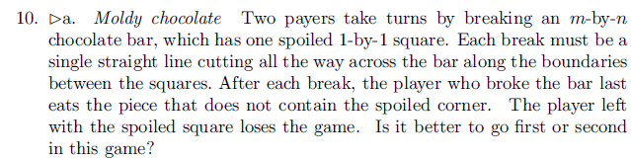
Author's Hints: 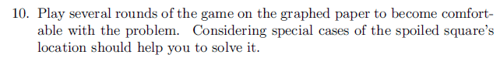

Problems 8-10: 4.5.4-4.5.6 [5.6.4-4.6.6]
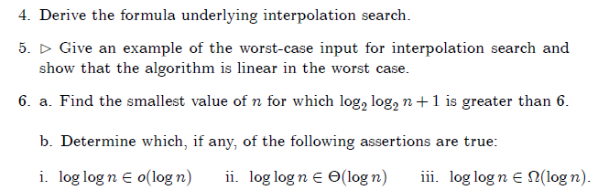

Author's Hints:
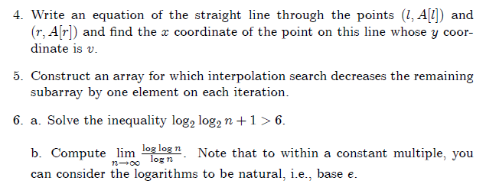

Instructor's notes:

4.5.5 Show that the worst case is Θ(N)
4.5.6 For part b, use the "limit of the ratio" approach.

