473 Levitin problems and hints HW 06

Problem 9: (9) 4.3.2 [ 5.4.2] Examples of permutation generation algorithms
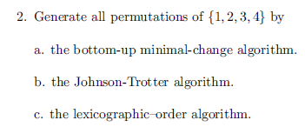
You do not have to write any code, but you can do it that way if you wish.
Author's Hints:
Problem 10: (10) 4.3.10 [ 5.4.10] Generation of all k-combinations from an n-element set
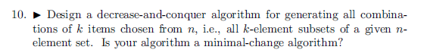

Author's Hints:
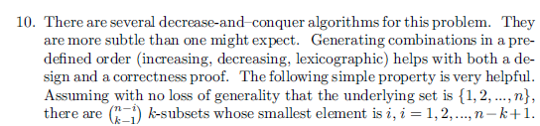

Problem 11: (10) 4.3.11 [ 5.4.11]
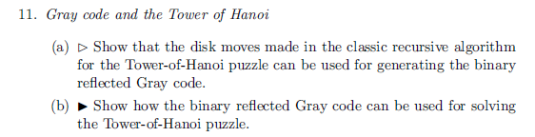
Author's Hints:

